Community Transforming Infrastructure, Bridge, Pathway, Wedding

I would like to discuss in this presentation how walking and cycling infrastructure can transform a community, through creating a new relationship between physical activity and transport. This new relation can then become a catalyst for change in a community.

Occasionally one project becomes the poster image of walking or cycling within a community, a firebrand, a call to action and others become the opposite. We know of such projects, like the light path in Auckland, Hagley Park cycleways in Christchurch and Island Bay facility in Wellington.

This discussion from the comfort of my living room couch, will follow the successful outcome of the Manawatu River Bridge and Pathway, He Ara Kotahi and explore how this project became such a Taonga of Palmerston North. Within 2 months of opening it was voted the best place to be in the Manawatu, it has had numerous wedding proposals and has held several formal weddings already.

On its first Saturday after opening, it had 15,000 visitors and has maintained its high usage ever since. On interviewing residents using this facility, a father and his daughter nailed it by saying – “before this was built there was nothing for us to do, but now this is our special place to go”.
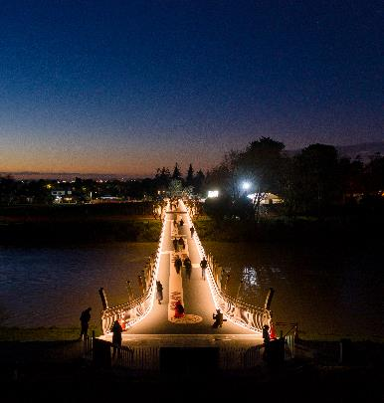
I want to dig a little deeper into what makes these projects stunning and community transforming.

I can give you a little spoiler alert... ‘natural beauty, water, interpretation, story, placemaking and quality urban design’ along with some other ingredients are essential to this recipe, which I hope to share from my couch, dressed as a master chef.

A free give away from this discussion will be a Community Transformation Recipe for all to take home.


