TRANSPORTATION GROUP 2024 CONFERENCE

HOW NELSON-TASMAN DOUBLED BUS PATRONAGE IN THREE MONTHS

This paper has been peer reviewed

Chun-Lin Lee, BE(Hons)(Civil), MEngNZ
Senior Transportation Engineer/Planner, Stantec NZ
chun-lin.lee@stantec.com

Doug Weir, BCom (Transport & Logistics), NZCE (Civil), CMCILT, MEngNZ
Senior Principal Transport Planner/Practice Leader, Public Transport, Stantec NZ
doug.weir@stantec.com

ABSTRACT
Good public transport has and will continue to have an important role in Aotearoa’s journey towards a more sustainable transport system with a reduced carbon footprint. But what does a ‘good’ public transport system look like, and what encourages people to use it?

In 2020, Nelson City Council (NCC) and Tasman District Council (TDC) recognised that their joint public transport system could contribute more to meet the environmental and social goals for the region. A review of the region’s public transport was undertaken. The review recommended three stages of improvements over a 10-year investment period. NCC and TDC implemented Stage 1 of the improvements in August 2023, and in just three months total network patronage had doubled.

This practice paper outlines the background to the review, its process, recommendations, and implementation, and the outcomes of the first stage of improvements to date. These improvements include a new route network, increased and consistent service levels, upgraded facilities, new electric buses, lower and simpler fares, a new ‘eBus’ brand, and easier to understand information.

The patronage trend seen over the first three months has continued, with network patronage in the seven months since implementation being 113% higher than the patronage over the same period in the previous year, which is much higher than predicted. This significant and sustained uptake in customers demonstrates a shift in the public perception of public transport in Nelson-Tasman and appears to be linked to the whole-of-system approach. It is expected that many of the same principles could be applied to other regions in New Zealand to achieve similar results and promote mode shift to sustainable transport.

INTRODUCTION
Nelson and Tasman are located at the top of the South Island, and although they have relatively small populations, are amongst New Zealand’s fastest growing areas. While NCC and TDC are separate unitary authorities responsible for the provision of public transport in their respective areas, they partner to deliver public transport services and infrastructure across the wider Nelson-Tasman region. This is because travel patterns are diverse and transport demand is not confined to their respective area of responsibility, such as travel between the centres of Nelson (NCC) and Richmond (TDC); public transport services operate as one network; and some of the services cross the territorial boundary.

In 2020 NCC and TDC commissioned Stantec to review the region’s public transport network, to inform the development of each council’s 2021 Regional Land Transport Plan (RLTP) and Regional Public Transport Plan (RPTP) and support the aspirations of the joint Nelson Tasman Future Development Strategy. The review’s primary objectives were to improve public transport coverage and service levels to support mode shift and sustainable growth, and, in so doing, provide a regional integrated network that would:
- provide attractive, economic, and viable transport choices for all sectors of the community,
- reduce reliance on motor vehicles, and
- be sustainable and reduced carbon emission based.

The review’s primary focus was on Nelson City, and Tasman District north of Wakefield and east of Motueka. This included the Nelson-Richmond urban area, where all existing scheduled public transport service was provided. Some consideration was also given to the transport needs outside of the focus area.

This practice paper outlines the background to the review, its process, recommendations, and implementation, and the outcomes of the first stage of improvements to date.

REVIEW BACKGROUND

Network and services
In August 2020, the Nelson-Tasman bus network consisted of the eleven routes shown in Figure 1, plus the Late Late Bus, a Friday and Saturday late-night service that operated after 10pm.

There was considerable variation in service levels, both within and between routes, with service frequencies that differed depending on the given route, time of day and day of week. While weekday peak frequency was generally every 30 minutes, the peak period wasn’t consistent. Some routes did not operate at all during the peak. Weekday interpeak frequencies and periods also varied considerably. One-way loop services providing basic access to Richmond and Stoke alternated between route variants, were indirect and had irregular frequencies, and provided poor customer level of service.

This pattern of variability extended to the weekends, where each route had a different service span and frequency depending on the route and time of day. Some routes did not operate at all on weekends, while others did not operate on Sundays. Routes 1 and 2, the two trunk routes, provided only a basic two-hourly service between Nelson and Richmond on both weekend days.

The variance of service frequency and span by route, time of day and day of week made the public transport system more complicated for customers to understand and trust to get them where they need to go. This was particularly relevant to customers who needed to connect between services to access their destination, increasing journey time and making public transport less viable.

Some important nodes of the region were not linked into the public transport network. This included the airport in the urban area, and regional centres like Motueka, Māpua, and Wakefield, where people were travelling regularly to access employment, education, and services, such as healthcare. For example, 93% of people in Māpua relied on private vehicles for travel, 52% were travelling daily, and 44% were travelling weekly (Māpua and Districts Community Association, 2019).

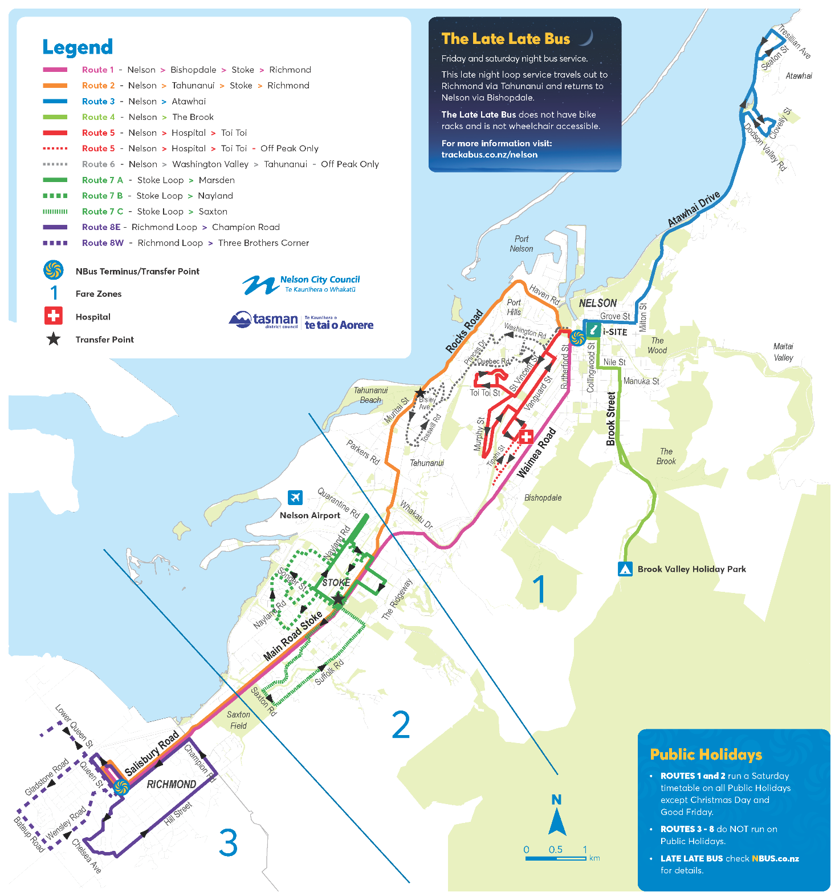
Figure 1: Nelson-Tasman’s bus routes in August 2020

Fares
The fare structure consisted of three zones, as shown in Figure 1. To illustrate the structure, an in-zone journey was charged a one-zone fare, a journey from Stoke to Nelson or Richmond a two-zone fare, and a journey from Nelson to Richmond a three-zone fare. Table 1 below shows the Bee Card (electronic ticketing) fare for each of these journeys. A one-hour free transfer window between services was provided to Bee Card users.

Bee Card Fare | 1 Zone (Nelson) | 2 Zones (Nelson-Stoke) | 3 Zones (Nelson-Richmond)
Adult | $2.00 | $2.40 | $2.80
Child/Student/Community Services Cardholder | $1.35 | $1.80 | $2.25
Table 1: Previous Bee Card fares
Although the three-zone fare system had been collapsed from the previous four-zone system, it was still confusing and expensive. Each of the zones covered a relatively small geographic area. The distance (as the crow flies) from Nelson to Stoke is roughly 6km, and from Stoke to Richmond roughly 5km. In comparison, Queenstown has a flat fare structure, which covers the 17km distance from Queenstown to Arrowtown, as well as services to Arthurs Point, Jack’s Point and Kelvin Heights.

Fleet and infrastructure
Services were provided by a mixed fleet of diesel buses, which varied considerably in size and age. Bus stop infrastructure was primarily provided on the main trunk routes, with many other parts of the network operating on a hail and ride basis only.

Customer response
Patronage had largely been static over the preceding five years, both at the network level and across most routes, although patronage was declining on some. Engagement with stakeholders and the public found that public transport was viewed as being complex and unattractive, with particular emphasis on times and timetables, routes, and fares.

REVIEW PROCESS AND RECOMMENDATIONS
The review assessed the performance of the existing system against six key attributes, to identify the main deficiencies that should be addressed through the recommendations:
- coverage – whether the network links people to the places that they want to get to,
- convenience – whether services enable people to travel when they want to, swiftly and reliably,
- facilities – whether the supporting infrastructure and fleet are comfortable and attractive,
- fares – whether the fare is intuitive and affordable,
- information – whether it is easy for new users to find, understand and use services, and
- delivery framework – whether the institutional framework is appropriate.

Coverage is crucial to basic access, for example, to employment, education, retail, and health services. However, it can be over-emphasised in network planning, and this can result in the artificial impression of good access provision. This spreads resources widely, which can constrain service levels and may result in poorly designed routes that don’t connect people to where they want to go. A route that provides direct access to a range of destinations is an essential prerequisite to any convenience-related improvements.

Convenience is frequently cited as a key reason for not using public transport and is critical to its attractiveness. Frequency is the most important element of convenience, although travel time and reliability are also important. The lower the frequency the more people must schedule other activities around public transport times and thus the more it is only useful for people who cannot drive. It is therefore particularly critical to mode shift. Days and hours of service are also vital elements of convenience and attractiveness.

The remaining attributes play an important supporting role by ensuring that public transport is easy to use, that customers are comfortable and feel valued, and by providing good value for money compared to other transport alternatives.

A range of programme options for addressing the deficiencies was next identified, representing low, medium, and high levels of change and investment. The options applied the following service design principles:
- the network and services should be simple, connected, and regular, and
- the overall offering should be easy for customers to understand, use, and remember.

The review recommended that the medium change programme be implemented, as it included the most desired mix of improvements, met the objectives identified, and offered a strong patronage response while also being affordable. It consisted of improvements to:
- the route network,
- service levels,
- facilities,
- vehicles,
- fares, and
- brand and information.

The programme was split into three stages to align with the likely implementation phasing. The most important programme elements were prioritised to provide a good platform on which to build, with later improvements incrementally increasing service levels to further strengthen the overall public transport offering. The staged approach was also intended to maintain affordability for ratepayers and taxpayers, since significant public investment would be required, and the benefits would accrue over a long period.

STAGE 1 IMPLEMENTATION
Stage 1 included the most significant changes of the programme and was intended to bring a step change to public transport in the region. It was implemented in August 2023 following retendering of the bus operating contract.

The focus of this stage was on the introduction of a simplified and planned network of connected and regular services in the urban area and establishing formal public transport in regional areas. This was supported by improvements to facilities, fares, information, branding, and marketing. These changes provide a more competitive and compelling option for more journeys than the old service offering and provide the platform for growth.

Network and services
The Stage 1 network is shown in Figure 2. It included:
- a simplified urban route network of four routes running every 30 minutes all day on a ‘7-7-7’ timetable (between approximately 7am and 7pm, seven days a week), which provides better network connectivity and better service to growth areas,
- a new responsive service to supplement the main routes at off-peak times and provide basic access in Stoke,
- new regional routes from Motueka and Wakefield to Richmond, and from there to Nelson, connecting peri-urban areas with the two primary regional centres and offering a limited stop service in the urban area,
- the retained Late Late Bus, operating on Friday and Saturday nights after 10pm.

The upgraded network enabled access to public transport for almost 22,000 more people who now live within a 10-minute walk of a seven-day bus service.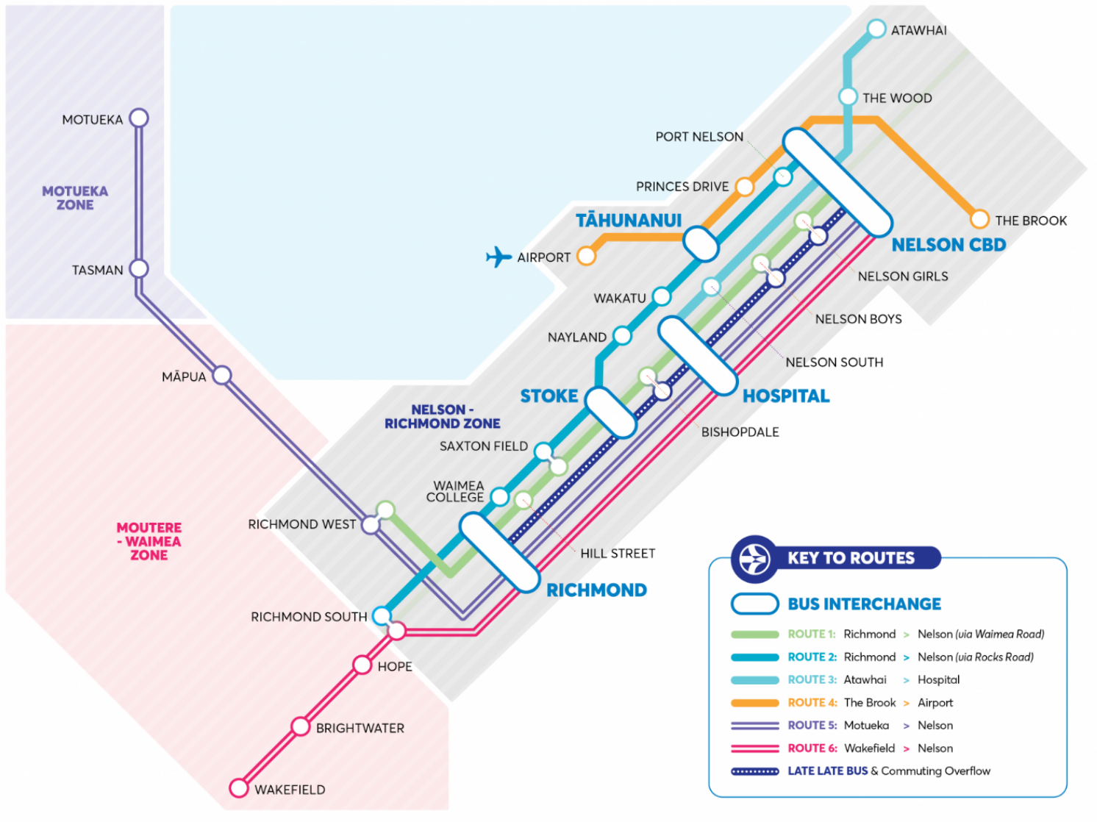
Figure 2: Stage 1 network

Fares
Stage 1 significantly simplified public transport fares by shifting from a three-zone structure in the Nelson- Richmond area to a single urban fare zone. This is similar to the fare structures used in Queenstown, Rotorua, Tauranga, and other comparable urban areas.

Two regional fare zones also were created:
- Zone 2, encompassing communities beyond the urban area, as far as Māpua and Ruby Bay in the west and Wakefield in the south, and
- Zone 3, encompassing communities beyond Ruby Bay, including Motueka.

Regional fare levels were roughly based on distance, set at logical increments compared to the urban zone price-point.

Table 2 shows the Bee Card fare structure at implementation. Fares have been set at competitive price-points to incentivise public transport as a mode for longer journeys (such as between Richmond and Stoke to Nelson), where private vehicle is the main competitor, traffic congestion is an issue, and mode shift is desired.

The Community Connect scheme was in place when the new fare zones were implemented, which resulted in three additional fare types as shown in the table. The scheme is set to be scaled back to only provide half price fares for Community Services Card holders from 1 May 2024.

Bee Card Fare | 1 Zone (Nelson-Richmond) | 2 Zones (Nelson-Wakefield) | 3 Zones (Nelson-Motueka)
Adult | $2.00 | $4.00 | $6.00
Youth 19-24/Community Services Cardholder | $1.00 | $2.00 | $3.00
Youth 13-18 | $0.50 | $1.00 | $1.50
Infants and children up to 12 years | $0.00 | $0.00 | $0.00
Table 2: Bee Card fares introduced as part of Stage 1

Infrastructure
Bus stops were formalised on all bus routes, with new bus stops located close to walking links to maximise the access catchment via the footpath network. New stops were established with a concrete pad (if not located on a footpath), a branded bus stop flag, and route and timetable information. These elements help to establish the presence of the bus service from a branding perspective and provide both the location and information needed for new users to understand and access the service.

Shelters with seating have also been installed, prioritised at bus stops with higher boarding levels or located close to rest homes, schools, shops, community facilities, and other similar destinations. Shelter is an important feature to improve the customer experience.

Fleet
The retendering of the bus operating contract allowed the replacement of the old and variable quality vehicle fleet with one that meets higher customer and environmental standards. The tender specified a low emission Euro 5 or 6 bus fleet (or higher Euro standard), or a zero-emission bus fleet, powered by electricity (battery), hydrogen or other zero carbon source.

The winning tender proposed a standardised fleet of electric buses, making the Nelson-Tasman fleet the first to be fully electrified. The electric buses support environmental goals and are attractive to customers. The standardised fleet also provides consistent quality and features such as air conditioning and full wheelchair accessibility. It demonstrates that all routes have an important network function and provides operational flexibility.

Brand and information
A joint public transport brand, eBus, was developed to support the unified approach to public transport planning and delivery, communicate the step change improvements being made, and position public transport as a desirable transport option. It replaced all previous NBus branding, including on information material, bus stop signage, and buses.

The ebus.nz website provides a ‘one source of the truth’ for information, which is easy to find and accessible. Improvements to bus stops across the network also improved information availability, particularly the provision of real-time information at network nodes, and timetable information at other stops. Marketing was increased to support brand positioning and the roll out of the changes.

PLANNED STAGE 2 AND STAGE 3 IMPLEMENTATION
Two subsequent stages are planned, subject to funding availability. Stage 2 is tentatively set for 2026, and Stage 3 for 2029. Either set of improvements can be accelerated if justified by demand, or changed or delayed if the patronage response is slower than expected.

Stage 2 is planned to include:
- the addition of weekend bus services on regional routes, and
- introduction of park and ride facilities.

Stage 3 is planned to include:
- increased peak frequencies on the urban routes, with a focus on Routes 1 and 2.

STAGE 1 OUTCOMES

Patronage response
The patronage response to the Stage 1 improvements has been significant. In the first three months after implementation (August to October 2024) total network patronage doubled compared to the same three months in 2023. Figure 3 shows that this trend has continued, with total network patronage over the seven-month period from August 2023 to February 2024 being 113% higher than the patronage seen from August 2022 to February 2023. Figure 4 shows a clear month-on-month upward growth trend, particularly when compared to the August 2019 to February 2020 period, just prior to the significant impact of COVID-19.

The patronage response has been higher and much more immediate than typically seen in response to service changes. If the current level of growth is sustained for the March to July 2024 period, then patronage for the 12-month period will be around 33% higher than the 746,000 projected for the first year by the elasticity-based demand model used for the review, which accounted for ramp up and used demand elasticity rates at the higher end of the ranges contained in NZ Transport Agency’s Monetised Benefits and Costs Manual. This suggests that the whole of system upgrade to Nelson-Tasman public transport has had a transformative impact.

It is worth noting that there was a marginal reduction in people with access to any type of bus service, but a significant increase in the number of people with access to a seven-day bus service. This supports the argument that coverage by itself is not sufficient to meet the needs of customers.

The increase in patronage from the Stage 1 improvements is over and above the increases associated with the half-price fares scheme, which ran between April 2022 and June 2023, and the subsequent Community Connect scheme. However, it is expected that some of the current response relates to the latter scheme, and patronage growth may slow when that scheme is scaled back from May 2024.

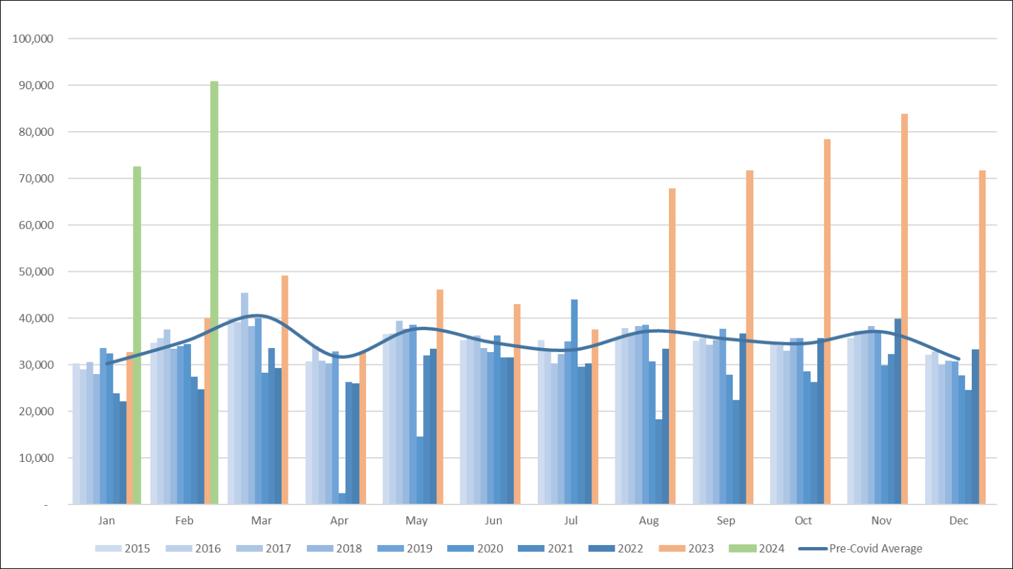
Figure 3: Monthly patronage from 2015 to 2024 (Stage 1 implemented on 1 August 2023)

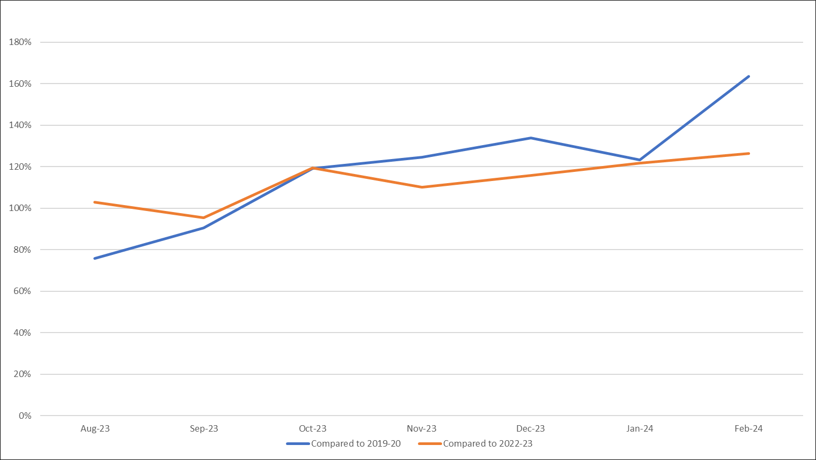
Figure 4: Month-on-month patronage growth trend
As expected, patronage on the urban routes dominate, with patronage on the new regional routes (Motueka-Nelson and Wakefield-Nelson) accounting for 8% of total patronage over the first seven months, although these routes account for only 7% of bus trips, so usage is roughly proportional to the urban network. In fact, Route 5 carries more passengers per trip on average than routes 1 and 2, with 20 on average, compared to 19 and 18 respectively. Patronage per trip has increased on the urban network, by around 5% on routes 1, 2 and 3 compared to their equivalents in 2019, and by 171% on Route 4, although the western leg of that route (which connects previously poorly served suburbs to the city centre, employment, and recreation in Tāhunanui, and the airport) is largely new.

Pleasingly, the average passenger trip length is 7 km on urban services and 24 km on regional services. As typical average walking and cycling trip leg lengths are 1km and 4km respectively according to the Ministry of Transport (2023), this indicates that bus services are providing access for trips that would otherwise be taken by car or would not be made at all. This is particularly the case for regional trips, where driving is the only viable alternative for such a trip length.

Public perception
While no formal post-implementation customer satisfaction surveys have yet been completed, the public response to the Stage 1 upgrades has been positive.

As reported by Gee (2023), a bus customer waiting to catch the Route 3 bus from Nelson to her home in Atawhai was quoted saying “It's really exciting having weekend buses, it's like gold and the buses are going to be quiet, they are not going to be noisy.”

An interview by eBus (2023) quotes a customer saying “Out of the new routes to places like Wakefield, Brightwater, Motueka and Māpua, I’m looking forward to getting out to Motueka. Just take the bus there and go for a walk somewhere I haven’t been able to go on my own before.” He goes on to say of the Route 2 bus as it reaches Rocks Road and opens up to a panoramic view of Tāhunanui Beach and Tasman Bay, “You can't really beat this view from the bus… This is now the most peaceful bus journey in Nelson."

Until a wider customer satisfaction survey is undertaken, these anecdotes can be taken to represent a small sample of the overall public perception. These positive comments about the upgraded public transport system align with the significant patronage response.

CHANGES SINCE IMPLEMENTATION
Since the implementation of Stage 1, a small number of adjustments have been made.

Timetable adjustments to reflect running times
After widespread network changes, it is good practice to review and adjust the timetables to reflect the actual running times after implementation. Services have been generally found to be running on time, but some issues have been identified, particularly in relation to slower than expected running times on new route sections through Richmond, which is partly related to road congestion and partly to the higher-than-expected passenger response. Timetable adjustments are currently being planned to address these.

Route change due to road damage
The heavier weight of electric buses compared to an equivalent passenger capacity diesel bus has resulted in pavement failures occurring on some roads. This has included seal cracking, heaves, and potholes. While it is difficult to attribute the cause of the pavement failures solely to the new electric buses, due to the increased weight of heavy vehicles in general and damage sustained in intense weather events, some issues occurred after implementation and appear to be linked to the use of heavier buses, which has resulted in NCC and TDC needing to address the pavement issues. Route 3 services have been re-routed from one section to avoid further damage, reducing the catchment of the service in South Nelson (a subsequent crash at an intersection has required a further route revision).

Removal of on-demand services
Use of the Stoke on-demand service has steadily declined, from 148 people in August 2023 to only 48 in February 2024. Nelson City Council decided on 4 April, on the recommendation of the Joint Nelson Tasman Regional Transport Committee, to end the service on 30 April 2024, due to the poor value for money offered by the scheme. The on-demand service was cited as costing $215 per passenger journey.

CONCLUSIONS AND RECOMMENDATIONS
There are several conclusions that can be drawn from the outcomes achieved by the implementation of Stage 1. These can be applied to other cities considering potential changes to their public transport network, especially in regions that share similarities with Nelson-Tasman.

A public transport system is greater than the sum of its parts
The whole-of-system approach to upgrade the public transport system in Nelson-Tasman, which delivered improvements to the network, service span and frequency, fares, infrastructure, fleet, branding, and information, revealed latent demand and was consequently able to achieve more than the incremental benefits each component part may have achieved on their own. Together the upgrades were able to provide improvements across all six of the key attributes intended to be addressed by the review recommendations – coverage, convenience, facilities, fares, information, and delivery framework.

Fixed-route services can be attractive and successful in peri-urban zones that are reliant on regional centres
The regional routes from Motueka and Wakefield to Richmond and Nelson have been very successful and provide important access and mode choice benefits. Although they currently only operate on weekdays, the patronage response demonstrates that public transport is a viable mode for connecting the peri-urban areas with regional centres. Without public transport services, driving is the only alternative mode for these journeys, making this an important cohort of customers to consider and provide for when striving for a more sustainable transport system. For customers who are non-drivers, these services provide important access to centres and their amenities that would otherwise be unrealised for this transport-disadvantaged group.

On-demand solutions have their benefits but are expensive
The off-peak only on-demand service in Stoke was ultimately unsuccessful. Usage was low and declining, and the service was expensive to deliver per person. While demand responsive solutions can be useful to address access concerns, they can be difficult to justify from a value-for-money perspective if they don’t result in a significant patronage increase.

Major network changes can result in unintended outcomes
The scale and speed of the patronage uptake, resulting from the improvements, impacted the running times of services due to the increased dwell times at bus stops. While this is a marker of success, it had a subsequent impact on service reliability, and had knock-on impacts for customers planning on taking connecting services and for subsequent trips. These adjustments can be expensive to rectify, particularly when the network has been designed to enable connections.

The weight of electric buses can be an issue
Electric buses are heavier than traditional diesel buses, which may limit their use in some places, or require pavement improvements. While it would be impractical to test pavement strength across the network before deploying electric buses, it is worth being aware of the potential implications of the heavier vehicles for the roading network.

REFERENCES
eBus. (2023) The feels on the bus. [Online] Available from: https://ebus.nz/news/the-feels-on-the-bus/ [Accessed 12th April 2024].

Gee, S. (2023) New fleet of electric buses hits the road in Nelson and Tasman. [Online] Available from: https://www.rnz.co.nz/news/national/494947/new-fleet-of-electric-buses-hits-the-road-in-nelson-and-tasman [Accessed 12th April 2024].

Māpua and Districts Community Association. (2019) Community Wellbeing Survey – Mapua & Districts July 2019. [Online] Available from: https://www.ourmapua.org/wp-content/uploads/2019/06/Grouped-Survey-Results-Aug20.pdf [Accessed 30th May 2024].

Ministry of Transport. (2023) Household travel. [Online] Available from: https://www.transport.govt.nz/statistics-and-insights/household-travel/ [Accessed 12th April 2024].

ACKNOWLEDGEMENTS
This paper has been developed with the support of NCC and TDC, namely Margaret Parfitt (NCC) and Jamie McPherson (TDC), who provided information and reviewed the paper.

Our acknowledgements extend to NCC and TDC staff who were involved in the 2020 Nelson-Tasman Public Transport Review and the implementation of Stage 1 improvements, including Margaret Parfitt (NCC) and Drew Bryant (TDC).

AUTHOR CONTRIBUTION STATEMENT
Chun-Lin Lee – Development of ideas/thoughts, prepared the paper.
Doug Weir – Development of ideas/thoughts, prepared and reviewed the paper.

59,300 people previously had access to a bus service, but only 35,200 people had access to a seven-day service. This has increased to 57,100 people.
Excluding backup buses, on-demand, and the Late Late Bus.

