PALMERSTON NORTH URBAN CYCLE NETWORK MASTERPLAN
(This paper has been peer-reviewed)

John Lieswyn, MET, PTP (presenting and corresponding author)
Senior Transport Planner, ViaStrada
john@viastrada.nz

Victoria Edmonds
Planner, Palmerston North City Council

Adam Jarvis
Sustainability Officer, Palmerston North City Council

Matthew Kilpatrick
Transport Planner, Beca

ABSTRACT
Palmerston North once had the highest rate of cycling to work (as measured by the Census) in New Zealand, but in recent years the number of cycling trips has been declining. The 2007 Manawatu Active Transport Strategy led to the development of a shared path network around the city, recently bolstered by the opening of He Ara Kotahi (with a major new bridge across the Manawatu River). It also included some 30 kilometres of standard painted cycle lanes. Nevertheless, many primary cycle routes are characterised by narrow lanes next to parked cars. Others end abruptly into parking lanes or when all the available road space is allocated to cars at traffic signals.
With a goal to “have the most active community in New Zealand”, elected members directed staff to develop a masterplan that would set a long-term direction as well as inform a $2.9M investment in the near term. This presentation describes how the public and key stakeholders were included in the development and the use of an online StoryMap to communicate network-level details.
The final plan highlights four main challenges to implementation: limited funding; road space allocation at traffic signals; the need for a comprehensive local street traffic management policy; and on-street parking impacts. These are not just technical problems to be quantified by economists and solved by engineers. A project-related “bike-lash” (pushback from business owners) also highlighted the need to work with affected communities to demonstrate why change is needed and to explore alternatives that meet our shared liveability, accessibility, and safety objectives.

AUTHOR CONTRIBUTION STATEMENT
John Lieswyn was the lead author of the masterplan and this paper. Victoria Edmonds led the consultation phase of the masterplan. Adam Jarvis was the client, a substantial co-author of the masterplan, and a key contributor to the scoring of corridors in ActiveTrans. Matthew Kilpatrick (in his previous role as transport planner at the council) was the client for the business case and managed concurrent cycling project delivery.

INTRODUCTION
Many councils develop cycling network plans to signal where investment is proposed and what form it may take. The plans are also used to coordinate activities internally via intranet-hosted maps, support funding applications, and inform public-facing maps. Palmerston North City Council has used a network plan originally adopted in 2007 (Palmerston North City Council and Manawatu District Council, 2007) . Implementation progress, updated national guidance, and changing customer expectations led to a need to refresh the network plan. Council instructed officers to develop a new plan that would inform how a two-year $2.9M ($33 per capita) investment should be made and how it would fit into a longer term network.
The result of this work built on the examples set by Hamilton’s Biking Plan (Hamilton City Council, 2015), Auckland Transport’s investment programme summary (Auckland Transport, 2017), and Wellington’s Cycleways Programme Master Plan (Wellington City Council, 2015). The work was also conducted while council managed local “bikelash” to the College Street cycleway project and informed by learnings from other cities (MorrisonLow, 2016, NZ Transport Agency and Empathy, 2017).
The Palmerston North Urban Cycling Network Masterplan was adopted in September 2019 (PNCC, 2019). In an official submission, NZ Transport Agency staff said the draft Masterplan “convey(s) a detailed business case in a straightforward way for the community to understand, that shows both the long-term vision and the shortterm priorities. The interactive map is great and shows an inspiring vision”. Bike Auckland said (via social media): “How to transform a city! This consultation is brilliant. Big vision, clear targets and timeline, great maps and imagery, and both reassuring and inspiring.”

Background and previous strategic work
Palmerston North is ideal for cycling, with temperate weather, flat topography, and a compact urban form. The inner suburbs have a grid street layout with short block lengths, although outer suburbs have a more car-oriented “loops and lollipops” (cul-de-sacs) street pattern.
Increasing the number of people cycling in the city has been a key priority of the Council for over 15 years. This priority is now aligned with the latest Government Policy Statement (GPS) on Land Transport, which prioritises safety and more transport choices by signalling investment in cycleways, speed management, and promotional activities (New Zealand Goverment, 2018).
Previous strategic work includes:
- The 2007 Manawatū Active Transport Strategy informed the development of today’s primary on-road cycling and shared path network.
- The Urban Design Strategy 2010 sought to “increase numbers of people who ride bicycles” as a measure of success.
- The Cycling Investigation Working Party published a Cycle Action Plan in 2015 with actions intended to help deliver on that vision, many of which have been completed or carried forward in the Masterplan.
- A gap analysis developed internally by PNCC in 2016.
- A technical corridors-based plan was developed internally in 2017.
- A review of the council’s Bikes in Schools programme was completed in 2017
- The purpose of the 2018 Active and Public Transport Plan is to have a safe, efficient, and effective active and public transport system.
- The Roading and Parking Asset Management Plan (AMP) aims to reduce injuries and deaths by improving the quality and condition of the cycling network, including at intersections.

Cycling network planning guidance
In the early 2000’s, New Zealand local authorities had to have a walking and/or cycling strategy in order to apply for central government funding assistance under the walking or cycling activity class. Research on best practices conducted in 2004/05 found there were 36 known strategies in New Zealand (Macbeth et al., 2005). The Cycle Network and Route Planning Guide (LTSA, 2004) recommended that strategies should include three main components:
- Strategic context (background, vision, objectives, policies, targets)
- Network plan (usually in map form)
- Implementation plan (timing and responsibility for each action in tabular form)
In the last decade, the requirement for a strategy in order to receive funding assistance was dropped. For major programmes of work or projects exceeding $1M, a business case is now required. Many councils have moved towards integrated multi-modal transport strategies rather than single-mode strategies. However, even an integrated strategy should still assess existing network conditions and propose improvements for each mode, so the content of former cycling strategies are often subsumed into a chapter of the integrated strategy. The authors recommend that any such chapter should still retain a focus on each mode. Historically, the priority given to motorised modes has limited active modes. While Palmerston North has an Integrated Transport Strategy (PNCC, 2015) and a Roads and Streets Framework is currently in development, this paper explains the development of a separate cycling-specific masterplan that considers the inter-relationship of all transport modes.

Developing the masterplan
Upon Council resolution instructing officers to develop the masterplan, a Terms of Reference (ToR) document was developed to define the objectives, scope, stakeholders (with level and timing of participation), and project risks. The lead consultant was a former council officer, author of the original 2007 strategy, and worked on secondment in-house for an average of six business days per month.
The following innovations and approaches were used.

ActiveTrans Priority Tool (APT)
The purpose of this assessment is to prioritise Council’s investment plan for delivering cycling infrastructure within Long Term Plan 10-year programme. The prioritisation placed strong emphasis on what can be achieved before the end of the 20/21 year. The same process can be rerun with different weightings once those projects have been delivered. As new information becomes available, the second tranche of projects may see a change in ranking.
Project identification was from a review of council’s existing transport plans and strategies, in addition to input from People on Bikes forum members, and a desktop analysis supported by fieldwork and observations. A range of neighbourhood greenways have been identified but not included because there is a need to update the Council’s Local Area Traffic Management (LATM) policy before further assessment can be completed. Those included now are key central city links.
Method. The United States’ National Cooperative Highway Research Program has funded the development of the ActiveTrans Priority Tool (APT) a transparent and flexible spreadsheet tool for walking and cycling projects based upon multi-year research and the experience of the top jurisdictions in the US (NCHRP, 2015). This was the author’s fifth application of ActiveTrans and second in New Zealand after Hastings District’s iWay network. APT was used for the masterplan; the prioritisation can be updated as more information becomes available.
Criteria used are included in Table 1.
Table 1: corridor prioritisation criteria

The results were generally consistent with expert opinion and the views of the community as expressed in masterplan submissions.

Keeping it strategic
Council wanted a strategy, not a research report. Much of the detail behind the masterplan is contained in the separate business case. Therefore the masterplan project scope included graphic design as an important component from the outset. The relevance of cycling to council’s 10-Year Plan and other key documents like the Creative and Liveable Strategy and the Active and Public Transport Plan was covered in one page (Figure 1), when in many strategies published before 2010 this material would take much more space.
Figure 1: strategic alignment
Vignettes (Figure 2) tell the story of people who currently ride – this doesn’t mean that they are happy with existing conditions, but more to humanise “cyclists” (Koorey, 2007) for any readers not already convinced about the merits of investing in cycling (NZ Transport Agency, 2016).
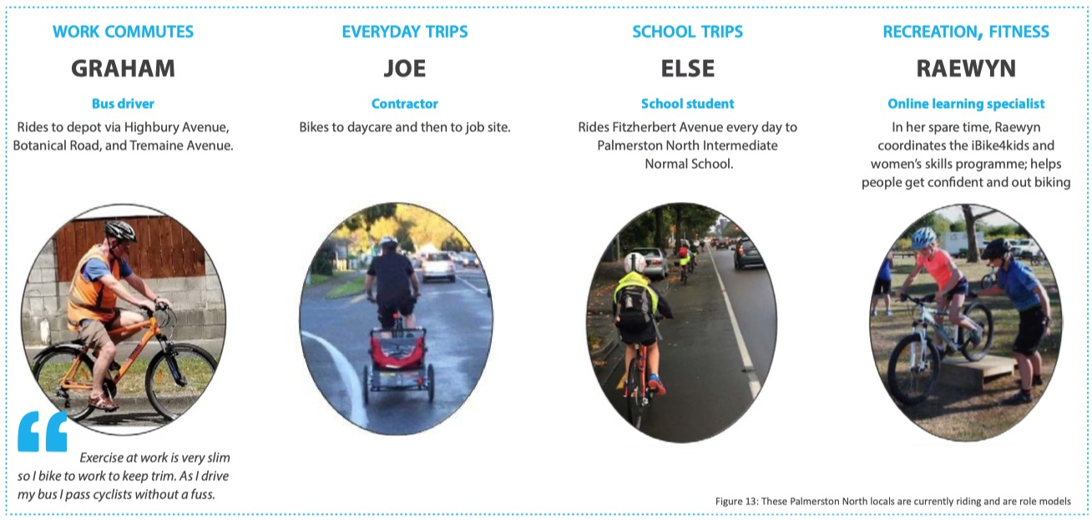
Figure 2: vignettes tell the story of people who ride now
A graphic (Figure 3) relates the target audience (Geller, 2009, Dill and McNeil, 2012) with facility types and associated numerically graded skill level (NZ Transport Agency and ACC, undated). | 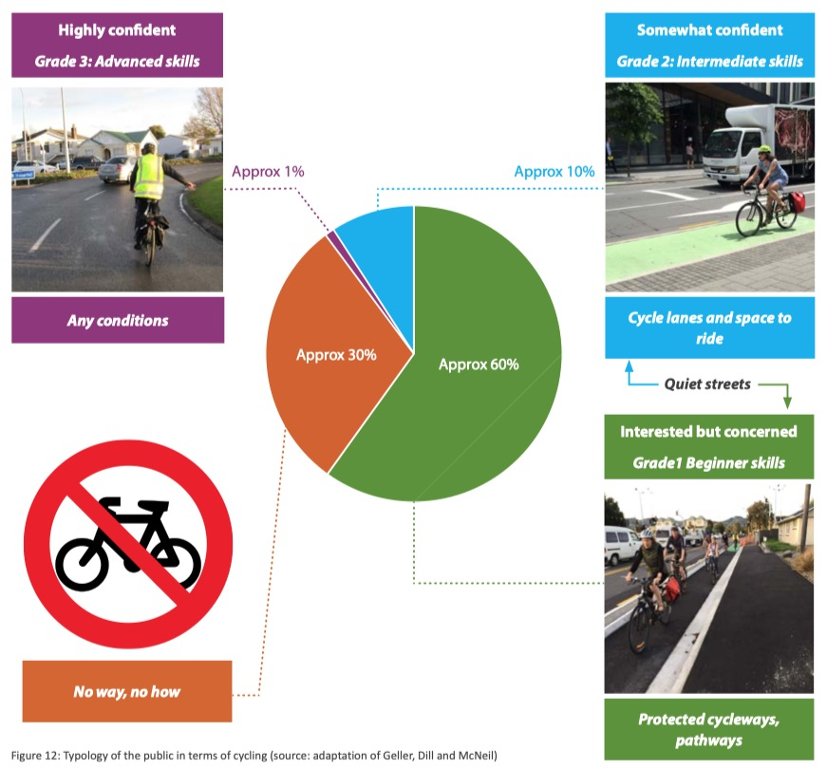  Figure 3: relating a typology of the public with skills and facilities
Previous engagement showed that many members of the community defined cycleways narrowly and inconsistently. One page of the masterplan was dedicated to graphically showing how to provide for cycling along streets and another focused on intersections. Throughout the plan, graphics about the types of facilities are generally colour-coded to match the network map line type symbology and was developed based in part on the Cycling Network Guidance definitions (NZ Transport Agency, undated).
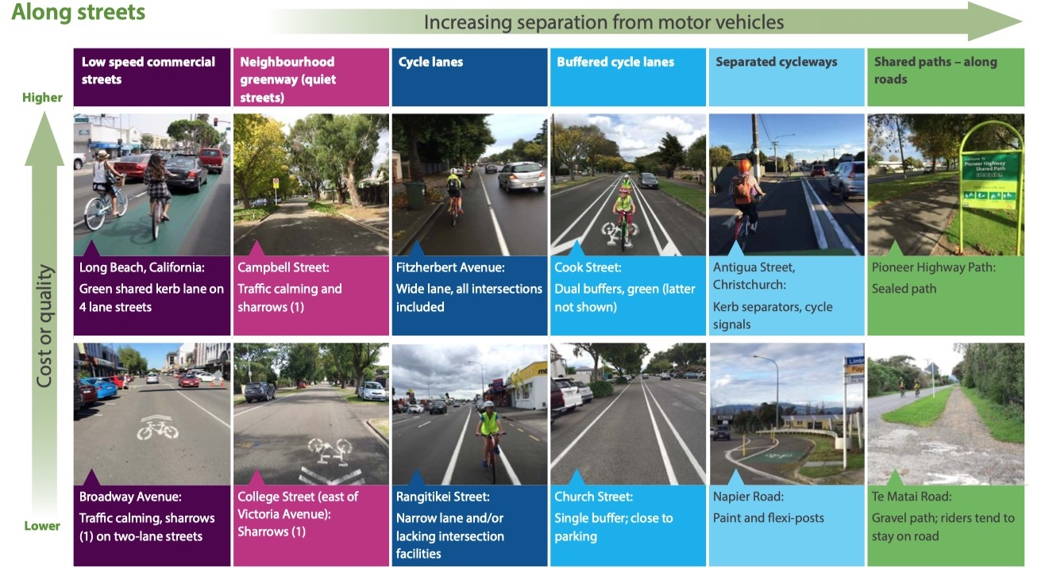
Figure 4: screenshot from the masterplan showing means of providing for cycling

Using ArcGIS Storymap
Most strategies have maps that are static (fixed in time). With this masterplan, council sought an online map tied to GIS and RAMM data that would be easy to update as projects are completed, new information is collected, and inevitable errors are corrected. It would also allow viewers to zoom in for a level of detail not possible even with an A3 size page or the most carefully crafted map symbology. Like most councils, Palmerston North uses ESRI ArcGIS for geographic information. The Storymap ArcGIS web application was chosen as it is a built-in feature without any additional cost to council. The lead consultant was assigned a username and password and given editing permission to a set of map layers that were copies of the latest existing datasets. This way the masterplan author could develop the Storymap at the same time as the plan itself, minimising back and forth with council GIS staff. The result was a publicly accessible webpage with links provided in consultation materials, on the council website, and embedded in the masterplan (via a “click here” type button and with a written URL for those reading the plan on paper).
The map has 11 pages covering who rides, how to provide for cycling (with two arterial road examples), the existing network and conditions, and three phases of network development. A final page shows the location and type of all council-provided cycle parking stands.
Viewers can zoom in or out, pan around, scroll through text and photos, and click on links or intersections to learn more about each. Schools and parks are labelled at certain zoom ratios. A screenshot is provided in Figure 5.
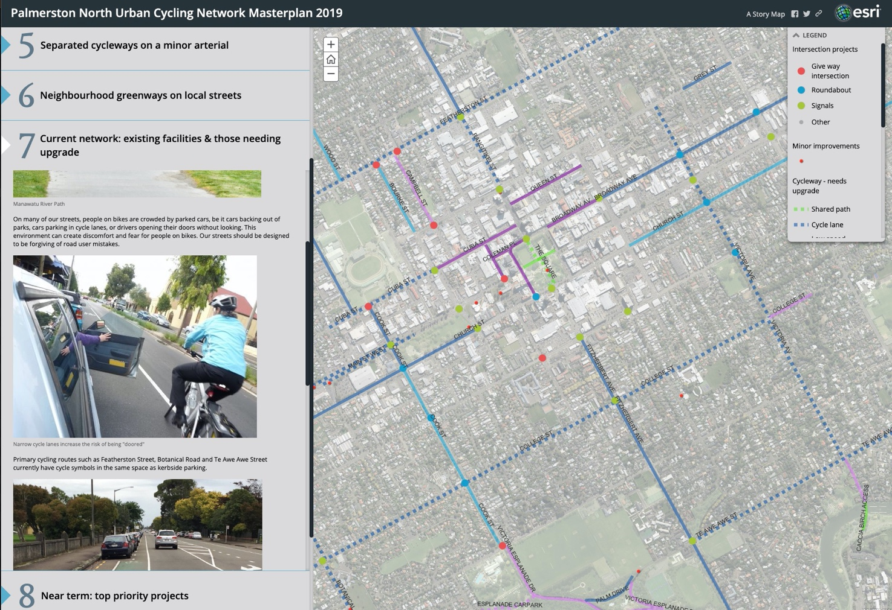
Figure 5: Screenshot of Storymap; online access via: https://arcg.is/nfOui

Consultation results
Engagement included an open-invite public forum, four key stakeholder meetings, two presentations to the People on Bikes Forum, and councillor workshop. For the draft masterplan, public consultation ran for seven weeks from 13 May to 5 July 2019. It was noted in the consultation material that further project-level engagement would also be undertaken during implementation. Submissions (156) were received from individuals, community groups and key stakeholders such as the NZ Transport Agency, NZ Police, Midcentral Health, Sport Manawatū, and Massey University. A common theme was the need for more transport choices in the face of climate change and rising obesity. There were many comments about the need to balance community needs for parking with safety of people on bikes; many requests for more detail on accessing the central city by bike; and a strong preference for physically separated cycleways. The principal changes made as a result of the consultation included:
- For some streets, start with painted cycle lanes and upgrade to separated cycleways in coordination with the street maintenance programme. In new urban development areas, separated cycleways will also be the preferred type of provision on new roads designed for higher traffic volumes. The type of provision will be confirmed through the planning process, taking into account the context of the surroundings.
- Separated cycleways were strongly favoured. However, they are more expensive per kilometre and have a greater impact on parking than wide paint buffered cycle lanes. To improve safety city-wide, focus on buffered cycle lanes and cycle facilities at intersections. Kerb separated cycleways are proposed on several corridors and will be the first option considered for street renewals or new streets designed for higher traffic volumes.
The feedback form asked whether respondents agreed with the vision, the network plan, and the phasing (priorities). These responses are summarised in Figure 6.  The majority of respondents agreed with the vision, with slightly less agreement on the form of the network and prioritisation of corridors.  Prioritisation includes technical aspects as discussed on page 2 and Table 1. The team held group and one-on-one briefings to further explain the priorities. | Figure 6: Consultation results
Social media was extensively used; the masterplan was featured in four posts during the consultation period on PNCC’s Facebook page, which has 14,621 followers. The first post was boosted to appear in more feeds during the consultation period. These posts made it into a total of 52,000 newsfeeds and had a total of 976 likes/ comments/ shares (168 of these were comments). The majority of social media respondents were opposed to providing for people on bikes, probably because consultation on the masterplan ran concurrently with front-page headlines on the College Street cycleway. This resulted in many social media posters conflating the two projects and ‘venting’ about cycleways in general with a particular message prompted by the media in mind.

Challenges
The masterplan highlights four main challenges.

Better or more? Limited funding
Council has allocated $2.9M to jump-start the network improvements signalled in this Masterplan, but leveraging central government funding is never guaranteed and maintaining ongoing funding will require a long term commitment. A key question that kept coming up during the masterplan development was “better or more?”. Council could completely rebuild a few kilometres of streets with fully separated cycleways or take a lower cost “paint and posts” temporary approach to address urgent safety issues like pinch points city-wide. In the end, a spending split of about one-third separation and two-thirds “paint and posts” was agreed.

A connected network: road space allocation at traffic signals
At intersections, many existing cycle lanes drop out in favour of multiple lanes for cars. Residents say this isn’t good enough to encourage them onto their bikes (Cheyne et al., 2015). The masterplan spells out compromises such as street widening, traffic lane width reductions, turn restrictions and/or combining of left and through movements. A current project is underway to tackle the most problematic traffic signal controlled intersections, including modelling of level of service impacts and potential improvements for pedestrians.

Quiet streets: the need for a local street traffic management policy
On some otherwise quiet residential streets, speeding endangers people and pets, disrupts sleep, and discourages walking and cycling. Streetscape features such as landscaping help reduce traffic speeds and improve amenity with a minimal impact on parking. Council may also need to restrict motor vehicle turns and/or install mid-block traffic signals where these routes intersect with busy roads. A separate project will update a ten year old Local Area Traffic Management Policy and is planned to be coordinated with a “Roads and Streets Framework”.

Parking: always the biggest issue
Main thoroughfares are primarily for the safe movement of people and goods whether walking, cycling or driving. Council's responsibility is to balance these different uses of the street. A big issue that affects most users is on-street parking. On some streets with commercial shopping centres, council aims to retain as many car parks as possible by removing berms, narrowing flush painted medians, or completely redesigning the street as a slow speed shared space (subject to funding). On other streets with sufficient off-street parking, such approaches are not cost-effective. Each street will be different – there is no single solution. A city-wide parking strategy is planned, aiming for Councillors to approve high level policy and (mostly) delegate implementation to officers.
Case study: the College Street Corridor
The College Street transport upgrade proved to be a significant learning for council in the push to establish a safe and connected cycle network. College Street is a 4.5 km minor arterial corridor traversing nearly the full width of the city and is identified as a primary route in the cycle network. The street has a variety of adjacent land uses including residential housing, schools, places of worship and employment.
Wider segments of College Street were marked with cycle lanes in 2003. In 2006, additional blocks were treated with innovative curved cycle lanes with parking alternating sides of the street. However, some segments were only 11.1 m wide from kerb to kerb and could not accommodate even minimum width cycle lanes while retaining parking on one side (Figure 8). Nevertheless, College Street is well used by more confident riders and holds significant strategic value to the other cycle network routes including the recently completed He Ara Kotahi Bridge.
College Street was identified in early 2017 for improvements due to the inconsistent cycle lanes and aforementioned strategic importance. Council staff had a $140,000 budget to work with and proposed removal of all parking for several blocks (Figure 7 and Figure 9)
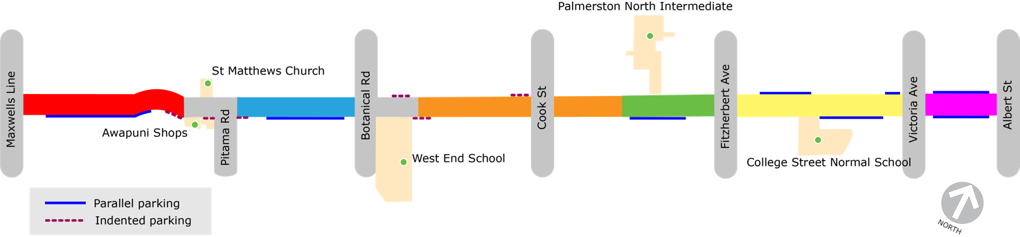
Figure 7: the College Street corridor with proposed limited on-street parking (2017 plan)
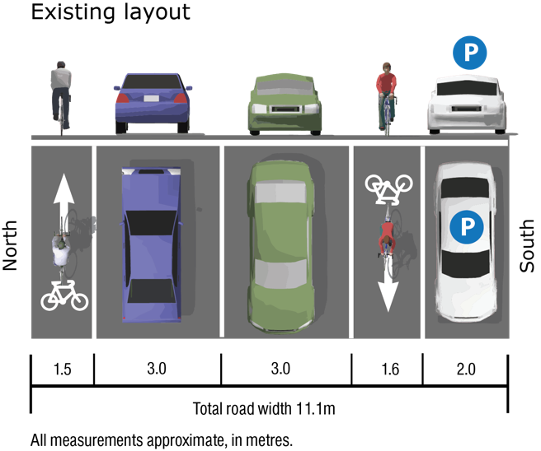  Figure 8: Orange segment (existing) | 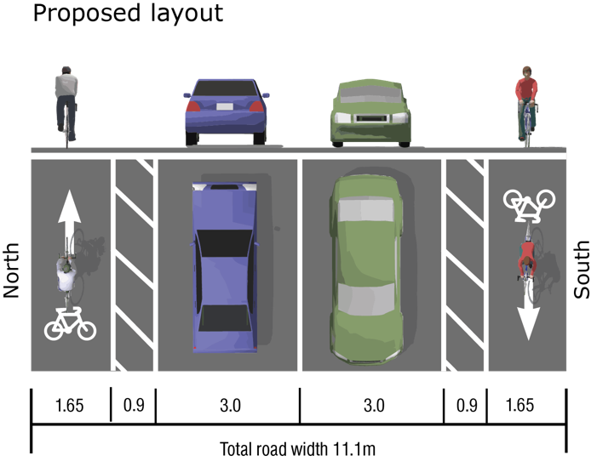  Figure 9: Orange segment (proposed)
This set the stage for substantial “bike-lash” with residents and business owners around the allocation of road space, and later impacted Council’s ability to implement the Urban Cycling Master Plan. As greater political interest over the project increased throughout 2017 and early 2018, the expectations for improved facilities also increased. The project would propose consistent length buffered cycle facilities, 12 indented bus bays, and over 50 indented car parks to ensure the corridor had enough separation between parked vehicles and people on bikes. In mid-2018, the estimated project cost had increased to $1.2M.
Through early 2019, council faced growing concerns with residents and business owners who remained unhappy with the parking loss and perceived lack of consultation about the proposed design. Despite having off-street carparks, businesses and churches near the Awapuni shops section of the corridor believed they were most affected by the proposed parking loss, and therefore contested the changes directly with councillors.
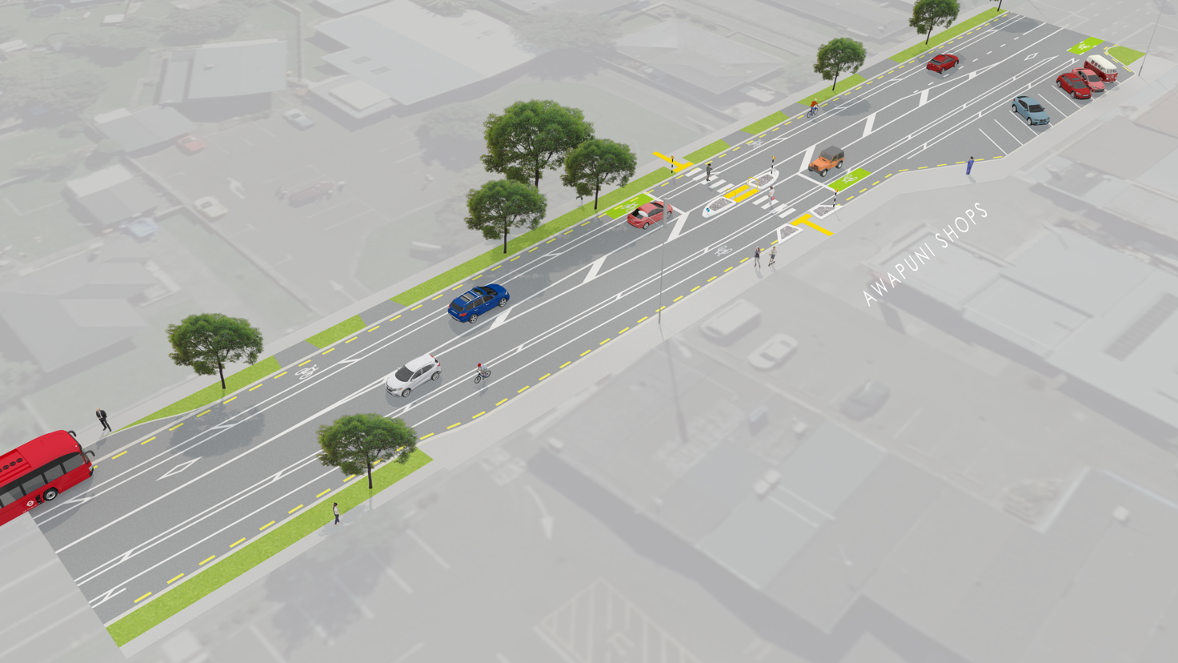
Figure 10: the originally proposed scheme for the Awapuni shops included no on-street parking
The project was paused while letter drops, email and phone correspondence, numerous site visits, and public meetings were conducted. Where possible, adjustments were made to the proposed design. The project has since progressed in sections, with indented bus bays completed and further consultation on alternative designs for the Awapuni village shops. It cannot be understated that the College Street project was not just about infrastructure, but a delicate education and behaviour change project. The learnings from College Street have been incorporated into the masterplan and council processes, as the summary states:
Addressing these challenges may increase project costs and/or motorist travel time. The combination of safety, health, and environmental benefits will nearly always outweigh the costs by a large margin. These are not just technical problems to be quantified by economists and solved by engineers. We need to work with affected communities to demonstrate why change is needed and to explore alternatives that meet our shared liveability, accessibility, and safety objectives.

A call to Action
The two-page summary in the masterplan includes a call to action:
It is clear that our streets and the behaviour of people using them can be improved. This Masterplan is only one part of the solution. We will leverage our stunning He Ara Kotahi pathway with the completion of pathways to Ashhurst, Feilding and the coast. Success will also depend on the implementation of other strategies and policies governing parking, traffic speeds, multi-modal street design, our regional freight network, land use, and the design of our central city. Let’s have the most active community in New Zealand!
This call is quite important, because it points out that the masterplan and associated investment cannot succeed in meeting the objectives without a holistic approach. The authors and colleagues are now working on completing the business case and implementing the actions. Annual progress reports will be published.

REFERENCES
AUCKLAND TRANSPORT 2017. Auckland Cycling: An Investment Programme Proposed 2018-2028. https://at.govt.nz/media/1974167/auckland-cycling-10-year-plan-july-2017.pdf.
CHEYNE, C., IMRAN, M., SCOTT, M. & TIEN, C. 2015. Barriers to Active Transport in Palmerston North. https://bit.ly/2CYLiUn.
DILL, J. & MCNEIL, N. 2012. Four Types of Cyclists: Examining a Typology to Better Understand Bicycling Behavior and Potential. 92nd Annual Meeting of the Transportation Research Board. https://journals.sagepub.com/doi/10.3141/2387-15.
GELLER, R. 2009. Four Types of Cyclists. http://www.portlandoregon.gov/transportation/article/237507.
HAMILTON CITY COUNCIL 2015. Hamilton Biking Plan 2015 - 2045. https://www.hamilton.govt.nz/our-services/transport/bike-hamilton/Documents/Hamilton%20Bike%20Plan.pdf.
KOOREY, G. Are You a Cyclist or Do You Cycle? The Language of Promoting Cycling. New Zealand Cycling Conference 2007, 1-2 November 2007 2007 Napier, New Zealand. University of Canterbury. http://hdl.handle.net/10092/688
LTSA 2004. Cycle Network and Route Planning Guide. Wellington: Land Transport Safety Authority. http://www.nzta.govt.nz/resources/cycle-network-and-route-planning/.
MACBETH, A., BOULTER, R. & RYAN, P. 2005. New Zealand walking and cycling strategies - best practice. Wellington, New Zealand.
MORRISONLOW 2016. Review of Wellington City Council's Urban Cycleways Programme. https://www.nzta.govt.nz/assets/resources/review-of-wellington-city-councils-urban-cycleways-programme/Review-of-wellington-city-councils-urban-cycleways-programme.pdf.
NCHRP 2015. ActiveTrans Priority Tool (APT). http://www.pedbikeinfo.org/planning/tools_apt.cfm.
NEW ZEALAND GOVERMENT 2018. Government Policy Statement on Land Transport 2018/19 - 2027/28. https://www.transport.govt.nz/assets/Uploads/Our-Work/Documents/c6b0fea45a/Government-Policy-Statement-on-land-transport-2018.pdf.
NZ TRANSPORT AGENCY 2016. Benefits of investing in cycling in New Zealand communities. NZ Transport Agency. http://nzta.govt.nz/walking-cycling-and-public-transport/cycling/benefits-of-investing-in-cycling/.
NZ TRANSPORT AGENCY. undated. Cycling network guidance - planning and design [Online]. Available: https://www.nzta.govt.nz/walking-cycling-and-public-transport/cycling/cycling-standards-and-guidance/cycling-network-guidance/ [Accessed 2018].
NZ TRANSPORT AGENCY & ACC undated. BikeReady website. https://www.bikeready.govt.nz/.
NZ TRANSPORT AGENCY & EMPATHY 2017. A deeper understanding of bikelash. https://www.nzta.govt.nz/assets/Walking-Cycling-and-Public-Transport/docs/NZTA-x-Empathy-Understanding-Bikelash-17.08.2017.pdf.
PALMERSTON NORTH CITY COUNCIL & MANAWATU DISTRICT COUNCIL 2007. Manawatu Active Transport Strategy. Palmerston North.
PNCC 2015. Integrated Transport Strategy. http://www.pncc.govt.nz/media/3129397/integrated-transport-strategy-2015.pdf.
PNCC 2019. Urban Cycling Network Masterplan. https://pncc.govt.nz/council-city/official-documents/plans/urban-cycle-network-masterplan/.
WELLINGTON CITY COUNCIL 2015. Wellington Cycleways Programme Master Plan. https://wellington.govt.nz/services/parking-and-roads/cycling/cycling-master-plan-and-framework.

https://www.pncc.govt.nz/council-city/official-documents/research/bikes-in-schools-programme-assessment/
https://www.pncc.govt.nz/activeplan
the title “Masterplan” can be perceived to be a dominant masculine label. The project was well advanced when this was realised and changing the term to a simple “plan” turned out to be too difficult. Staff are likely to avoid the word “master” in future planning documents.

