Resilient Access for the Marlborough Sounds

(This paper has been peer reviewed)

Author:
Courtney M^{c}Crostie (Presenter)
Senior Transportation Engineer, Stantec
BEng (Hons) 1st Class, MEngNZ,
courtney.mccrostie@stantec.com

Co-author:
Sarah Connolly
Senior Principal Transport Planner/ Practice Leader: Sustainability & Climate Change, Stantec
BSc (Hons) 1st Class, MSc, Better Business Case Practitioner, ISAP
sarah.connolly@stantec.com

Abstract
Between July 2021 and August 2022 severe weather events significantly damaged Marlborough District Council’s (MDC) roading network. Over 670 km of roads were affected and over 5,000 faults were identified. Access in and out of the Marlborough Sounds was seriously impacted with a significant number of slips and dropouts making many roads impassable for long periods of time. Some roads are still operating under restrictions today.

In 2022 NZTA and MDC identified the need for a recovery plan. The purpose of the plan was to identify a sustainable long-term solution for safe and resilient access to the Sounds – now and into the future. More and more frequent weather events in the Sounds result in road closures leaving businesses and residents with limited or no access for prolonged periods, and sometimes with no feasible long term alternative access. In addition, many of the roads were not designed for their current level of use, with insufficient design for large vehicles creating an unsafe and challenging environment.

Stantec worked with MDC, NZTA, and the Sounds communities to determine the preferred way forward and identify a hazard adaptation pathway for the long term. A key consideration was an assessment to understand future constraints on access, and how to work within these limits. Constraints considered included: underlying geological conditions, impacts of sea level rise and land subsidence, and changing rainfall patterns. The preferred option for the Sounds includes a combination of road repairs, road improvements, and marine infrastructure improvements.

It was clear from the onset this project would be groundbreaking due to:
- Innovative approach to programme development to incorporate geotechnical risk profiles
- Identification of a Hazard Adaptation Pathway
- Consideration of marine transport as a real alternative within the transport system
- A lack of guidelines or policies to assist in the process of accommodating climate forced adaptation.

Introduction

Background
Marlborough Sounds (the Sounds) suffered four high intensity rainfall events between July 2021 and August 2022 which have caused significant damage to the Marlborough District Council (MDC) transport network, occurring during July 2021, February 2022, July 2022, and August 2022.

The July 2021 event caused approximately 900 faults across the Sounds and just over 1,000 faults across the Marlborough District (including the Sounds). $85M funding (Phase 1) was received from central government to repair damage to roads across the Marlborough District including the damage to roads in the Sounds.

The August 2022 event had a significantly greater impact than the three preceding events. It resulted in 2,750 faults identified across 500 km of road in the Sounds, and just over 4,000 faults across all the Marlborough District.

Approximately 2,000 permanent residents and 150 business owners in the Sounds were affected. Communities were cut off from service centres and markets in Marlborough and Nelson with both State Highway 6 and State Highway 63 closed.

Figure 1 shows the length of key roads across the Sounds that were closed or have had restricted access since August 2021. Following the August 2022 event, the road network was closed for six weeks, and Kenepuru Road is still under restricted access today, nearly three years on from the first event.

Figure 1: Road status for key routes in the Sounds following the July 2021 event

Prior to the August 2022 event approximately $45M of the Phase 1 funding had been spent completing repairs. $20M of the remaining $40M was diverted to emergency response works to make roads safe across the district. The remaining $20M was wrapped into the Phase 2 funding request ($53M) to complete repair works outside the Sounds and essential repairs within the Sounds. Phase 1 and 2 funding addressed 2,105 of identified faults in the Sounds, but there were 1,535 faults outstanding.

The breadth and complexity of the faults experienced across the Sounds meant that early estimates to complete repairs for the remaining 1,535 faults were in the order of $300 - $400M. This extremely high cost, combined with pre-event discussions around high maintenance costs for roads in the Sounds prompted the NZTA board to request MDC complete a business case to unlock further funding to address the outstanding faults in the Sounds. This was the first time a business case had been required for event repair works in New Zealand, as a result of serious concerns about affordability of the proposed repair programme. Reassurance was needed that the proposed approach was fit for purpose into the future, given the underlying geology, topography and changing weather patterns which combine to make the roading network vulnerable.

Purpose
The current situation where access is severely affected for long periods following a storm event is unsustainable economically and socially for authorities and locals alike. To provide certainty for all parties, the business case was established to identify a sustainable long-term solution for safe and resilient transport access to the Sounds.

Extent
As the study area was large, the Sounds were divided into five zones as shown in Figure 2. Within each zone, roads (or combinations of roads) were split into separate segments, to reflect different road functions and hazard susceptibility. A total of 28 segments were identified across the five zones (refer to Figure 3 for an example of route segments). The existing marine infrastructure in each zone was also identified.

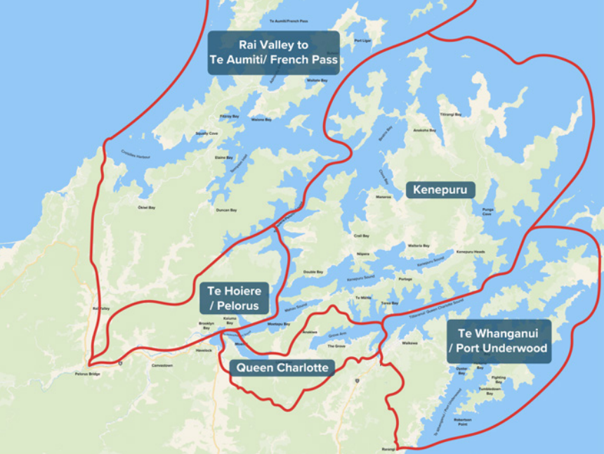
Figure 2: Project extent and zones

Hazard Assessment
A preliminary natural hazard susceptibility assessment was completed to understand the impacts and implications of geology and topography on the likely future land stability (Clapcott, K., et all, 2023). The methodology included a desktop natural hazard literature review of technical reports, maps, LiDAR terrain information, and historical aerial photography. A project GIS webmap was prepared, which also included faults recorded after the 2021 and 2022 storm events. Seven types of natural hazard were identified as described in Table 1.

Table 1: Natural hazard descriptions
Type | Description
Natural slope instability | Underlying geology (deeply weathered semi-schist with limited topsoil) is such that the land is naturally unstable under certain conditions, eg when there is high soil moisture, steep slope angle, weathering of bedrock, shallow depth to bedrock, presence of vegetation – which can either provide a benefit through anchoring and/or a burden due to added weight. The resulting slope failures when conditions are met (usually through a trigger event such as storm) occur as part of natural processes, in the absence of human impact on the landscape.
Human induced slope instability | Where terrain has been modified by human activities, (such as road building) this can result in unstable slopes. Vegetation removal can be a contributing factor, as can inadequately designed and/or poor road construction techniques when comparing the road’s uses today with when they were created – a common feature of roads across the Sounds. Instability can be associated with main roads and smaller access tracks on farms or forestry blocks. Drainage patterns are also changed because of road construction, and there is a tendency to focus water discharge, exacerbating instability issues. The slips that occur include over slips, under slips, upslope failures and failure of retaining systems e.g. walls. The likelihood is that instability would not occur without this human intervention in the landscape.
Liquefaction | Strong seismic shaking results in loss of strength in the soil and surface cracking, dislocation, ground distortion, slumping, large settlements and lateral spreading.
Flood inundation | Rainfall related flooding of roads, which can make roads unsafe for driving, and lead to waterlogging which results in direct or indirect damage to the road.
Coastal inundation and erosion | Tide levels, sea level risk, storm surge and wave run up can all lead to flooding and erosion of low-lying land, including roads.
Tsunami | Sizeable waves resulting from seismic or other activity, leading to flooding, erosion and destruction.
Debris flows | Slope instabilities confined to natural waterways e.g. valleys, streams, channels. Resulting hazards are usually constrained to locations where these waterways cross the road corridor. Debris flows are water laden masses of soil and debris that move at speeds of up to 70 km/h in a fluid like manner, carrying large boulders and destroying downslope roads and infrastructure.

To complete the susceptibility assessment, assumptions were made based on probability of triggering events (storm events, coastal events, and seismic hazard).

Hazard susceptibility tables (Table 2) and maps were developed and road network exposure assessed using a four-level natural hazard susceptibility classification (very high (VH), high (H), medium (M), low). The results were verified by comparing the defined hazard susceptibility classification against historic network fault data. Input was also provided by Marlborough Roads personnel, who shared knowledge of the network gained over the last 25 years.

Table 2: Percentage length of Kenepuru road segments very highly or highly susceptible to natural hazards
Seg-ment | Natural Slope Instability |  | Human Induced Slope Instability |  | Lique-faction | Flood Inundation |  | Coastal | Tus-nami | Debris Flow (# per km)
Seg-ment | VH | H | VH | H | M | VH | H | H | M | VH | H
1 | 14% | 0% | 66% | 3% | 25% | 0% | 0% | 0% | 0% | 1.3 | 2.9
2 | 29% | 0% | 70% | 15% | 5% | 0% | 0% | 1% | 10% | 2.5 | 1.3
3 | 52% | 0% | 74% | 24% | 4% | 0% | 0% | 0% | 4% | 2.1 | 1.9
4 | 54% | 1% | 64% | 22% | 11% | 0% | 7% | 2% | 9% | 2.2 | 2.1
5 | 17% | 0% | 34% | 42% | 31% | 0% | 0% | 9% | 50% | 1.8 | 2.6
6 | 14% | 0% | 23% | 47% | 36% | 0% | 0% | 18% | 31% | 1.1 | 1.7
7 | 5% | 2% | 17% | 35% | 62% | 0% | 2% | 6% | 15% | 2.1 | 1.9
8 | 18% | 0% | 10% | 47% | 21% | 0% | 9% | 1% | 3% | 2.2 | 1.5
9 | 60% | 12% | 71% | 29% | 0% | 0% | 0% | 0% | 1% | 3.7 | 2.0

The assessment found that:
- Kenepuru zone has greatest lengths of roads with high to very high natural slope instability. Kenepuru Road between Mahau and Kenepuru Head and Moetapu Bay Road have notably higher proportions of very high natural slope instability compared to anywhere else in the Sounds (>50% of length). Kenepuru Road between Moetapu Bay and Mahau also has a significant length of road (29%) with high to very high natural slope instability.
- All road segments except two have significant (>50% length) proportions that have either high or very high human induced slope instability.
- The Waikawa Marina, Havelock Marina, Okiwi Bay foreshore, French Pass wharf, and all bridges are at risk from liquefaction.
- The overall flood inundation risk across the Sounds is very low, but 45% of Kaiuma Bay Road and 35% of Opouri Road are a high risk. There are also a number of bridges across the Sounds at risk.

This hazard susceptibility information was used to develop the programmes in the following main ways:
- Segments with high or very high hazard susceptibility due to a lack of natural slope stability as a result of underlying geology and topography - it was assumed that slips would continue to happen on these sections of road due to storm or other trigger events, regardless of any potential improvements. It would be difficult or impossible to strengthen the roads adequately to reduce this risk. For these segments, the approach was to accommodate the risk by building back with targeted resilience improvements which would improve resilience in the short-medium term, but assume that over time there would be a decrease in the level of service provided by the road – for example an increase in unsealed, one-way sections, and more vehicle length and/or weight restrictions. As the section of road was expected to continue to experience slips and progressive loss of access, marine transport alternatives would be improved to ensure alternative access could be provided well into the future. Roads falling into this category included Kenepuru Road between the Moetapu Bay turn off and Kenepuru Head, and Moetapu Bay Road.
- Segments that were at less risk of natural slope stability and were therefore less susceptible to natural hazards – it was assumed that as the underlying geology and topography was more stable, these roads could potentially be protected from further hazard and loss of access through strengthening or other interventions to address the existing issues.
- Segments with higher hazard susceptibility due to human induced instability – it was assumed that these roads could be protected from future hazard risk if this was justified. Engineering interventions such as stormwater improvements, retaining walls and road reconstruction would be likely to reduce hazard risk, as long as the natural slope instability risk was low. These interventions would add resilience to the asset and to access. In these locations less investment would be needed in marine alternatives.
- Much of the existing primary marine infrastructure (for example at Picton and Havelock) is low lying, and the underlying land is at risk of liquefaction in a seismic event, as well as inundation through flooding. All programmes therefore included added protection for existing marine infrastructure, to ensure this is resilient into the future.

Programme Development

Road Network Strategic Responses
A range of Road Network Management strategic responses were identified, using the Resilience Response Framework (NZTA, n.d.) and the Protect Accommodate Retreat Avoid (PARA) framework from the National Adaptation Plan (Ministry for the Environment, 2022). The strategic responses represent different approaches to the hazard risk, from a build back stronger approach (protect) to a marine access approach (retreat) where roads are not repaired unless required for access to a marine hub. Each strategic response provides a different level of service in terms of number of lanes and surface type, and different levels of investment in stormwater and geotechnical improvements, as shown in Table 3.

Table 3: Possible road network management strategic responses
Road Management Strategic Response |  |  | Capital Works
Approach |  | Vehicle Restrictions | Lane Width | Surface | Stormwater | Geotechnical
Ai | Protect: Build back stronger | No additional restrictions | As existing | As existing | Whole route upgrades | Existing failures and improvements
Aii | Protect: Build back stronger | Additional restrictions | More one lane sections | More unsealed sections | Whole route upgrades | Existing failures and improvements
Bi | Accommodate: Targeted improvements | No additional restrictions | As existing | As existing | Existing failures and improvements | Existing failures
Bii | Accommodate: Targeted improvements | Additional restrictions | More one lane sections | More unsealed sections | Existing failures and improvements | Existing failures
C | Accommodate/ Retreat: Essential repairs | Additional restrictions | More one lane sections | More unsealed sections | Existing failures | Existing failures
D | Retreat: Marine access | Additional restrictions | More one lane sections | More unsealed sections | Existing failures | None

Each road segment was considered separately, and the range of suitable Road Management Strategies identified, with some excluded. Strong and evidence-based justification was required to exclude a Road Management Strategy. For example, if there was no coastline, Approach D was excluded. This left a range of approaches for each segment. These approaches were then put together into different programmes for each zone. This allocation of approaches by segment and then into programmes was underpinned by local knowledge, susceptibility to geohazards, road function and use, and scope for marine access.

When assigning the range of suitable Road Management Strategies, consideration was also given to the current traffic volumes and mix of traffic, and land uses served. Also important was whether the road segment provided the primary link to the zone from the main arterial network. If this part of the network had high natural slope instability, care would need to be taken for all roads that were downstream of this point, for strengthening those roads may not be worthwhile, it there was already a weak link in the network. However, the strategic nature of these critical branches, on which access across the whole zone relied, also needed to be recognised. In the Kenepuru Zone (Figure 3), segments 1-4 perform this role.

In most options considered as the road became more distant from the arterial network it served less properties and significant investment was harder to justify.

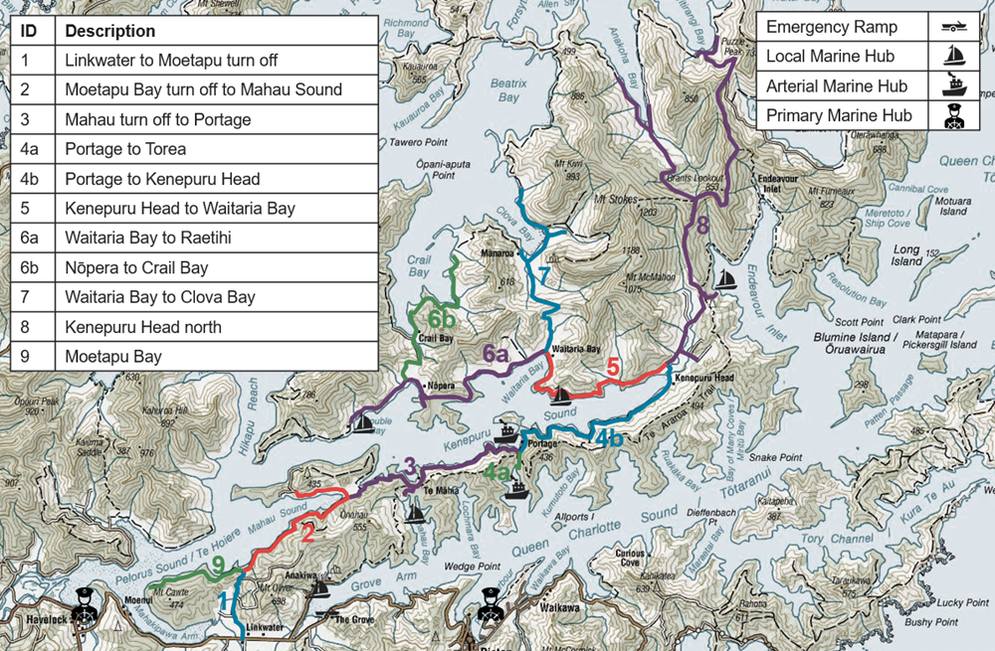
Figure 3: Route segmentation for Kenepuru zone

A further learning was that many of the Sounds communities were already reasonably resilient and able to cope without a road access for lengthy periods, as this had been their experience of living in the Sounds, and they were already equipped to deal with this circumstance when it arose. Community resilience was high. However, this was not true for all sectors of the community and was a significant challenge to some. For example, farming was difficult without reliable road access and led to economic losses for businesses, particularly increased costs relating to animal welfare due to increased transport times. Understanding the local community and location of road-sensitive businesses was important in allocating appropriate Road Management Strategies.

Marine Strategic Response
In tandem, a draft marine network was developed based on existing marine infrastructure and services, which could both be further developed if required. Marine hub locations were based on likely demand for marine services, and consideration of resilience risk for the roads and the extent to which this could be addressed through engineering works. Most marine hubs sites which have potential to be used, or used more, for this purpose already have some marine infrastructure, such as a jetty or ramp.

Siltation is an issue and this limits the feasibility of some potential marine sites, and/or requires very long jetties to enable deeper water to be accessed. Additional dredging is likely to be required to maintain the proposed marine network. Primary, arterial, and local marine hubs were identified, and indicative concepts developed. Marine interventions were then added to each zone, to complement the Road Management Strategy.

Figure 4 shows the existing marine infrastructure and services that operate in the Sounds. The dots indicate the type of infrastructure already in place at each location, and the symbols show the proposed marine hub level. Red hubs are locations where new infrastructure was proposed. Not all new sites or routes shown in Figure 4 were progressed.
The different marine hub levels are as defined in Table 4.

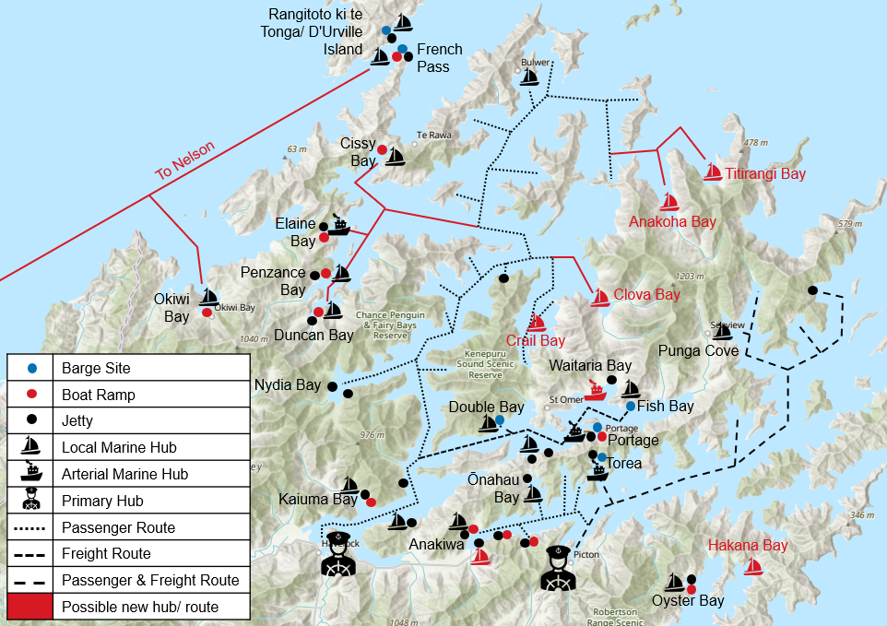
Figure 4: Existing and proposed marine infrastructure and services in the Sounds

Table 4: Indicative concepts for marine hubs
Facility | Example | Indicative Concept
Primary marine hub | Picton, Havelock | Function: primary hubs for transfer of significant volumes of goods and passengers.  Significant landside and marine infrastructure
Arterial marine hub | Portage | Function: important hubs with good facilities able to support multiple transfers and primary/most frequent marine services.  Landside: Terminal building with passenger waiting area, dry storage facility, toilets, etc, around the size of a small community hall. Parking for at least 12 cars, loading/unloading area for freight (tennis court sized), lighting, and a livestock yard within certain distance if  required.  Marine: A small marina of 12 or more moorings, including jetty, with floating component. Concrete launch ramp approximately 4 m wide, potentially on reclaimed land 20 – 30 m offshore. Likely to require localised dredging.
Local marine hub | Bulwer Bay | Function: hubs providing local connection between arterial marine hub and origin/destination of goods and passengers, reducing distance travelled by road.  Landside: Bus shelter type structure, lighting, parking for six cars.  Marine: Approximately six moorings. Jetty, with floating component, likely to be 20 – 30 m from the shore. Concrete launch ramp approximately 4 m wide. Potential to require some localised dredging.
Emergency ramp | Fish Bay | Function: emergency back up in case of a road outage, providing access to marine hub network, and goods, services and markets.  Landside: no facilities  Marine: ramp made from well graded gravel, potentially lined with rock riprap on sides. Likely to be 20-30m from shore, about 4 m wide, with sloped sides.

Programme Overview
Four to five programmes were developed for each zone, by bringing together different combinations of road network management options for each road segment and then considering supporting marine infrastructure and services that could be feasible and support access across each zone. Although some road network management options had been excluded there were still a significant number of possible permutations and combinations that could be produced. To limit the number of programmes, an approach was taken whereby Programme 1 focussed on protecting and making road access more resilient, and Programme 5 tended to be more focussed on investment in marine access and retreat from roads, if marine access was a possibility. Programmes 2-4 represented a progression from road focus to marine focus.

Five potential programmes were identified:
- Programme 1: Road Focus: Many road segments in the zone strengthened where this is justified, to provide a resilient road network where roads can withstand events and unplanned closures are minimised. Marine access is primarily for emergency response
- Programme 2: Road Access: The most important road segments in the zone are strengthened. Where marine access is available, this provides an alternative if roads are closed during or following an event.
- Programme 3: Balanced: Essential road segments are strengthened where this is possible. Other road segments are repaired to a basic level. Marine alternatives start to represent a real choice, particularly where road segments have a high exposure to geohazard risk.
- Programme 4: Marine Access: Essential road segments are repaired to a basic level. Marine alternatives are a significant part of the network within the zone and are more available and resilient.
- Programme 5: Marine Focus: Roads are repaired where affordable, by roads primarily providing access to the marine hub, where this exists, and marine transport is the primary mode for access into and out of the zone.

A total of 26 Programmes were identified across the five zones. Finally, land use and planning interventions were added to all programmes. These are primarily part of MDC’s business as usual and will be progressed outside the business case process.

Programme Assessment

Assessment Method
The programmes were assessed using multi-criteria analysis (MCA), economic impact (likelihood of option enabling full restoration of previous economic activity) assessment, and high level engineering cost estimates. The initial transport efficiency benefit cost ratio (BCR), and wider economic impact (WEI) factors for each option were also considered.

The assessment was used to identify an Emerging Preferred Option (EPO) and a Hazard Adaptation Pathway (HAP) for each zone. A summary of the performance of each programme is provided in Table 5.

The BCRs shown in Table 5 are not the final BCRs for the project. These were recalculated following confirmation of the EPO for each zone and updated cost estimates. The final project BCR was 1.8.

Table 5: Summary of assessment results for each zone
 | Considerations | Do Minimum | Road Focus | Road Access | Balanced | Marine Access | Marine Focus
Te Aumiti/ French Pass | MCA Score | -0.36 | 0.40 | 0.70 | 0.88 | 0.87 | -0.16
Te Aumiti/ French Pass | Initial BCR | 0.30 | 0.57 | 0.76 | 0.83 | 0.61 | 0.49
Te Aumiti/ French Pass | WEI Factor | 2.33 | 4.06 | 5.46 | 5.35 | 4.1 | 3.44
Te Aumiti/ French Pass | Cost Estimate | $4.1M | $75.4M | $43.1M | $27.0M | $22.0M | $20.2M
Te Aumiti/ French Pass | Economic Impact | Unlikely | Almost Certain | Almost Certain | Likely | Likely | Possible
Te Aumiti/ French Pass | Decision |  |  | EPO |  | HAP
Te Hoiere/ Pelorus | MCA Score | 0.435 | 1.095 | 0.94 | 0.52 |  | -0.025
Te Hoiere/ Pelorus | Initial BCR | 0.39 | 0.51 | 0.63 | 1.14 |  | 0.82
Te Hoiere/ Pelorus | WEI Factor | 7.43 | 9.01 | 10.91 | 22.91 |  | 17.94
Te Hoiere/ Pelorus | Cost Estimate | $0.8M | $6.1M | $4.2M | $2.2M |  | $1.8M
Te Hoiere/ Pelorus | Economic Impact | Unlikely | Almost Certain | Almost Certain | Almost Certain |  | Likely
Te Hoiere/ Pelorus | Decision |  | EPO |  | HAP
Queen Charlotte | MCA Score | -0.155 | 0.39 |  | 0.16 | -0.245 | -0.94
Queen Charlotte | BCR | 0.68 | 1.68 |  | 3.01 | 1.97 | 0.68
Queen Charlotte | WEI Factor | 6.57 | 16.36 |  | 27.47 | 16.27 | 16.29
Queen Charlotte | Cost Estimate | $1.9M | $32.2M |  | $12.2M | $9.2M | $7.9M
Queen Charlotte | Economic Impact | Unlikely | Almost Certain |  | Likely | Possible | Possible
Queen Charlotte | Decision |  | EPO |  |  | HAP
Kenepuru | MCA Score | -0.52 | -1.06 | -0.67 | 0.07 | -0.24 | -0.38
Kenepuru | Initial BCR | 0.57 | 0.86 | 1.07 | 1.12 | 0.59 | 0.53
Kenepuru | WEI Factor | 5.57 | 7.72 | 9.56 | 10.2 | 5.81 | 5.56
Kenepuru | Cost Estimate | $8.6M | $145.2M | $81.9M | $57.6M | $46.5M | $41.6M
Kenepuru | Economic Impact | Unlikely | Almost Certain | Likely | Likely | Possible | Possible
Kenepuru | Decision |  |  |  | EPO |  | HAP
Te Whanganui/ Port Underwood | MCA Score | 0.06 | 1.27 | 1.12 | 1.01 | 0.14 | -0.09
Te Whanganui/ Port Underwood | Initial BCR | 0.22 | 0.37 | 0.49 | 0.51 | 0.73 | 0.72
Te Whanganui/ Port Underwood | WEI Factor | 1.54 | 2.6 | 3.34 | 3.41 | 4.95 | 4.95
Te Whanganui/ Port Underwood | Cost Estimate | $3.2M | $41.4M | $21.4M | $17.0M | $7.2M | $6.7M
Te Whanganui/ Port Underwood | Economic Impact | Unlikely | Almost Certain | Likely | Likely | Likely | Possible
Te Whanganui/ Port Underwood | Decision |  |  | EPO |  | HAP

Emerging Preferred Option
For Te Hoiere/ Pelorus, Queen Charlotte and Kenepuru, the top ranked MCA programme was selected, as decision makers were comfortable with the initial cost estimates and likely economic impact.

For Te Whanganui/ Port Underwood the second ranked programme was chosen. This was because the MCA scores were very close, yet the second ranked programme was around half the cost, so was better value for money.

For Te Aumiti/ French Pass the third ranked programme was selected. This was because the MCA scores were very close between the top three scoring programmes, but the EPO provided a better balance between level of disruption and provision of alternatives, and the marine programmes were considered too big a step change for the community, with too much uncertainty around feasibility of implementation. Marine Access was therefore presented as the HAP.

Hazard Adaptation Pathway
The EPO represents the appropriate approach to the current resilience risk in the Sounds. However, over time, events such as storms, earthquakes and sea level rise are likely to occur which will make it progressively difficult to maintain a resilient road network. Early in the PBC process it became apparent that a long-term hazard adaptation option (the HAP) would also need to be identified to address these risks.

A HAP option was identified for each zone. The HAP represents the lowest level of service Council believes it can provide, while still delivering safe transport solutions and access in and out of the Sounds. For Kenepuru the lowest level of service is the Marine Focus Programme, for the other four zones it is the Marine Access Programme.

Adaptation is a journey – a series of steps. The EPO can be considered the starting point of that journey, and the HAP the end point. Any significant event that causes substantial damage to the transport network will potentially start the adaptation process. The event would be a trigger for Council to assess the Road Management Strategy for that road segment and decide whether it is realistic to continue with the agreed strategy, or transition to a different strategy for that segment.

Figure 5 provides an overview of a possible adaptation map. The transition from the EPP to HAP is unlikely to be linear and each road segment will follow its own path based on its importance and the impact and timing of each event.

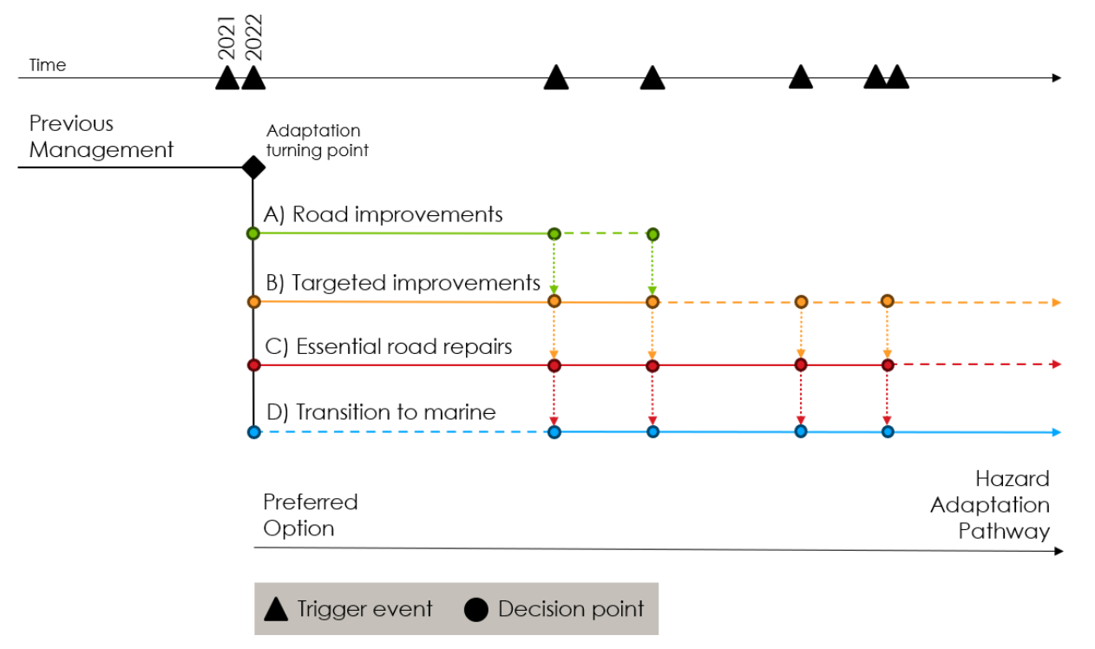
Figure 5: Possible adaptation route map for the Sounds

Consultation
Consultation commenced on 16 June with the opening of the online survey, to which 1,700 responses were received. This equates to approximately 85% of the permanent population of the Sounds. This level of response was unprecedented for MDC. The survey opened the same day as the stakeholder workshop on the emerging preferred options, and the first of seven drop-in sessions held across the Sound. Over 500 people attended the drop-in sessions in person, and 50 people attended the online session. An additional 43 written submissions were provided.

Consultation focussed on the EPO, but the HAP was also presented to initiate a conversation and indicate that further engagement would follow post-PBC.

Figure 6 shows levels of support for the EPO for each zone. People were supportive of Te Aumiti/ French Pass, Queen Charlotte and Te Whanganui/ Port Underwood, with 69%, 76% and 63% ticking ‘supportive’ or ‘somewhat supportive’, respectively.

Support was lower for Te Hoiere/ Pelorus (47% supportive or somewhat supportive) and Kenepuru (36%). Minor changes were made to these programmes to reflect the issues that people raised through consultation. For example, the approach for Kenepuru Road (Portage to the Heads) remained as ‘essential repairs’, but with some low-cost targeted improvements added to improve resilience.

Figure 6: Respondents support for the emerging preferred options

Prefered Programme
Consultation feedback, PV analysis and MCA scores were considered, and the Preferred Programme was finalised. The Preferred Programme includes the following components:
- Roading Maintenance and Operations: Changes to maintenance and operations, that can improve resilience of the roading asset. These will be completed within existing budgets.
- Road Repairs: Confirmed outcome for the 1,535 outstanding faults on the road network that have not yet been repaired and are still affecting access.
- Road Improvements: To improve resilience of the road network, where this is justified. If above the low-cost, low-risk improvements threshold, these may require a separate business case.
- Marine Improvements: To improve resilience of the marine network, where this is justified. In this way the marine network can be used to improve access to the Sounds in the long term.
- Marine Maintenance: Maintenance of marine infrastructure.
- Sounds wide studies: a Marine Study and a Resilience (drainage) Study, to determine further investigate options, priorities, feasibility and detailed costs, and determine a clear way forward for Marine Improvements and Road Improvements, plus a Plan Change to incorporate land use/development changes.
- Other Activities: Non-infrastructure solutions, such as land use controls and community preparedness/response planning. These will be completed within existing budgets.

The peer reviewed P50 cost estimate for the overall programme is $234M. The cost breakdown is shown in Table 6.

Table 6: Indicative capital cost breakdown of the preferred programme
Zone | Road Repairs | Road Improvements | Marine Improvements | Total
Sounds wide studies | - | $3M | $7M | $10M
Te Aumiti/ French Pass | $26M | $15M | $9M | $50M
Te Hoiere/ Pelorus | $2M | $4M | - | $6M
Queen Charlotte | $14M | $6M | $6M | $26M
Kenepuru | $94M | $12M | $18M | $124M
Te Whanganui/ Port Underwood | $11M | $8M | - | $19M
Total | $146M | $48M | $40M | $234M

Conclusions and Recommendations
This is the first time a business case has been required for event repair works in New Zealand. Guidelines and policies that assist in the process of accommodating climate forced adaptation are still being developed. This lack of established guidance means that the business case had to rely on a balance of best practice, local knowledge, engineering judgement and ‘what feels right’. There were no previous studies to lean on or learn from. In addition, the business case proceeded at pace to provide certainty to the community.

Despite this we arrived at a preferred programme that nearly everyone can accept, at an estimated cost of just over half the initial repair estimate of $400M. The NZTA board endorsed the business case in December 2023 and agreed to fund 71% of road repairs and 51% of road improvements. Alternative funding sources are being sought to help fund marine improvements.

Although the business case is finished, the work on this project is still ongoing. Due to the significant impact Council’s share of funding would have on rates they are going through a special consultative process with all community members and ratepayers in the Marlborough District. The outcome of this will impact on what work goes forward.

Acknowledgements
The support of Marlborough District Council in allowing this paper to be presented is gratefully acknowledged. The authors would also like to acknowledge the efforts of other Stantec, MDC and Marlborough Roads staff who contributed to the business case.

AUTHOR CONTRIBUTION STATEMENT
Courtney McCrostie: development of ideas/ thoughts, preparation of paper
Sarah Connolly: development of ideas/ thoughts, paper review

References
CLAPCOTT, K., ABREY, R., CHING, R & BOZEK, K. (2023) Marlborough Sounds Future Access Study Preliminary Natural Hazard Susceptibility, Implications and Interventions. Stantec

Ministry for the Environment (2022). Aotearoa New Zealand’s first national adaptation plan, viewed 8 March 2023, https://environment.govt.nz/assets/publications/climate-change/MFE-AoG-20664-GF-National-Adaptation-Plan-2022-WEB.pdf

NZ Transport Agency Waka Kotahi (n.d.) Resilience Response Framework, viewed 8 March 2023, https://www.nzta.govt.nz/assets/Highways-Information-Portal/Technical-disciplines/Resilience/Resilience-evaluation-process/Response-framework.pdf

