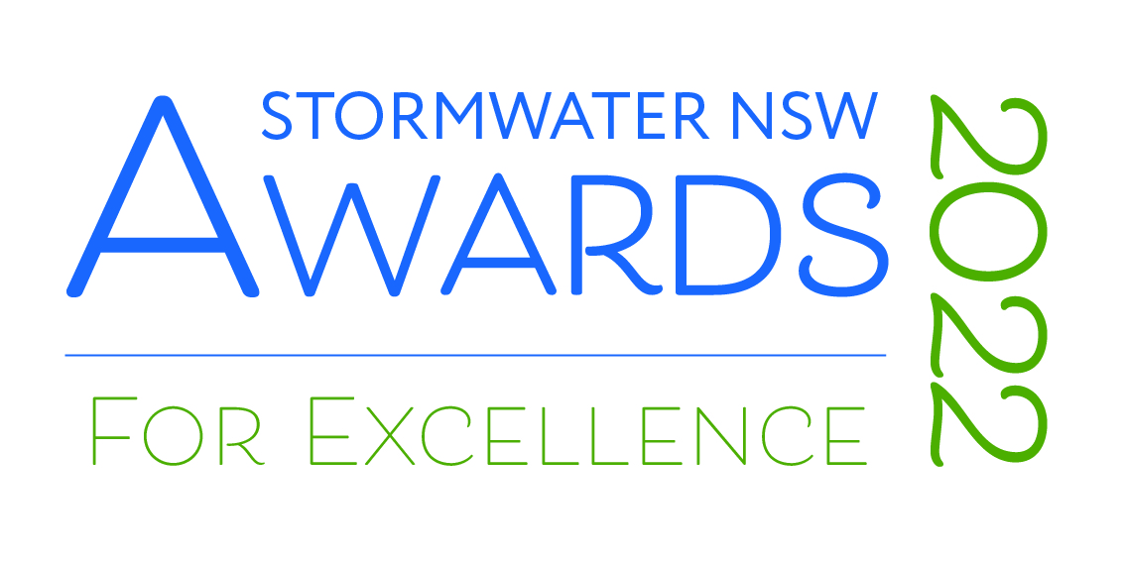
DRAFT ENTRY FORM
Entry Submission
Category of Entry
The Award categories for the 2022 Awards for Excellence are:

- Excellence in Strategic or Master Planning
- Excellence in Infrastructure
- Excellence in Asset Management
- Excellence in Research and Innovation
- Excellence in Policy or Education
- Excellence in Integrated Stormwater Design
- Young Stormwater Professional of the Year

Note: Only one entry can be completed at a time using this form. For multiple entries from the same organisation, please open a new copy of this form for each entry you wish to lodge. A project may be entered into more than one category, however it is important that the criteria specific to each award category are addressed in the application. Separate entry fees are required for each entry submitted.

Please tick the category you wish to enter from the list below:

Excellence in Strategic or Master Planning
Excellence in Infrastructure
Excellence in Asset Management
Excellence in Research and Innovation
Excellence in Policy or Education
Excellence in Integrated Stormwater Design
Young Stormwater Professional of the year

Entry Contact Details
This section details the authorised officer for all official communication in relation to this submission:
Title:
Name:
Job Title:
Organisation:
Postal Address:
City Suburb:
State: |  | Postcode:
Landline: |  | Mobile:
Email:

Entry Billing Details
For the purposes of raising a Tax Invoice for your entry submission, if the invoice is not to be marked to your attention, please enter the details below to indicate the person within your organisation responsible for authorisation of the invoice. The cost of submission is $400 for Stormwater New South Wales Members and $600 for Non-members.
Name:
Job Title:
Organisation:
Email:
Project Title
Please provide the title of the project to be entered into the 2022 Awards for Excellence. This title will be used on all marketing material should your entry be successful as a finalist or winner.
Project Organisation Name/s:
Please provide the organisation name or the collaborators names for this project. This information will be used on all marketing material should you be successful as a finalist or winner.

If this is a joint project, please include all organisations that need to be officially acknowledged in marketing materials:
Geographic Coverage/Location of the Project
Please indicate the geographic coverage and location of the project (if applicable) otherwise specify 'not applicable' (maximum 500 words).
Project Timeframe
Please indicate the project timeframe including a statement confirming that the project has been finished within a two year period prior to the Award submission closing date – COB Tuesday, 20th September 2022
Overview/Description of the Project
Please provide an overview of the project being submitted for an award (maximum 500 words).
Identification of Stormwater Issues Addressed by the Project
This section should be used to identify and describe the stormwater issues addressed by the project including water quality, stormwater reuse, ecosystem health, flooding and drainage control, public health and safety, placemaking/amenity and adaptation to climate change (maximum 500 words).
[Delete any that are not applicable]

- Water quality
…

- Stormwater reuse
…

- Ecosystem health
…

- Flooding and drainage control
…

- Public health and safety
…

- Placemaking/amenity
…

- Adaptation to climate change
…

- [Other]
…

Description of How the Projects Meets the Judging Criteria
This section should describe how the project meets and demonstrates each of the judging criteria for the nominated category (maximum 500 words per criterion).
[COMPLETE ONLY THE CATEGORY FOR WHICH THE PROJECT IS NOMINATED (ONE COLOURED BOX ONLY)]

EXCELLENCE IN STRATEGIC OR MASTER PLANNING

- The project is expected to result in significant benefits and achievement of project objectives when the recommended approaches, strategies and / or design are implemented.
… [response]

- The project demonstrates excellence in the application of best planning practices for stormwater.
… [response]

- The project has integrated stormwater management within broader considerations, such as land use planning, integrated water management, sustainability and liveability, to ensure multiple benefits and the best overall outcomes are achieved.
… [response]

- The project demonstrates excellence in consideration of economic, environmental and social factors.
… [response]

- The project involved meaningful collaboration with stakeholders
… [response]

EXCELLENCE IN INFRASTRUCTURE

- The project will deliver significant benefits (including stormwater management outcomes that exceed minimum legislative requirements).
… [response]

- The project demonstrates excellence in design
… [response]

- The project demonstrates excellence in construction technique.
… [response]

- The project demonstrates excellence in consideration of economic, environmental and social factors
… [response]

- The project involved meaningful collaboration with stakeholders.
… [response]

EXCELLENCE IN ASSET MANAGEMENT

- The project will provide significant benefits
… [response]

- The project promotes or employs processes or practices that prolong the life of stormwater systems and ensure they meet or exceed expected levels of reliability, functionality and ease of operation
… [response]

- The project demonstrates excellence in consideration of economic, environmental and social factors
… [response]

- The project integrates with other areas of organisational planning and follows established asset management frameworks to allow broader policy and continuous improvement outcomes to be achieved
… [response]

- The project involved meaningful collaboration with stakeholders
… [response]

EXCELLENCE IN RESEARCH AND INNOVATION

- The project clearly identifies knowledge gaps and/or information needs to improve stormwater management practices
… [response]

- The project demonstrates its ability to fill knowledge gaps and/or address information or technology needs which lead to improvements in the sustainable use and management of stormwater.
… [response]

- The project involved meaningful collaboration with stakeholders.
… [response]

- The project demonstrates excellence in consideration of economic, environmental and social factors which may, in part, be defined by financial efficiency or value for money.
… [response]

- Describe how the project relates to the definition of research/innovation [delete whichever N/A], and include references to definition cited, benchmarks of excellence against the cited reference and how project relates to these.
… [response]

EXCELLENCE IN POLICY OR EDUCATION

- The project clearly identifies knowledge gaps and/or information needs and sets a relevant standard for attainment of improved stormwater management within a target community.
… [response]

- The project demonstrates its ability to facilitate or accelerate the uptake of stormwater management principles and practises that lead to the sustainable use and management of stormwater.
… [response]

- The project involved meaningful collaboration with stakeholders.
… [response]

- The project demonstrates excellence in consideration of economic, environmental and social factors which may, in part, be defined by financial efficiency or value for money
… [response]

- Describe how the project relates to the definition of policy/ education [delete whichever NA], and include references to definition cited, benchmarks of excellence against the cited reference and how project relates to these.
… [response]

EXCELLENCE IN INTEGRATED STORMWATER DESIGN
- The project is expected to result in significant multiple benefits to the community, environment and water quality
… [response]

- The project demonstrates excellence in the delivery of Integrated Design principles by creating adaptable, enduring, flexible and resilient spaces
… [response]

- The project integrates stormwater management to ensure multiple benefits and the best overall outcomes are achieved at the local (project) scale
… [response]

- The project demonstrates how outcomes achieved are able to be integrated within a broader catchment context which includes land use planning, integrated water management, sustainability and liveability and biodiversity outcomes
… [response]

- The project demonstrates collaboration between multiple disciplines and stakeholders at all stages of the project
… [response]

YOUNG STORMWATER PROFESSIONAL OF THE YEAR

- Contribution to the well-being of the industry, the profession and/or society
… [response]

- Demonstrated resourcefulness and leadership in the planning and in the solution of design problems
… [response]

- Use of sustainable practices
… [response]

- Innovative design, construction and aesthetic values
… [response]

Summary
Please summarise why the project is an exemplar of excellence in the nominated category (maximum 500 words).
Estimated Project Cost
Please specify the estimated project cost including the cost of the stormwater component and total project cost. (This is to allow the judges to compare the benefits relative to the costs across projects).

Referee Contact Details
Please supply the contact details of two individuals who can support your entry.

Referee 1

Title:
Name:
Job Title:
Organisation:
Landline:
Mobile:
Email:
Referee 2

Title:
Name:
Job Title:
Organisation:
Landline:
Mobile:
Email:
Information for Media Releases
Please provide a short (50 word) project description and preferred media contacts to include in media distribution announcing finalists and winners

Please ensure you submit your entry via the online submission portal by Tuesday, 20th September 2022.

