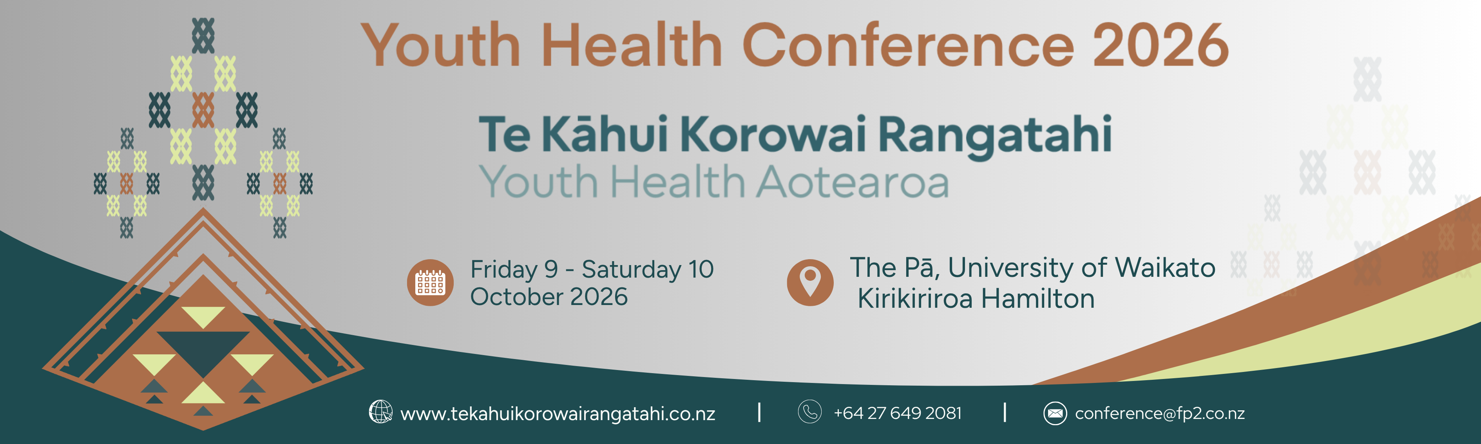

CONFERENCE SCHOLARSHIPS

Would you love to join us at the Youth Health Conference in Kirikiriroa Hamilton this October, but funding is a barrier?

Te Kāhui Korowai Rangatahi wants engaged people like you there with us and we can help make it happen.

We have 10 scholarships available to cover conference registration, opening the door for you to be part of the energy, ideas, and connections shaping youth health across Aotearoa.

Whether you’re presenting your work or looking learn more, this is your chance to step in and connect with others doing inspiring mahi.

We’re especially keen to support:

- nurses and students
- Māori and Pacific applicants
- Those working alongside Māori, Pacific, rainbow, care-experienced, and/or disabled young people.
Spaces are limited, so don’t miss out, apply now and bring your voice into the room.

Applications close 12.00pm, Wednesday 8 July.

Individual applicants will be notified of their application and outcome on Wednesday 5 August 2026.

Please fill out the application form and email to:
TKKR 2026 – Conference Scholarships
E: conference@fp2.co.nz



CONFERENCE SCHOLARSHIPS REQUEST

PLEASE RETURN COMPLETED FORM BY 12.00pm on Wednesday 8 July 2026 TO

Paula Armstrong| Project Director | E: conference@fp2.co.nz

Please tab to enter into fields and complete all questions:

Your contact details
Name
Organisation
Town/City
Professional Role
Telephone
Email
Are you a Te Kāhui Korowai Rangatahi - Youth Health Aotearoa member? | □ Yes □ No
If you receive a scholarship, will you have funding to cover the remaining registration, travel and accommodation costs? | □ Yes □ No  □ No but I have applied for additional funding
Have you had an abstract accepted as presenting author for an oral or poster presentation | □ Yes □ No
Circle the groups of people you work with | - Māori young people  - Pacific young people  - Rainbow young people  - Care-experienced young people  - Young people with disability  - Other  Please state_______________________________________
What are you excited about in this year’s conference programme?
How will attending the conference benefit you or the people you work with?

