**WASTE MINIMISATION / ENVIRONMENTAL - ENTRY FORM**

***Please ensure you save your document regularly as you work through the form.***

*All sections must be completed (excluding optional - section 6 and 10).*

*Your entry will be judged in the appropriate Excellence in Business categories and in addition, at the time of judging, your entry will be considered for the additional Awards categories.*

**Supporting Documentation**

Remember – you must provide evidence to support your claims.

Please include any supporting evidence in each of your individual entry documents.

All applications and supporting documentation must be uploaded into the entry portal. Each section of the application is its own **WORD** document with a maximum upload of one **WORD** document (max size 5MB) per section. This document must include any photos or supporting information for the relevant section.

Supporting evidence could include general financial overview - possibly showing changes as percentages rather than actual numbers, performance reports, strategic/ operational plans, examples of quality process or regulatory forms, data tables, graphs, images (.jpg or .eps) or hyperlinks to other forms of media (video etc).

Please ensure you retain a copy of your complete entry with all supporting information.

**SECTION 7: Waste Minimisation Environmental Award  
*(Category Award)***

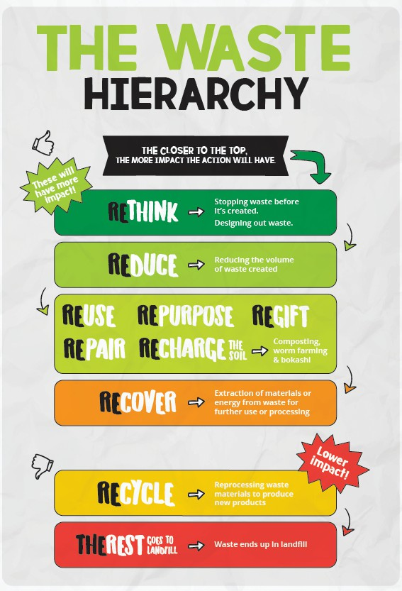

Demonstrate how your organisation and its people are actively involved in implementing practices and achieving waste minimisation both within and outside your business. (Maximum 1000 words, please include supporting evidence in your entry document).

The waste hierarchy (right) is a useful framework to think about how we create waste and what we do with it. The closer to the top, the more impactful the action.

★ Describe an action your organisation has taken that is closest to the top of the hierarchy and how that helped you reduce waste.

★ Tell us what inspired you to make a start and outline the journey you have taken to minimise waste in your organisation.

★ Provide details of waste types reduced, and volumes, if known.

★ Share a waste minimisation success you are most proud of, and a challenge you faced on your waste minimisation journey and how you overcame this.

**What the judges are looking for:**

★ Evidence of action/s which make an impact in actively reducing and minimising waste in your organisation.

★ A demonstration of understanding of business relevant waste minimisation practices

*The box below will adjust in size as you enter your content into it. It is not indicative of the maximum 1000-word count.  
Please include any supporting evidence in each of your individual entry documents.*

|  |
| --- |
|  |