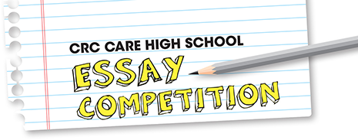



A safer, cleaner environmental future:
crcCARE High School Essay Competition 2024

ENTRY FORM
Please complete this form and email it with your essay to Cintya Dharmayanti at cintya@scientell.com.au.
Entries must be received by Tuesday 20th August 2024.
Before you fill in the details, please read our terms and conditions.
If you are under the age of 18, parental permission is required before entering.
Category (tick one):
- The Dr Roneal Naidu Award - How can innovative technologies help clean up emerging contaminants, such as pharmaceuticals and micro-nano plastics, to protect human health and the environment? ☐

- The CRC CARE Award - How can packaging be redesigned to facilitate a circular economy, and can Indigenous knowledge help guide modern environmental practices? ☐
Name (include both your first and last names):
Age (on 20 August 2024):
Name and signature of parent/guardian (if entrant is under 18 years old):

Postal address:

Phone number:
Email:
Teacher’s name:
Teacher’s email and phone number:
School/Education institution:
I have read and agreed to the terms and conditions:
(https://adelaide2024.cleanupconference.com/high-school-essay-terms-conditions) Yes / No
I have read the privacy statement:
(https://adelaide2024.cleanupconference.com/high-school-essay-privacy-statement) Yes / No
I have included my essay, between 500 and 1000 words in length: Yes / No

