



crcCARE High School Essay Competition 2026

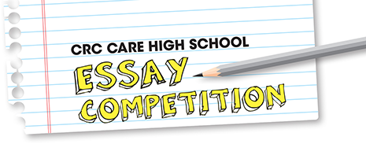

ENTRY FORM
Please complete this form and email it with your essay to Cintya Dharmayanti at cintya@scientell.com.au.
Entries must be received by Friday, 31 July 2026.
Before you fill in the details, please read our terms and conditions.
If you are under the age of 18, parental permission is required before entering.
Essay category details:
- The Dr Roneal Naidu Award – How can artificial intelligence and data help us detect, understand and manage environmental contamination?

Student name (include both your first and last names):
Age (on 31 July 2026):
Name and signature of parent/guardian (if entrant is under 18 years old):
Postal address:
Phone number:
Email:
Teacher’s name:
Teacher’s email and phone number:
School/Education institution:
I have read and agreed to the terms and conditions: Yes / No
I have read the privacy statement: Yes / No
I have included my essay, between 500 and 1000 words in length: Yes / No

