
A Geological Tour of the Fleurieu Peninsula
Travel from 1600 My to Recent geological time as the rocks and landscapes of the picturesque Fleurieu Peninsula reveal ancient cratons, orogenic deformations, large igneous intrusions, two global ice ages, block faulted ranges and recent localised sedimentary basins.
This three-day tour, guided by two experienced educators, will take you around the Fleurieu Peninsula, with overnight cabin stays at the seaside Normanville Holiday Park. Here, you will have the opportunity to sample the region's wines and cheese in the evening.
Proposed Itinerary for Fleurieu Peninsula.
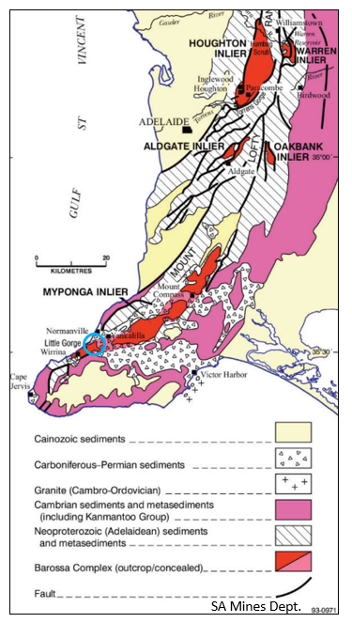
DAY 1
We leave Adelaide, travelling south, traversing the three major Block Faults that make up the Mt Lofty Ranges. Winding our way as we climb, passing the Happy Valley Reservoir and then up through Clarendon towards the Willunga Basin to view the famous McLaren Vale Wine region. No winery stops because tonight we will sample wines made in different areas of McLaren Vale to pick out the influence local geology has on the flavour of these wines. From here, we make our way to the coast, to our first stop, Maslin Beach.
GEOSITE 1 Maslin Beach. A fossil-packed beach walk observing the Tertiary sedimentary sequence in the cliff face, revealing the changing environment of sedimentation. Observe an angular unconformity and fossil assemblages.
From Maslins, we travel to Sellicks Beach, where the Willunga Fault meets the sea to view erosion of alluvial fans that make up the Willunga escarpment.
GEOSITE 2 Sellicks Beach, where recent alluvium covers the Willunga Basin. A dissected alluvial fan is revealed at Cactus Canyon.
As we travel up the Willunga Fault and turn off the main road, we pass by the Myponga Reservoir, where we will have a quick explanation on geology and dam wall construction. Heading towards Normanville on the coast, we will arrive at Lady Bay, Little Gorge carpark.
GEOSITE 3 Here we are at the foot of an ancient cliff face now abandoned due to lower sea levels. These are the oldest rocks (1650 My) we will see on this excursion and represent an Inlier of the Barossa Complex. These rocks form the basement of the Adelaide Superbasin. Time permitting, we may get to see the 900 My unconformity between these complex Basement rocks and the first sediments laid down in the Adelaide Super Basin, then later overturned by a major thrust fault. If time permits, we may travel to Wirrina Cove to view the overturned and stretched pebbles in the Sturt Tillite as it overlies the younger Tapley Hill Formation.
We now travel to our accommodation at the Normanville Holiday Park, where we will enjoy a regional wine and cheese tasting followed by an Aussie-style BBQ.

DAY 2
We are now deep in the Delamerian Orogeny zone, where deformation is intense and further complicated by major thrust faults.
GEOSITE 4 Second Valley is a marvel of geological contortions caused by the Delamerian Orogeny that folded and uplifted the Mt Lofty and Flinders Ranges. Lots of structural geology to see here, including an upside-down island (geologically speaking).
We continue to move southwards, stopping to look across to Kangaroo Island, an extension of the Mt Lofty Ranges. The thick covering of unconsolidated sediments at this location is from the extensive Permian Ice sheet, demonstrating the erosive power of glaciers and ice sheets.
GEOSITE 5 Cape Jervis. A short stop here to get a close-up look at the Permian fluvial-glacial sediment deposits, this location is considered the ‘Type Section’ for this deposit. From here, we move a little further down the coast to Cable Beach to look at the underlying Backstairs Passage metasiltstone that dominates the coastline from here to Pt Elliot to the west.
GEOSITE 6 The Talisker silver/lead mine. This mining area has been restored to give visitors an idea of the challenges that early miners had in excavating and smelting the ore. There is very good interpretative signage.
We now return to our accommodation at Normanville Holiday Park. If time permits, we can make a short stop at Rapid Bay to view the redundant quarry that supplied limestone as flux for the BHP Iron Ore Blast Furnaces at Whyalla. Dinner tonight at the local Aqua Blue restaurant.

DAY 3
Leaving Normanville, travelling west to the Inman Valley, a glacially eroded valley with many Permian glacial features.
GEOSITE 7 Selwyn Rock or Glacier Rock is a striated glacial pavement showing the movement direction of a glacier over the landscape, the same Ice sheet as seen in Hallett Cove.
As we travel to Victor Harbor, we will stop at a viewing spot to see the line of Delamerian Granites that skirts the coastline, forming islands that are resistant to sea erosion.
GEOSITE 8 We travel down to the coastline, to The Bluff, a distinctive hump shaped granite headland. Here outcroppings are igneous intrusions. We will study the contact metamorphism zone between the Bluff granite and the sedimentary siltstone, which itself is overlain by Permian glacial deposits. On the other side of the Bluff, we shall get down to the rocky shoreline to inspect the effect of low-grade metamorphism on siltstones that still manage to retain their sedimentary bedding structures.
Lunch here at Victor Harbor, once a whaling station, now a retirement seaside town.
GEOSITE 9 From Victor, we move onto Port Elliot to view the intruding granites, similar but different to the Victor Harbor granite, showing secondary phases of intrusion, while the cliff top has been scraped over by the moving Permian Ice sheet. From a viewing location, we will look over Horseshoe Bay, to see how geology has played a role in the shaping of this bay.
GEOSITE 10 Middleton foreshore, where the rocky metamorphosed Middleton Metasandstone is exposed as steeply dipping beds, with remanent sedimentary structures.
GEOSITE 11 Up in the foothills from the recent beach location is the Middleton Quarry. Here we are on the western exposed edge of the Adelaide Superbasin, raised by the Encounter Fault as we look westwards to the more recent Murray Basin, which extends 100’s km westwards. In this quarry, we can see evidence of a secondary deformation as small-scale folding. The rocks here exhibit regional metamorphic features, characteristic of sediments in the Kanmantoo trough, a later western depression in the Adelaide Superbasin.
This is where our excursion ends and we head back to Adelaide, traversing the beautiful Fleurieu Peninsula.
ABOUT THE EXCURSION LEADERS.
This excursion is being led by two experienced educators, Kym and Peter, who are also geologists and have run many successful short and long excursions in SA and Victoria as part of the Field Geology Club of SA. Our approach to running excursions can be simply summarised as consisting of three steps in outdoor geological learning.
STEP A: What’s the excursion about? ….. What are the geological features/concepts you see on this excursion that will support the textbook learning? This is the main feature of the excursion.
STEP B: The geological feature is the end result of much geological history that has occurred over millions of years. This is the ‘big picture’ that explains the geological history of the region and how it got to this point. This needs to be in place before we begin step A
STEP C The surrounding landscape is also the result of many millions of years of geological processes, now cloaked in topsoil and vegetation. This needs to be revealed in an overarching narrative. Giving this background gives an overall picture of the day's excursion.
You could imagine these three steps as concentric circles with Step A in the centre. We want our participants to come away with a broad landscape interpretation, along with observing specific geological features.

