ACLCA Early Career Professional (ECP) Session 2026
CleanUp 2026 organising committee is pleased to welcome ACLCA to host the Early Career Professionals (ECP) 2026 Session.
Following successful sessions at CleanUp 2022 and CleanUp 2024, ACLCA’s ECP program provides young professionals with a unique opportunity to present their work at an international conference, connect with peers and industry leaders, and gain valuable experience presenting to delegates from Australia and around the world.
The following shortlisted ECPs have been selected through a rigorous judging process and will present their papers at CleanUp 2026.
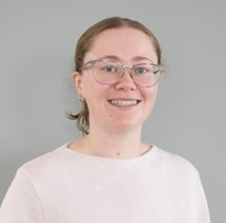
Maddison McLeod
Environmental Scientist
JBS&G, Victoria
Maddison commenced working at JBS&G this year as a Project Scientist. Before joining JBS&G, she studied Chemistry at The University of Melbourne, where she completed a research project in Analytical and Environmental Chemistry focused on understanding the source of novel Per- and Polyfluoroalkyl Substances (PFAS) in the environment. Since finishing university, her main area of interest has been PFAS contamination and identifying possible sources at different sites. In her first few months at JBS&G, she has been fortunate to expand her knowledge of environmental contaminants and is excited about what the future holds in this ever changing field.
Maddison will be presenting on “The PFAS Soup – Understanding the True Complexity of PFAS in the Environment “

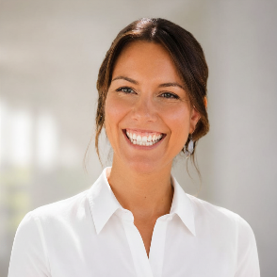
Rebecca Lauterbach
Environmental Consultant
JBS&G, QLD
Rebecca is an Environmental Consultant with over three years of experience in contaminated land management, environmental assessment, and environmental monitoring projects. Rebecca has worked extensively across petroleum hydrocarbon sites throughout Queensland and the Northern Territory, supporting a range of site investigations, monitoring programs, and remediation projects.

Rebecca was part of the Petrie Remediation project team, responsible for completing quarterly environmental monitoring and supporting the ongoing remediation.

Rebecca will be presenting on “From field observation to awareness: assessment of source pathway receptor linkages at low-lying landfills and contaminated sites in Queensland under projected climate change conditions”

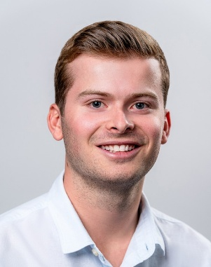
Kyle Ser
Environmental Scientist
Reditus Consulting, NSW
Kyle’s initial passion for landscape photography growing up led to a strong interest in pursuing a career in the environmental sector. He commenced work at Reditus Consulting and in the contaminated land industry at the beginning of 2022, after graduating from the University of Wollongong. His career at Reditus has been diverse, with travel across the country and work on projects for local and state governments, as well as several large corporations.
Key projects have included complex Detailed Site Investigations, assessments of legacy landfill sites, several assessments at Sydney Airport, and statewide bore monitoring for the NSW Government. One of the highlights of his career to date and the topic of his presentation is the assessment of Me-Mel Goat Island in Sydney Harbour.
Kyle will be presenting on “From Field Lead to Trusted Adviser: Advanced Contamination Characterisation at Goat Island”

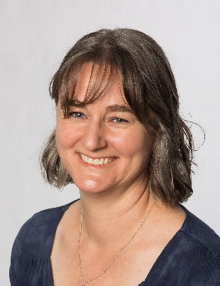
Samantha Donnell
Environmental Scientist
TMK Consulting Engineers. SA
Samantha joined TMK Consulting Engineers in early 2024 as an Environmental Scientist and graduated with a Bachelor of Environmental Science from the University of South Australia in September 2024.

Her work is both in the field and in the office. Obtaining data, conducting desktop investigations, and writing the resulting reports for change-of-land-use investigations.

Samantha will be presenting on “Finding the balance: Benzo(a)pyrene in Adelaide soils, a bioaccessibility and risk-based case study

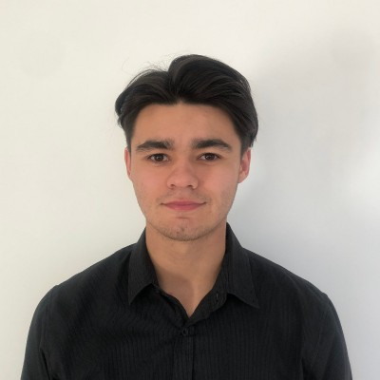
Dylan Steele
Project Environmental Scientist - Contaminated Sites
Aurora Environmental, WA
Bio Data awaited
Dylan will be presenting on “Influence of Climate Change on Total Trihalomethane (TTHM) Concentrations in Swimming Pools”
_________________________________________________________________________________
For all the young achievers out there, this event is an excellent opportunity to build your profile and advance your career.
ACLCA has always received great feedback from the ECP’s about the overall experience of presenting at the International CleanUp Conference, alongside other ACLCA nominees from different states.
When:
📅 Wednesday, 16 September 2026
⏰ 8:30 AM – 10:15 AM
All registered CleanUp 2026 delegates are welcome to attend.
Don’t miss this opportunity to support and celebrate the next generation of environmental professionals!
For further details about the program, please Click Here

____

