Godden, Lorraine
Consultant, Higher Education and Beyond
lorraine@hedbeyond.ca
Higher Education & Beyond

Title:
Creating Accessible, Inclusive and Equitable Work-Integrated Learning

Conference Theme:

This workshop proposal aligns with Best Practice – Tupuānuk, with its focus on nurturing best practices from the ground up in work-integrated learning. In particular, our OBEL Equity Cube helps to create sustainable accessible, inclusive and equitable ways for students to engage with learning in the workplace and other experiential learning spaces.
Language:
English

Abstract
This interactive workshop guides you through the practical OBEL-equity (Outcome-Based Experiential Learning) framework and process of identifying relevant dimensions of diversity, identifying their impact on the five OBEL design components for workplace learning, and selecting priorities and practical strategies for enhancing access, inclusion and equity in a variety of work-related learning contexts. Creating a future of equitable workplaces and work-integrated learning (WIL) requires addressing embedded inequity, and there are many disparities in access, retention, experiences, and impacts on future career planning for equity-seeking groups of students participating in WIL that need addressing. These disparities include cultural discrimination faced by international students, harassment and bullying and tangible barriers faced by students with visible and non-visible disabilities, and discriminatory attitudes and underrepresentation faced by 2SLGBTQI+ and female students within WIL placements. Limitations, in a social model of disability, are addressed as barriers in the environment rather than as something wrong with the person. Inequity and equity in WIL thus reflect built design. We describe how equity, access and inclusion can be built into the five OBEL design factors for a more equitable WIL experience. This workshop offers WIL stakeholders a practical, structured design framework for creating an equitable, inclusive and accessible future of WIL. We describe a tangible structured approach for identifying and implementing changes necessary for improved WIL access (pathways), inclusion (belonging), and equity (systemic) across nine dimensions of diversity and all five design factors for creating WIL experiences. At the end of this workshop, participants will be able to: identify relevant dimensions of diversity, identify the impact on five design components for work-integrated learning, and prioritize and plan changes for improved access, inclusion and equity.

Keywords: (3-5) Equity, accessibility, inclusion, design factors; work-integrated learning

Introduction
﻿Equity-seeking groups of students participating in work-integrated learning (WIL) face disparities in access, retention, and future employment, reflecting challenges and barriers associated with their intersectional identities and dimensions of diversity. These disparities include international students facing cultural discrimination, students with disabilities facing bullying, and 2SLGBTQIA+ and female students facing discriminatory attitudes and underrepresentation within WIL placement. Through the lens of the social model of disability, where limitations are viewed as barriers in the environment rather than personal deficits, designing for equity is essential. This workshop offers guidance to WIL stakeholders wrestling with expanding diversity and improving equity. Practical strategies for enhancing WIL access, inclusion, and equity are described for five identified design factors: context, timing, level of independence, degree of scaffolding (support), and connection with theory.

Objectives
This interactive workshop guides you through the practical OBEL-equity (Outcome-Based Experiential Learning) framework and process of identifying relevant dimensions of diversity, identifying their impact on the five OBEL design components for workplace learning, and selecting priorities and practical strategies for enhancing access, inclusion and equity in your context. At the end of this workshop, participants will be able to: identify relevant dimensions of diversity, identify the impact on five design components for work-integrated learning, and prioritize and plan changes for improved access, inclusion and equity.

Theoretical Basis
﻿Learners who disproportionately face barriers in work-integrated learning (WIL) include international students (language and cultural challenges and discrimination), students with disabilities (harassment and bullying, in addition to lack of assistive technologies, health, and pain issues, and sensory and communication barriers), 2SLGBTQ+, and female students (discriminatory attitudes and underrepresentation, in addition to overrepresentation in gender stereotypical roles) (see, e.g., Cocks et al., 2015; Moylan & Wood, 2016; Taylor et al., 2015). Such equity-seeking groups of students participating in WIL face disparities in access, retention, experiences, and impacts on future employment outcomes (Cukier et al., 2018). Hiring preferences and criteria derived from social capital, educational attainment, and citizenship status may also reinforce discrimination (Mackaway & Winchester-Seeto, 2018). Nielsen et al. (2022) summarized compounding barriers for Indigenous learners, including exclusion and tokenization (Pidgeon, 2016), misinterpretations and appropriations of Indigenous knowledge (Kovach, 2009), and privileging written traditions and positivist assumptions (Atleo, 2004), as well as intersectional impacts of finances and family structures/dependent care (Nielsen et al., 2022).

Methodology

﻿To offer strategies for (re)designing WIL’s assessments, processes, policies, structures, and learning environments, this workshop will share how we applied the five design factors from the Outcome-Based Experiential Learning (OBEL) framework (Hoessler & Godden, 2021) and Universal Design for Learning (UDL) as a conscious process of planning decisions to help all students learn and achieve expected outcomes from WIL (Novak, 2016). ﻿Hoessler and Godden’s (2021) five design factors for leaders, employers, coordinators and other stakeholders to consider when enhancing WIL design are:
- Social and physical context (e.g., layouts, desks, lunch culture),
- Frequency and length of the experience (e.g., 5 days a week for a month or 1 day a week for a term),
- Level of independence and responsibility reflecting the leap from current to expected practice,
- Degree of scaffolding specifying the level of guidance and feedback provided, and
- Sequencing of theory and application (e.g., theory then work experience or work experience than theory).

Diverse Learners
Drawing on Gardenswartz and Rowe’s (2003) internal (e.g., 2, 3, 4, 5) and external (e.g., 1, 6, 7, 8) diversity dimensions, our work examines the implications for WIL design on access, inclusion, and equity for eight dimensions of diversity (acknowledging there are more that should be considered):
- Financial,
- Neurodiversity,
- Physical ability/disabilities,
- Subjected to decolonized/colonized perceptions & practices (including people who experience racism),
- Gender (including relative risk of harassment),
- Family structure/dependents,
- Religion and culture (including the identifiers, social norms and embodied mores by which human sub-groups defined themselves and are defined), and
- Rural/urban.

﻿Each learner has more than one dimension of diversity, and that intersectionality is reflected in their lived realities (Crenshaw, 1989). The importance of considering intersectionality is highlighted by recommendations for Indigenous learners by Nielsen and colleagues (2022), who note the impact on access based on financial and family intersecting with colonial barriers. In addition, women with physical disabilities face heightened disadvantages including “more psychologically affected by inequitable workplace conditions, partly because they earn less, are exposed to more workplace stress, and are less likely to experience autonomous working conditions” (Brown & Moloney, 2019, p. 94), with Lee (2015) recommending strategic considerations to “reduce structural, environmental and attitudinal barriers to employment equity” (Lee, 2015, p. 89) for women with disabilities.

Results
﻿To untangle the complex puzzle of improving equity, access and inclusion for WIL students, Figure 1 provides a visual representation of the puzzle. In this dimensional cube are ‘blocks’ that leaders, educators, coordinators and employers can focus on when (re)designing programs for inclusive WIL. Each block considers how one design factor impacts access, inclusion, or equity for one dimension of diversity. This three-dimensional cube representation approach was based upon Bray and Thomas (1995) and Godden’s (2016) work that use a cube’s visual form to prompt nuanced consideration of policy implementation.

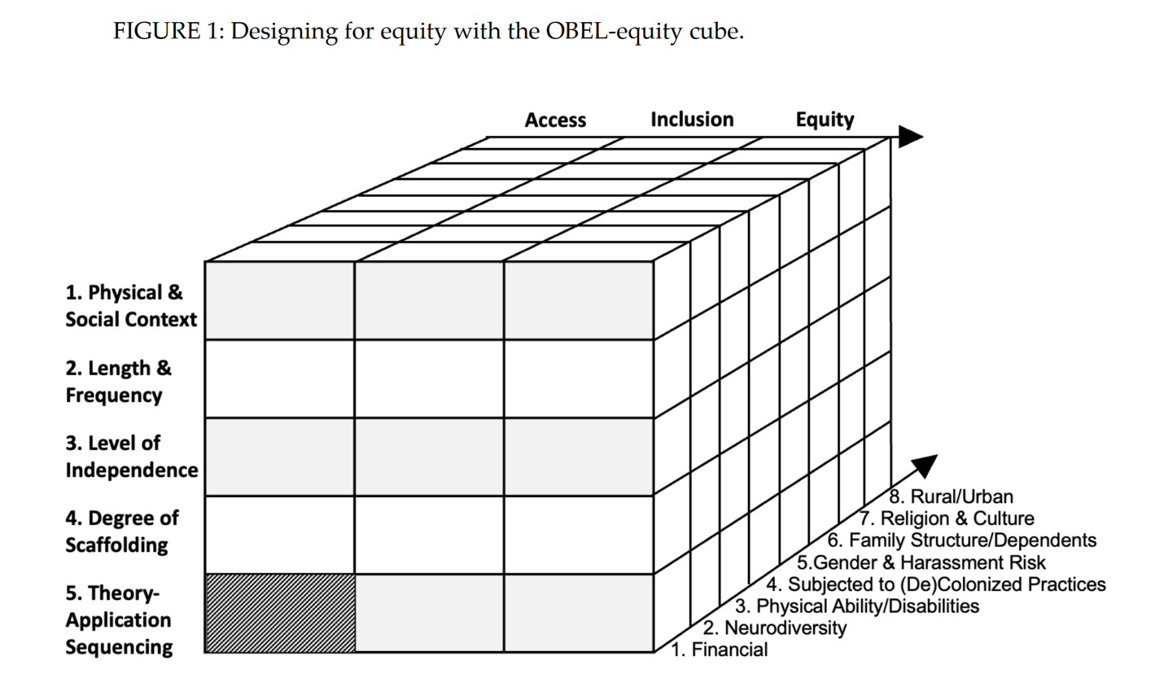
﻿Note. The cube is five rows, three columns and eight spaces deep. The five design factors are rows along the vertical y axis. Access, inclusion and equity are the three columns along the horizontal x-axis, and the 8+ dimensions of diversity are blocks along the z-axis.

﻿Applying an OBEL Equity Cube approach, an educator, employer, or program coordinator would: (a) select a block by choosing a goal of enhancing access, inclusion or equity; (b) select a design factor; and (c) identify implications of a proposed or existing design for one or more dimensions of diversity. For example, the shaded bottom left block (Access, Sequencing, Financial) examines how access is impacted by sequencing for people of varied or lower financial circumstances, including how unpaid final year placements may impede participation after years of tuition payments even though learners benefit from having the theory.

Conclusions
﻿This paper invites leaders, employers, educators, coordinators, and programs to engage in a tangible process for (re)designing WIL for improved access, inclusion, and equity. Embedding equity into WIL design draws on Universal Design for learning (CAST, 2018) options for engagement, materials, and demonstrating competence with considerations of power and privilege (Fritzgerald, 2020). Research specifically into intersectional lived realities and needs in WIL experiences and programs, and specific ﻿settings (e.g., Campbell, 2009 on equity in ice arenas), particularly for partnerships with Indigenous communities (e.g., Nielsen et al., 2022) are key directions going forward. The OBEL Equity Cube allows employers, educators, and program coordinators to focus on specific WIL design factors to identify and integrate impact on access, inclusion, and equity in WIL for multiple dimensions of diversity. The OBEL Equity Cube facilitates worthwhile practices including mentorship for the process and building skills in partners and educators in addressing discriminatory norms (e.g., Nielsen et al., 2022). WIL advocates, policymakers, educators, employers, mentors, supervisors, and learners now have a structured tangible process for addressing the needs of learners and transforming WIL design for learner and organizational thriving.

References

﻿Atleo, E. R. (2004). Tsawalk: A Nuu-chah-nulth worldview. UBC Press

﻿Bray, M., & Thomas, R. M. (1995). Levels of comparison in educational studies: Different insights from different literatures and the value of multilevel analyses. Harvard Educational Review, 65(3), 472 - 90.

Brown, R. L., & Moloney, M. E. (2019). Intersectionality, work, and well-being: The effects of gender and disability. Gender & Society, 33(1), 94–122. https://doi.org/10.1177/0891243218800636

﻿ ﻿Campbell, L. M. (2009). Creating and maintaining gender (in)equity in Ontario ice arenas: A case study of London, Ontario and Windsor, Ontario (Publication No. 7165) [Master’s thesis, University of Windsor]. Electronic Theses and Dissertations. https://scholar.uwindsor.ca/etd/7165

CAST. (2018). Universal design for learning guidelines version 2.0. https://udlguidelines.cast.org

Cocks, E., Thoresen, S. H., & Lee, E. A. L. (2015). Pathways to employment and quality of life for apprenticeship and traineeship graduates with disabilities. International Journal of Disability, Development and Education, 62(4), 422- 437
﻿
﻿Crenshaw, K. (1989). Demarginalizing the intersection of race and sex: A black feminist critique of antidiscrimination doctrine, feminist theory and antiracist politics. University of Chicago Legal Forum, 1, Article 8. http://chicagounbound.uchicago.edu/uclf/vol1989/iss1/8

Cukier, W., Campbell, M., & McNamara, L. (2018). Ensuring equitable access to work-integrated learning in Ontario. Diversity Institute, University of Ryerson.
﻿
﻿Gardenswartz, L., & Rowe, A. (2003). Diverse teams at work: Capitalizing on the power of diversity. Society for Human Resource Management.

﻿Godden, L. (2016). Interpreting documents and making sense of public policy goals for career guidance in secondary schools: A multi-perspective comparative study (Publication No 105885588) [Doctoral dissertation, Queen’s University]. ProQuest Dissertations Publishing. https://www.proquest.com/openview/2820ba4ff9b60ef2b80c0e06e6858cf3/1?pqorigsite=gscholar&cbl=18750

﻿Fritzgerald, A. (2020). Antiracism and universal design for learning: Building expressways to success. CAST Professional Publishing.

Hoessler, C., & Godden, L. (2021). Outcome-based experiential learning: Let’s talk about, design for, and inform teaching, learning, and career development. Higher Education and Beyond.

Kovach, M. (2009). Indigenous methodologies: Characteristics, conversations, and contexts. University of Toronto Press

﻿Lee, S. S. (2015). Gender and disability in Canadian workplaces: Lived experiences, diversity practices, and cultural shifts. In D. W. Edgington, N. Ota, N. Sato, & J. F. Steele (Eds.), Culture, identity and citizenship in Japan and Canada (pp. 89-104). Institution of Social Science, the University of Tokyo.

Mackaway, J., & Winchester-Seeto, T. (2018). Deciding access to work-integrated learning: Human resource professionals as gatekeepers. International Journal of Work-Integrated Learning, 19(2), 141-154
﻿
Moylan, C. A., & Wood, L. (2016). Sexual harassment in social work field placements: Prevalence and characteristics. Affilia, 31(4), 405-417
﻿
Nielsen, J., Livernoche, R., & Ramji, K. (2022). The Indigenous work-integrated learning resource hub: A needs-based approach to addressing barriers and opportunities for Indigenous students. International Journal of Work-Integrated Learning, 23(2),139-152.
﻿
﻿Novak, K. (2016). UDL Now! A teacher’s guide to applying universal design for learning in today’s classrooms. CAST Professional Publishing.

Pidgeon, M. (2016). More than a checklist: Meaningful Indigenous inclusion in higher education. Social Inclusion, 4(1), 77-91. https://doi.org/10.17645/si.v4i1.436

﻿Taylor, A., Hamm, Z., & Raykov, M. (2015). The experiences of female youth apprentices in Canada: Just passing through? Journal of Vocational Education & Training, 67(1), 93-108

Content, target audience, and format of the workshop (interactive)
The workshop will include an overview of the design factors, discussion on dimensions of diversity and sharing of the features of the OBEL Equity Cube. Participants will be able to takeaway materials they can use to apply the design factors in their own settings. Our target audience for this workshop includes anyone interested in how to create accessible, inclusive, and equitable work-integrated and or experiential learning opportunities for students. We imagine this group to include managers and program leaders from post-secondary institutions, faculty and instructors who teach experiential learning, policy-makers who support WIL and EL policy development, and representatives from employer groups. The workshop will be highly interactive, with many opportunities to apply key design factors to individual situations and contexts.

