Family name and first name of the first author: Seko Nagisa
Title/position of the first contributor/author: Master Student
E-mail of the first author: s2521240@u.tsukuba.ac.jp

Institution to which the first author belongs: University of Tsukuba
Family name, first name, institution and title/position of presenters at the conference
Seko, Nagisa, University of Tsukuba, Master Student
Title: A Study of Career Guidance Goals in Elite High Schools in Japan-Focusing on the Relationships among Institutions, Organizations, and Individuals-
Indicate which of the conference themes your paper is linked to: Hiwa-i-te-rangi - Research
Presentation language at the conference: English

Abstract:
This study examines career guidance practices in elite Japanese high schools, referred to as Shingakukou. Japanese high schools are structured within a hierarchical system, at the top of which are schools that enroll many students aiming for admission to prestigious universities. These schools are commonly called Shingakukou. In Japan, career guidance is typically not conducted by professional counselors but by teachers, who take primary responsibility for advising students on their post-secondary pathways. Previous research has shown that teachers in Shingakukou tend to prioritize sending students to university groups recommended by the school rather than encouraging them to reflect on their prospective academic majors or long-term career aspirations (Seko, 2026). More specifically, teachers often guide students in ways that align with numerical targets shared across the school organization, such as the number of students admitted to particular universities. These targets, hereafter referred to as “achievement targets,” function as central organizational goals, and teachers may engage in practices that effectively shape or control students’ educational aspirations to achieve them (Asahina, 2025).
However, guidance practices oriented toward achieving such organizational targets give rise to two major concerns. First, they may cause students to lose sight of the intrinsic value of university learning, as institutional prestige is prioritized over intellectual engagement. Second, when the attainment of achievement targets becomes an end, teachers—who serve as primary advisors to students—may inadvertently undermine students’ autonomy in decision-making. Despite these concerns, previous studies have paid little attention to the diversity of achievement targets across schools, nor have they sufficiently explained why teachers accept and reproduce such organizational goals.
In response to these gaps, this study aims to develop two hypotheses through a literature review. The first concerns the organizational structures that can explain the diversity of achievement targets among Shingakukou. The second concerns the factors that lead teachers to be shaped by such organizational goals. The analysis is structured around two analytical perspectives: the relationship between institutions and organizations, and the relationship between organizations and individuals.
Regarding the first perspective, this study draws on Meyer’s (1977) concept of institutional “charter” and Kariya’s (1981) model of school organization. These theoretical frameworks suggest that schools are structured in accordance with socially constructed expectations regarding their roles and functions. Achievement targets in Shingakukou can thus be understood as concrete manifestations of these expectations. Furthermore, differences in social contexts—such as regional location, public versus private status, and school history—shape school ideology and influence how goals are defined and prioritized. As a result, variations in the content and intensity of achievement targets across schools can be explained by differences in the social environments in which they are embedded.
Regarding the second perspective, this study examines how teachers’ practices are shaped by organizational goals, drawing on research on teacher culture. This study incorporates a strategic perspective that emphasizes teacher agency. From this viewpoint, teachers may conform to achievement targets to secure professional evaluation or maintain their position within the organization, even when such goals do not align with their personal values. In addition, insights from Asch’s (1951) conformity experiments suggest that uncertainty in decision-making, combined with social pressure and evaluation systems, can encourage individuals to align their behavior with majority norms.
Based on this analysis, two key implications are identified. First, achievement targets in Shingakukou are not absolute but are socially constructed and context-dependent, highlighting the need for teachers to critically reflect on their school’s values. Second, the findings underscore the importance of developing career guidance practices that are not solely driven by numerical performance indicators but instead emphasize dialogue with students and support for their self-realization. In an era in which performance-based evaluation of teachers is increasingly emphasized worldwide, the issues addressed in this study extend beyond the Japanese context and hold broader international relevance

Keywords: Elite High Schools / University-Oriented Career Guidance / Teacher Evaluation / School Organizational Goals / School Culture

Contents:
-Introduction
This paper examines career guidance practices targeting elite students in Japan. In the Japanese education system, students are not formally tracked by academic ability until the end of lower secondary school. However, at the upper secondary level, high schools form a stratified structure based on students’ academic achievement, with a stronger degree of stratification compared to Western countries (Shimizu, 1987). At the top of this hierarchy are schools attended by large numbers of students aiming to enter universities. Such schools are commonly referred to in Japan as Shingakukou.
In Japan, career guidance is generally not conducted by professional career counselors; instead, it is primarily the responsibility of teachers. Previous studies have shown that teachers in Shingakukou tend to prioritize guiding students toward universities recommended by the school, rather than encouraging them to think concretely about their academic majors or long-term career prospects (Seko, 2026). More specifically, in order to achieve numerical targets shared across the school organization—such as “the number of students admitted to particular universities” (hereafter referred to as “admission performance targets”)—teachers often engage in practices that effectively control students’ educational aspirations (Asahina, 2025).
One possible background factor for such practices is the stratified structure of Japanese society based on academic achievement. Japanese universities, like high schools, are also hierarchically organized according to academic level, and attending a higher-ranked university increases the likelihood of obtaining better employment conditions. This is closely related to Japan’s employment system. In cases where individuals seek employment in companies rather than in licensed professions, what is valued is not “what one studied at university,” but rather “the level of the university one graduated from.” This is because most employees in Japanese companies are hired as generalists, and thus, rather than specialized skills, their trainability—the capacity to perform a wide range of tasks—is emphasized (Hamaguchi, 2021). Given this broader social structure, it can be considered rational for teachers to encourage students to aim for admission to as high-ranking a university as possible. (See Figure 1.)
However, guidance practices aimed at achieving school-level admission performance targets can be understood as generating at least two major problems. First, they may cause students to lose sight of the intrinsic value of learning at university. A substantial body of research has shown that prioritizing the prestige or level of the university over the content of study can lead to maladjustment in higher education. This issue also has negative consequences for job hunting. Because many Japanese university students struggle to find meaning in their studies, they often face difficulties in connecting their learning to society. As a result, the job-hunting process in Japan tends to be prolonged compared to other countries, and many students experience psychological instability (Toyoda, 2013). Connecting learning to society is crucial, as it encourages students to reflect on how they wish to contribute to society, thereby enhancing their motivation to work (Tatsumi, 2020). Even if what is learned at university does not directly translate into job-related skills, it remains important to ascribe meaning to learning within the broader context of personal and professional development.
Second, for teachers—who serve as primary advisors for students—the pursuit of admission performance targets can become an end, leading to the marginalization of students’ autonomy in decision-making. Ball (2003) argues that when education is evaluated based on measurable outcomes, teachers tend to act in ways that align with how they are assessed, often at the expense of values such as integrity, professional beliefs, and meaningful dialogue with students. Although Ball’s analysis is situated in the context of UK education policy, the underlying mechanism—where numerical targets shape teacher behavior—can be seen as comparable (Seko, 2026). For instance, in a case reported by Asahina (2025), a student at Shingakukou was compelled to reconstruct their motivation for applying to university in a way that justified entry into a high-ranking institution. As a result, the student was forced to continue studying without a clear vision for their future, leading to confusion and distress. Such conditions, in which students’ self-realization is undermined, should be regarded as a serious concern.
Given these issues, it is important to consider how admission performance targets—capable of producing such outcomes—have been examined in previous research. First, multiple studies have shown that teachers believe producing strong admission results contributes to their school’s social recognition (Nakamura, 2020; Asahina, 2025; Nakadome, 2002; Tsuta, 2023). Furthermore, it has also been demonstrated that teachers perceive guiding students toward higher-ranking universities as beneficial for students’ future lives, and thus view the achievement of such targets as inherently positive (Nakamura, 2020; Tsuta, 2023).
However, existing studies have not sufficiently accounted for the uniqueness of individual schools. Each school operates with its own set of goals, and even within the shared category of Shingakukou, significant differences can be observed. Clarifying the diversity of these goals can enable teachers to relativize the notion of what is considered “desirable” within their own institutions, thereby fostering more flexible and pluralistic approaches to career guidance. Moreover, prior research has often portrayed teachers as uncritically accepting the goals set by their schools, despite variations in those goals. This tendency cannot be fully explained by the assumption that such practices are simply “beneficial for students’ lives.”
For these reasons, this paper aims to develop two sets of hypotheses: first, regarding the nature of school organizational structures that can account for the diversity of goals established within Shingakukou; and second, regarding the factors through which teachers’ practices become shaped and constrained by these organizational goals.

-Objectives
This study aims to develop two sets of hypotheses: first, regarding the nature of school organizational structures that can explain the diversity of career guidance goals established within Shingakukou; and second, regarding the factors through which teachers’ practices become shaped and constrained by such organizational goals.
By doing so, the study seeks to contribute to the exploration of career guidance practices that emphasize dialogue with students, in which teachers do not treat the values of their own schools as absolute. In recent years, there has been a growing international trend toward evaluating teachers based on external numerical targets. In this context of an increasingly performative evaluation culture, the concerns addressed in this study should not be understood as limited to the Japanese context alone.

-Theoretical basis
In this paper, school organizational culture is conceptualized based on the three-layered framework of institution, organization, and individual, as proposed by Sato and Yamada (2004). Sato and Yamada (2004) argue that analyzing only the internal dynamics of individual organizations is insufficient to fully explain the nature of organizations. Instead, they adopt the position that it is necessary to also consider “the influence of the cultural and institutional environment surrounding the organization on the organization itself” (p. 4).
Accordingly, they attempt to organize various organizational theories discussed thus far by employing a nested structural model, as illustrated in Figure 2.
The reason for adopting a framework that examines the influence of external institutional factors on school organizations is that, in order to understand the differences in admission performance targets set by Shingakukou, it is necessary to focus on variations in the social contexts in which these schools are situated. Furthermore, in analyzing how such targets shape and constrain individual teachers, the framework proposed by Sato and Yamada (2004) is also considered effective for the purposes of this study.
Accordingly, this paper first examines (1) the relationship between institutions and organizations, and then (2) the relationship between organizations and individuals.

-Methodology
This study employs a literature review methodology. For (1) the relationship between institutions and organizations, it draws on studies focusing on school organizational structures. For (2) the relationship between organizations and individuals, it draws on studies examining teacher culture.

-Results
(1) The relationship between admission performance targets in Shingakukou and institutional contexts
Meyer (1977) argues that schools are assigned socially expected roles, or “charters,” and that students come to acquire the dispositions and behaviors deemed appropriate to those roles. Similarly, Shimizu (1987) suggests that, within the stratified structure of Japanese high schools, teachers engage in educational practices aimed at maintaining or enhancing their school’s charter.
In the same vein, Kariya (1981) emphasizes the necessity of examining the mechanisms of school organization by considering the broader social context—specifically, the stratified structure characteristic of Japanese high schools (see figure 3). Accordingly, Kariya (1981) develops an analytical framework that explicitly incorporates this social context.
Kariya (1981) does not portray teachers merely as passive recipients of social context; rather, he develops a framework that incorporates the process through which teachers actively decide whether to accept or resist such contexts. According to Kariya (1981), social context shapes a school’s ideology. School ideology refers to the shared ideas, values, and beliefs held by the teaching staff. This ideology, in turn, influences teachers’ decision-making. When a group faces common problems and develops shared patterns of thought and action to make decisions, this is referred to as a “collective perspective.” Kariya (1981) hypothesizes that when a school’s ideology is compatible with the broader social context, its collective perspective will also align with that context. At the same time, his framework allows for the possibility that teachers may form an ideology that resists the dominant social context.
Applying Kariya’s (1981) framework to the logic of career guidance that prioritizes admission performance, admission performance targets can be understood as being formed based on the school’s charter, as noted by Shimizu (1987), concretizing the types of educational outcomes expected by society. Schools, in turn, seek to maintain these charters in response to social expectations, leading to the formation of ideologies that are compatible with the prevailing social context. These ideologies then function as a framework for determining instructional strategies aimed at maintaining the charter—namely, strategies for achieving admission performance targets—thereby fostering the development of a collective perspective. If different instructional strategies emerge, this can be explained either by the formation of an ideology within the teaching staff that resists the dominant social context, or by changes in the social context itself.
This framework is useful for explaining the variation in admission performance targets across schools, which is a central concern of this paper. While Kariya (1981) focuses primarily on school stratification as the relevant social context, it is possible that schools with similar academic levels are nonetheless embedded in different social contexts. For example, differences such as rural versus urban settings, public versus private institutions, or long-established versus newly established schools may all produce distinct contextual conditions. These variations can shape the content of the charter assigned to each school—that is, the types of educational outcomes expected by society—and, as a result, generate differences in both the nature and the strength of admission performance targets. By attending to these contextual differences, it becomes possible to capture the unique characteristics of individual schools.
At the same time, this analytical framework does not sufficiently explain the factors that shape how individual teachers are influenced by admission performance targets. Since the concept of a collective perspective refers to shared decision-making patterns within a group, it does not fully address the processes through which individuals interpret and enact these expectations in practice. Therefore, the next section turns to research on teacher culture, which focuses on individual teachers’ practices and meaning-making processes.

(2) The relationship between admission performance targets in Shingakukou and individual teachers’ career guidance practices
Nakamura (2020), in his review of research on teacher culture in Japan, organizes several approaches for explaining individual teachers’ educational practices. Drawing on this framework, this section attempts to explain why individual teachers comply with admission performance targets.
First, this study examines the approach rooted in the sociology of knowledge, which posits that teachers’ practices are shaped by interpretive frameworks shared within the teaching community. According to this perspective, individuals act by referring to taken-for-granted assumptions and norms that are formed through interaction within the group. For example, Sakai and Shimahara (1991) found that novice teachers tended to accept the instructional methods practiced in their schools without questioning them, and experienced difficulties when they were unable to implement those methods effectively.
However, this approach alone cannot fully explain all cases. While some teachers may indeed take admission performance targets for granted, there are instances that cannot be adequately accounted for in this way. For example, in Shingakukou located in rural areas, there are cases where strong emphasis is placed on guiding students toward national and public universities, which are positioned at the top of Japan’s higher education hierarchy (Tsuta, 2023). At the same time, such schools may employ teachers who themselves graduated from private universities and are therefore likely to understand their advantages. Nevertheless, these teachers still engage in practices that prioritize admission to national and public universities. This suggests that their behavior cannot be explained solely by uncritical acceptance of existing interpretive frameworks. Furthermore, teacher mobility within Japanese public high schools also complicates this explanation. Even within the same category of Shingakukou, career guidance goals differ across schools, making it unlikely that teachers consistently internalize a single set of goals as self-evident. These observations suggest that teachers’ practices are shaped not only by shared interpretive frameworks, but also by additional factors.
Next, this study considers the approach represented by strategy-oriented research, which emphasizes individual autonomy and agency. Unlike the sociology of knowledge perspective, this approach views individuals not as passively shaped by the group, but as actively forming their own criteria for judgment through interaction with the organization and acting to achieve personal goals. For instance, teachers may select particular practices as a strategy for self-preservation, such as adapting to school norms in order to secure their position within the organization.
From this perspective, it becomes possible to explain why teachers comply with admission performance targets. Even when teachers hold views that differ from the majority within the organization, they may align their behavior with dominant norms in order to gain recognition or avoid negative evaluation. Moreover, admission performance targets themselves may possess characteristics that promote conformity. In this regard, Asch’s (1951) conformity experiments are suggestive. Asch (1951) identifies three processes through which individuals conform despite holding differing judgments: “distortion of perception,” “distortion of judgment,” and “distortion of action.” Distortion of perception occurs when the majority’s view comes to appear correct; distortion of judgment arises when individuals lose confidence in their own judgments; and distortion of action occurs when individuals conform despite recognizing that the majority is incorrect, due to concern about social evaluation.
Applied to the context of career guidance, admission performance targets deal with students’ future pathways—an area where clear “correct answers” do not exist—making judgments inherently ambiguous. As a result, teachers may find it difficult to maintain confidence in their own decisions and become more likely to rely on majority norms. In addition, unlike in many Western countries, career guidance in Japan is conducted not by specialized counselors but by school teachers, who must make decisions based on limited information. In such conditions, if a culture exists in which admission to certain universities is treated as the “correct” outcome, teachers are more likely to conform to that standard. Furthermore, from the perspective of “distortion of action,” it is important to note that teachers’ evaluations are often linked to admission performance. Nakamura (2020), for example, points out that admission results function as an indicator of teacher competence, fostering a culture of competition among teachers. In such an environment, concern for external evaluation may lead teachers to prioritize achieving targets as an end in itself, strongly shaping their practices.
Taken together, admission performance targets can exert a powerful influence on teachers’ behavior, even when they do not align with teachers’ personal beliefs or values. Moreover, it can be suggested that teachers may engage in practices aimed at achieving these targets as a strategic means of fulfilling their own individual objectives within the organization.

-Conclusion
This paper, drawing on the framework proposed by Sato and Yamada (2004), has examined two sets of hypotheses: first, regarding the nature of school organizational structures that can explain the diversity of career guidance goals established within Shingakukou; and second, regarding the factors through which such goals shape and constrain teachers’ practices (see figure 4).
As a result, the analysis suggests the following two possibilities:
- Social context shapes school ideology, and based on this ideology, instructional strategies aimed at achieving admission performance targets are established through the collective decision-making of the teaching staff.
- Admission performance targets have the capacity to shape individual teachers’ career guidance practices, even in cases where their personal values differ from those of the group.
From these two hypotheses, this paper suggests two main contributions.
First, it enables individual teachers to recognize that the groups of universities considered “desirable” within each school are socially constructed and are not necessarily absolute. This study has indicated that teachers, by belonging to a school organization, may be inclined to conform to the majority within that organization. In light of this, adopting a perspective that relativizes what is defined as “desirable” by the school may contribute to forms of career guidance that do not treat institutional values as absolute, but instead emphasize dialogue with students.
Second, this paper presents an analytical framework for examining career guidance goals that are not reducible solely to numerical targets such as admission performance. The analysis suggests that an excessive focus on numerical targets may lead to situations in which teacher evaluation is prioritized over students’ self-realization. At the same time, even among Shingakukou, there are likely schools that place greater emphasis on students’ self-realization. Clarifying the social contexts under which such schools form either conforming or resistant ideologies may provide insights that are applicable to other Shingakukou.
Finally, it should be noted that the arguments presented in this study are hypothetical in nature. Future research will need to examine their validity through empirical investigation.

Figure

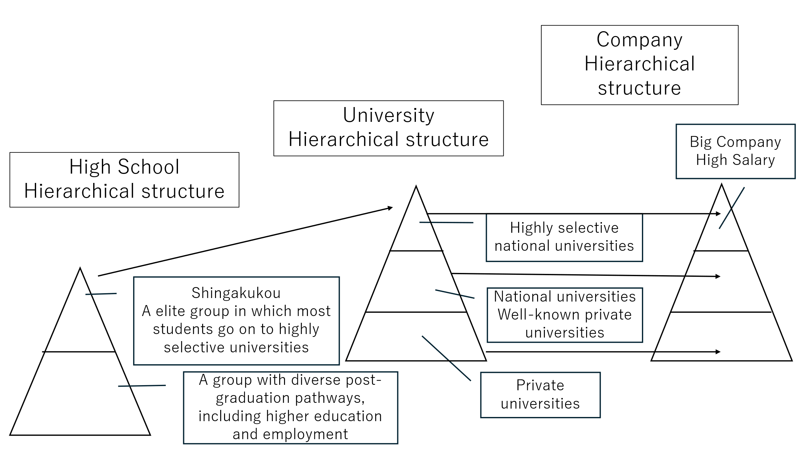
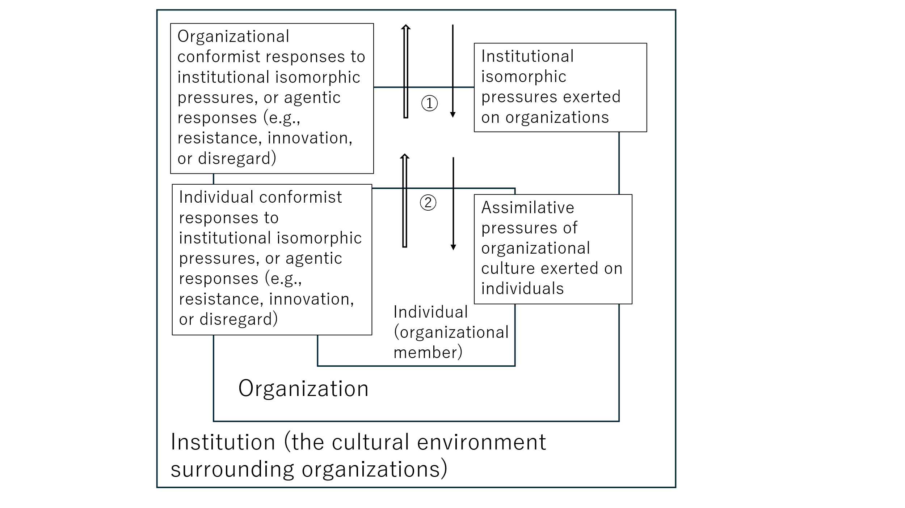
Figure 1
Figure 2
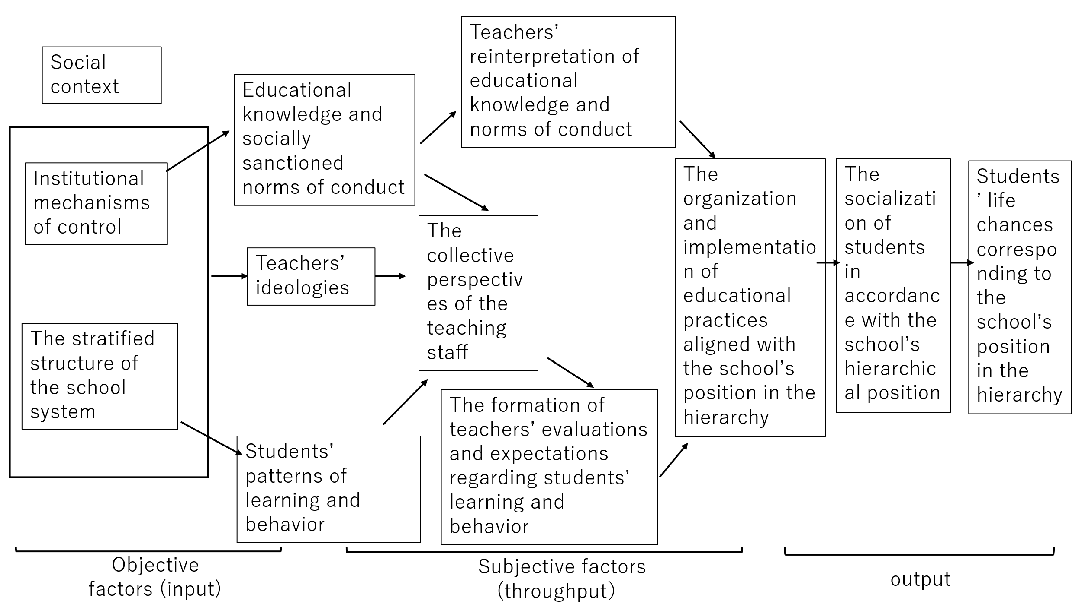
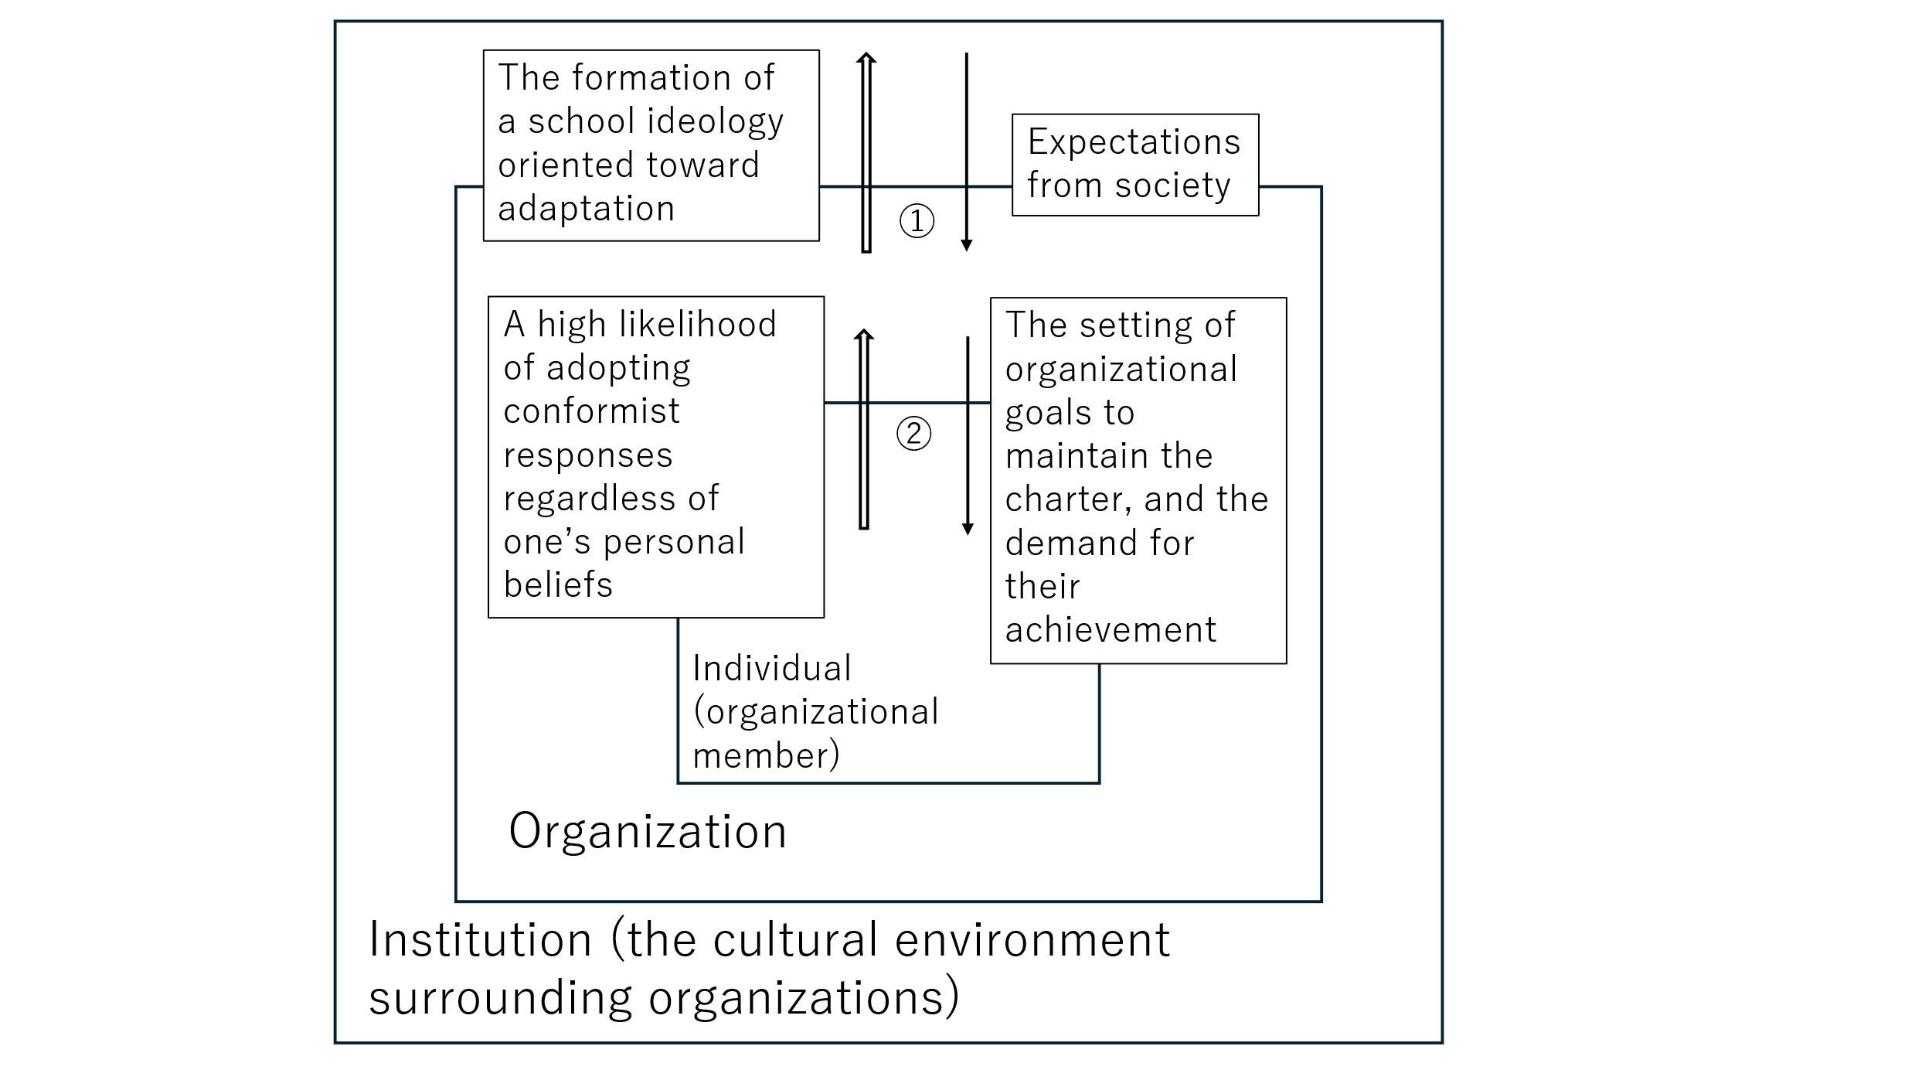
Figure 3

Figure 4

-Bibliographical references
Asahina, Y. (2025). How is admission to (super) elite universities from Tohoku justified? In F. Uchikoshi & Y. Honda (Eds.), Shingakukou no Shinro Sentaku to Gender [Career Choices and Gender in Elite High Schools] (pp. 115–148). Otsuki Shoten. (Japanese).
Asch, S. E. (1951). The modification and distortion of judgments. In H. Guetzkow (Ed.), Groups, Leadership and Men. Carnegie Press.
Ball, S. J. (2003). The teacher’s soul and the terrors of performativity. Journal of Education Policy, 18.
Hamaguchi, K. (2021). Jobu-gata Koyo Shakai to wa Nani ka [What Is a Job-Based Employment Society? Contradictions and Turning Points of the Japanese Employment System]. Iwanami Shoten. (Japanese).
Kariya, T. (1981). Gakko Soshiki no Sonritsu Mechanism ni Kansuru Kenkyu: Kotogakko no Kaisou Kozo to Gakko Soshiki [A study on the sustaining mechanisms of school organization: Stratification and organization in high schools]. Kyoiku Shakaigaku Kenkyu, 36. (Japanese).
Meyer, J. W. (1977). The effects of education as an institution. American Journal of Sociology, 83(1), 55–77.
Nakadome, T. (Ed.). (2002). Seito Shutai no Shinro Gakushu Dorikamu Plan: Fukuoka Kenritsu Jonan Koko no Kokoromi [Student-Centered Career Learning “Dream Come True Plan”: A Case of Fukuoka Prefectural Jonan High School]. Gakuji Shuppan. (Japanese).
Nakamura, T. (2020). Chiho Koritsu Shingaku Koko no Juken Shido [Entrance Examination Guidance in Local Public Academic High Schools: Formation and Transformation of Cultural and Cognitive Institutions at the Micro Level]. Toyokan Shuppansha. (Japanese).
Sakai, A., & Shimahara, N. (1991). Gakushu Shido Hoho no Shutoku Katei ni Kansuru Kenkyu: Kyoshi no Kyoiku Koi e no Chishiki Shakaigakuteki Sekkin [A study on the acquisition process of teaching methods: A sociology of knowledge approach to teachers’ practices]. Kyoiku Shakaigaku Kenkyu, 49. (Japanese).
Sato, I., & Yamada, M. (2004). Seido to Bunka: Soshiki o Ugokasu Mienai Chikara [Institutions and Culture: Invisible Forces That Drive Organizations]. Nihon Keizai Shimbunsha. (Japanese).
Seko, N. (2026). Shingakukou ni Okeru Shinro Shido no Kadai: Kyoiku Shakaigaku no Shiten kara [Issues in career guidance in elite high schools: From the perspective of sociology of education]. Career Kyoiku Gaku Kenkyushitsu Kiyo. (Japanese).
Shimizu, K. (1987). Gakko no Soseisei to Seito no Bunka: Gakko Bunka Ron e no Ichishikaku [School stratification and student differentiation: A perspective on school culture theory]. Kyoiku Shakaigaku Kenkyu, 42. (Japanese).
Tatsumi, T. (2020). The role of high school career education in career formation. Doctoral dissertation, Ochanomizu University. (Japanese).
Toyota, Y. (2013). What are the real challenges of the Japanese graduate employment market? A comparative analysis of career choice behavior in major Asian countries. Works Review, 8(3), 1–14. (Japanese).
Tsuta, S. (2023). Teachers’ contributions to career awareness of students in areas with few universities. Doctoral dissertation, University of Tsukuba. (Japanese).

