Proposal
Brodie Lee, Nalter Beth
Title:
Lee Brodie – Position: Career Consultant in Private Practice
lee@careerdynamic.com
Career Dynamic
Beth Nalter - Position: Careers Educator
bnalter@stdoms.ac.nz
St Dominics Catholic College

Introduction
Career education is most effective when it is both intentional and evidence-based, yet in many settings it remains fragmented—relying on one-off activities or exposure that do not build students’ understanding over time. This proposal presents a different approach: a structured career development process originally developed in a commercial setting and adapted for use in schools, which has been implemented and evaluated in a classroom context.
The approach brings together two key elements:
➡️ a coherent, evidence-informed curriculum that deliberately develops students’ career thinking over time
➡️ experiential learning strategies that enable students to actively engage with ideas, people, and possibilities
Rather than focusing on providing information about careers, this model supports students to explore, question, and make meaning of their future pathways.
This session will share the design of the programme, insights from its implementation, and practical ways educators can apply this approach to strengthen career education beyond traditional models.

Objectives
- To design and deliver a practical, structured career education curriculum for Years 11–13 (comprising approximately 40 hours of lesson content).
- To implement and evaluate the curriculum in a classroom setting.
- To share the curriculum and key insights from its application with workshop participants.

Theoretical basis
This curriculum is underpinned by principles from positive psychology, particularly Martin Seligman’s PERMA model (Seligman, 2002), which emphasises wellbeing, meaning, and engagement as central to human development. These concepts provide a foundation for supporting students to explore purpose and future pathways in a strengths-based way.
In addition, the curriculum draws on established career development theories, including the work of Mark Savickas, Kerr Inkson, John Krumboltz, Lynette Reid, and Jim Bright. Together, these perspectives emphasise career development as a dynamic, non-linear process shaped by identity, relationships, learning experiences, and opportunity.
The curriculum design is further informed by a practical model developed by Lee Brodie through her work with industry and private clients. This model has been adapted for use in a secondary school context, where the lessons are implemented and evaluated through classroom delivery.
Evaluation includes feedback from students and the Careers Educator, providing insight into the effectiveness of the curriculum in supporting career thinking and decision-making.
CAREER EDUCATION CURRICULUM
Four Sections - 10 topics per section – Years 11 - 13
40 distinct lesson plans for each topic that include a include a definition, suggested activities for individual reflection, small group and whole class activities and related resource material.
SECTION ONE - Career Thinking Metaphors
Career theories, concepts, stories or ideas that create a critical baseline of career related language, understanding and insight. Each metaphor is depicted visually with brief text.
TOPIC 1: Job Fit
Definition:
A job intuitively ‘fits’ when it aligns with your interests, values, personality, and strengths.
Visual Metaphor: Try a job on for fit
Sample Activity
- Individual: Students list 3 jobs that feel like a “fit” and why
- Group: Compare why the same job fits one person but not another
- Class: Rapid-fire job titles; students raise hands when something “clicks” and explains why.
- Student: Record your outcomes in your journal
SECTION TWO: Understanding Myself
Introducing a broad range of experiential activities and resources that provide information, insight, language and activities that explore career interests, preferences, strengths and practical assessment tools etc.
TOPIC 1: Useful Career Conversations
Definition:
Parents, teachers and total strangers often ask young people career questions that feel like a test or a lecture. We introduce an approach that is in essence a simple intentional career conversation between a young person and a caring adult. It focusses on “what do you want to be” and explores their interests and strengths. This approach frees up adults who genuinely want to help and enables the person to explore and imagine possible futures that put another piece of the career puzzle in place.
Sample Activity:
Group: Divide the class into small groups. Write one of the following questions onto large sheets of paper for each group to discuss and explore the question and describe how it felt.
- What do you really like doing outside of school and why?
- What kinds of problems do you enjoy solving?
- What really engages you?
- What is something that you have achieved in your life that you are proud of?
- What is a job you would like to explore even if you’re not good at it?
Class: Ask students to share some of their questions and answers.
Student: Record your outcomes

SECTION THREE: Understand how the marketplace works
Definition
Introducing a broad range of experiential activities and resources that provide information about how the marketplace is structured and works, the different types of jobs and ways of working, introducing the language of sectors, industries, organisations as the context for jobs of interest. It acts as a platform to define what jobs and career pathways they want to research, explore various forms of post school education and training, and broaden their insights and choices.
SECTION FOUR: Preparing to make decisions and plan actions
Definition:
This is the final step before students leave school to study or work and it needs
to be in place before a ‘gap year’. These activities enable students to synthesise and
make sense of future pathways and direction. They include:
- Gathering students’ insights into a 1-page Career Profile
- Exploring and reality testing education and training options
- Preparing a CV and LinkedIn profile that matches their interests and strengths
- Creating a template for writing cover letters that open doors
- Learn about and practice interviewing skills
Plan and activate meaningful contacts with employers and job holders in industries and career pathways of interest.
- Seek internships, work experience, a day in a business, work shadow, get a related part-time job
- Learn how to effectively network and search for jobs
- Ultimately make sound, well researched, reality tested and action-oriented career
decisions.

Methodology
The methodology is a single cycle action research methodology and is mixed methods research involving data from a student feedback survey which has quantitative and qualitative data and anecdotal evidence from conversations and interactions with the students. We are constantly refining the teaching lessons and materials as we go through an action research cycle and with the feedback gained from students adapting and revising the content and pedagogy used to deliver the information. We will include many opportunities for student shared feedback, self-assessment and reflective thinking.
Two workshops will be delivered this year—one for teachers at St Dominic’s and one for parents interested in the programme. These workshops aim to strengthen connections between staff and families, support parents to engage with the programme, and encourage participation in a local community network of workers willing to share insights about their roles and industries with students.
The programme includes a suite of facilitation strategies and activities that extend practitioners’ repertoire of experiential and reflective approaches, enabling the selection of methods appropriate for varying learner abilities and developmental stages.
Figure 1.
Action Research Steps
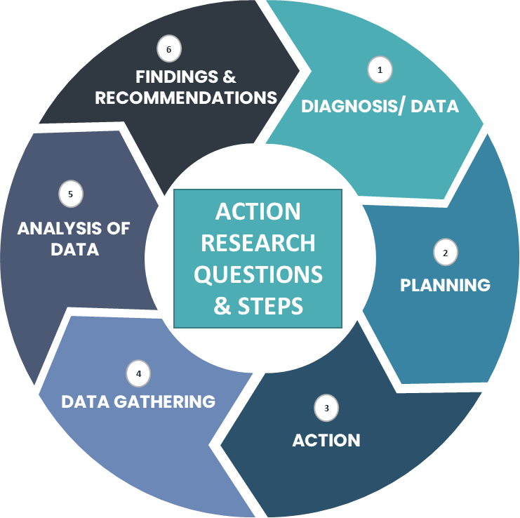
Adapted model from (McNiff, 2013).

Results
The results are presented in two sections: survey findings from student feedback and anecdotal recordings of interactions with the students during the lessons. Alongside this is excerpts of the students’ reflection comments recorded at the end of each lesson. This is an ongoing action research project which is happening this year with Year 11 and 13 students (an hour lesson a week with each age group) within a secondary school setting.

Conclusions
The first term of this year has seen the implementation of the first part of this programme and favourable results have emerged. The Career education is most powerful when it is both intentional and evidence-based, grounded in research about how young people develop career thinking, identity, and decision-making. Rather than relying on one-off activities or exposure alone, an effective programme is built on a coherent curriculum that deliberately develops students’ knowledge, skills, and dispositions over time. Over the year the whole programme will have been implemented and evaluated.

Workshop Presentation
An overview of the structured curriculum and examples of 5 lesson plans, to illustrate content, and evaluation of the programme from students’ comments on the survey and anecdotal evidence.

Content:
- Presentation on the current landscape of career education in New Zealand and globally
- Looking at a coherent and expansive plan of what career education could be and the positive outcomes that can result from the programme
- Present an overview of the structured curriculum and examples of 5 lesson plans, to illustrate content. Discuss in small groups. Share feedback
- Group Work – get participants to complete two activities themselves to see the potential of the process. Feedback from audience

Q & A time

Target Audience
Anyone involved in supporting others to make career decisions, including educators, career practitioners, and professionals working in corporate or private settings.

Format of the Workshop
Whole group presentation – of key concepts
Interactive – small group activities – hands on
Modelling of small group interactions

Bibliographical references
Bright, J. E. H., & Pryor, R. G. L. (2011). The chaos theory of careers: A new perspective on working in the twenty-first century. Routledge.
Handy, C. (2011). Beyond Certainty: the changing worlds of organisations. Random House.
Erikson, E. (1959). Theory of identity development. E. Erikson, Identity and the life cycle. Nueva York: International Universities Press. Obtenido de http://childdevpsychology. yolasite. com/resources/theory% 20of% 20ident ity% 20erikson. Pdf.
Hakim, C. (1989). Developing career choice and decision making. London, UK: Hodder & Stoughton.
Phil Jarvis (2026). Why teens need fewer answers and better questions [LinkedIn post]. LinkedIn. URL https://wix.to/2x6JNuy
Kashefpakdel, E., Percy, C., & Rehill, J. (2019). Motivated to achieve: How encounters with the world of work can change attitudes and improve academic attainmentElnaz.
Krumboltz, J. D. (2009). The happenstance learning theory. Journal of Career Assessment, 17(2), 135–154. https://doi.org/10.1177/1069072708328861
McNiff, J. (2016). Writing up your action research project. Routledge.
Reid, L. (2011). Looking back to look forward: Māori cultural values and the impact on career. International Journal for Educational and Vocational Guidance, 11(3), 187-196. https://doi.org/10.1007/s10775-011-9209-0
Reid, L. (2017). Understanding how cultural values influence career processes for Maori Auckland University of Technology]. Auckland, New Zealand. https://openrepository.aut.ac.nz/bitstream/handle/10292/1036/ReidL.pdf?sequence=1&isAllowed=y
Savickas, M. L. (2013). Career construction theory and practice. In S. D. Brown & R. W. Lent (Eds.), Career development and counseling: Putting theory and research to work (2nd ed., pp. 147–183). Wiley.
Seligman, M. E. P. (2011). Flourish: A visionary new understanding of happiness and well-being. Free Press.
Tertiary Education Commission. (2020). Drawing the future: exploring the career aspirations of New Zealand children.
Tertiary Education Commission. (2022). Transitions from secondary school. https://www.tec.govt.nz/assets/Publications-and-others/Transitions-from-Secondary-School.pd

