Resilience and Self-Consciousness in Japanese University Students' Job Hunting: Who Reaches Career Goal Clarification?
Conference theme: Well-being – Matariki (Mental Health and Resilience)
Presentation language: English

Keywords: job-hunting maintenance process; career resilience; self-consciousness; career goal clarification; school-to-work transition

Introduction
In Japan's mass new-graduate recruitment system (shukatsu), final-year university students must simultaneously apply to multiple companies and secure job offers within a fixed nationwide schedule. This structure renders rejection not exceptional but statistically inevitable: students apply to an average of 25.4 companies while receiving only 2.5 job offers (DISCO Inc., 2023). A central question for career guidance is therefore what enables certain students—facing the same adversity—to develop a clearer, more realistic sense of career direction through this process.

Theoretical Basis
This study draws on the Job-Hunting Maintenance Process (JHMP) framework (Karube et al., 2014, 2015), which encompasses two qualitatively distinct phases. The primary process consists of present-oriented, rejection-coping behaviors operative from the outset of job hunting. The secondary process represents a future-oriented, metacognitive phase that emerges progressively as experience accumulates. This study provides the first quantitative external validation of JHMP theory, examining whether resilience factors and self-consciousness traits predict career goal clarification—the pivotal entry point of the secondary process—beyond primary process behaviors (Figure 1).

Figure 1
The Job-Hunting Maintenance Process model (Karube et al., 2014). The dashed box represents the primary process; outside the box represents the secondary process.

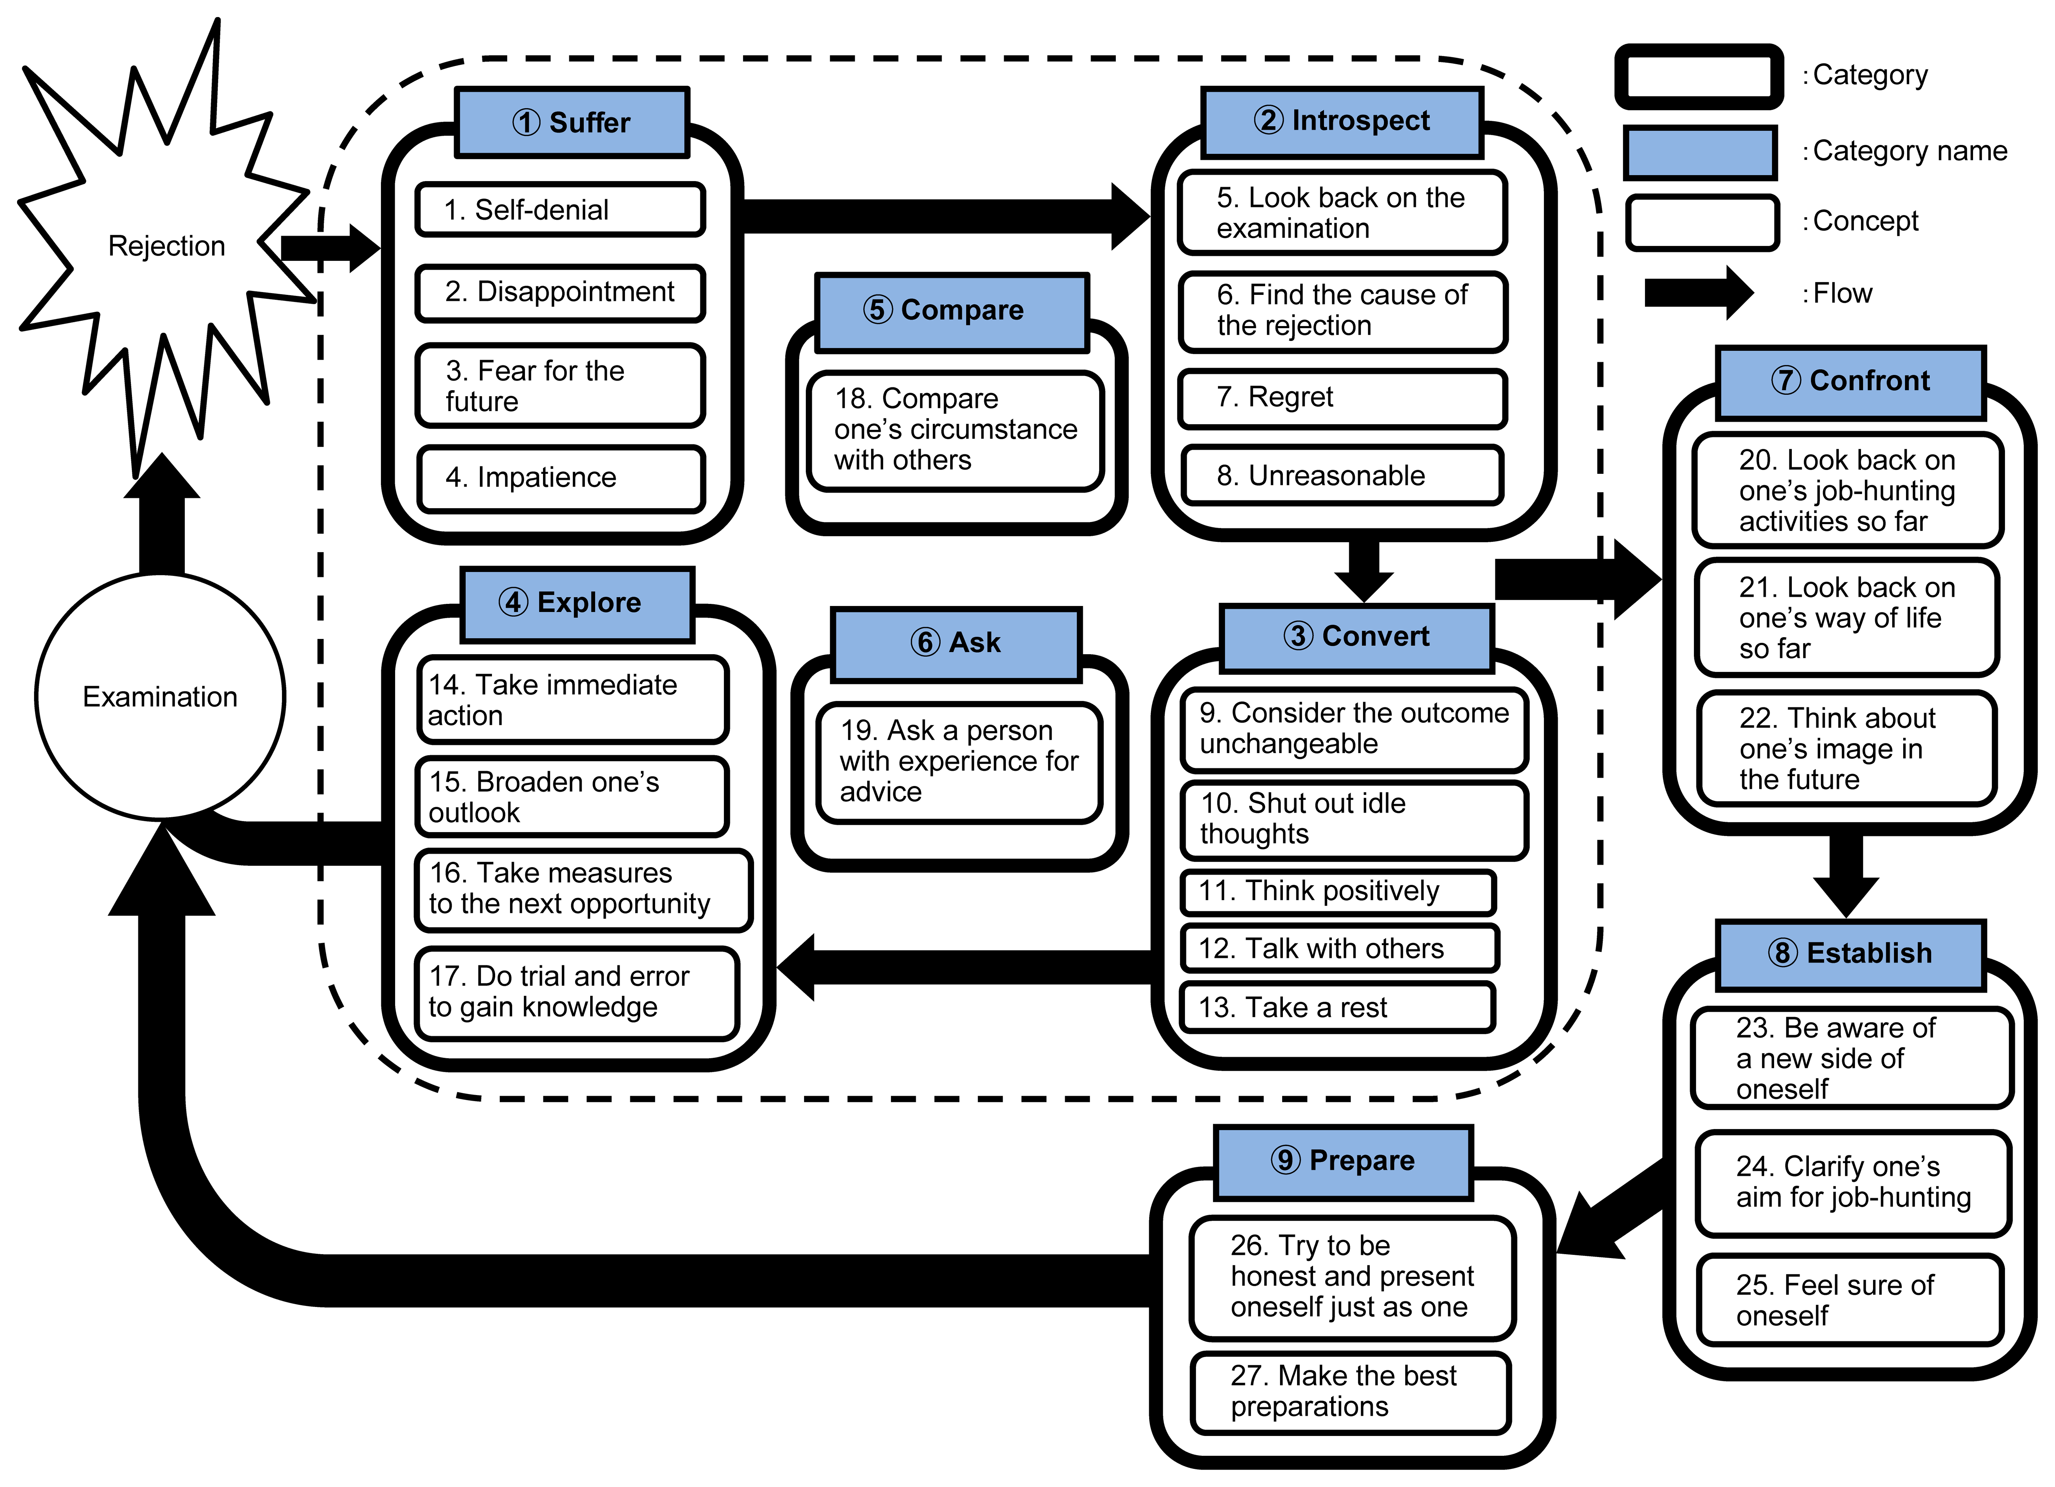

Objectives
Two classes of self-related traits were examined. Resilience factors were operationalized using the Bidimensional Resilience Factor Scale (Hirano, 2010), distinguishing innate factors (control, optimism, sociability, vitality) from acquired factors (attempting to solve a problem, self-understanding, understanding others). Self-consciousness traits were assessed using the Japanese Self-Consciousness Scale (Sugawara, 1984), measuring private self-consciousness (attention to inner states) and public self-consciousness (attention to external evaluation). Four hypotheses were tested: resilience factors positively predict goal clarification beyond primary process behaviors (H1); private self-consciousness is positively associated (H2); public self-consciousness is negatively associated (H3); and the facilitative effect of private self-consciousness is attenuated at higher levels of public self-consciousness (H4, exploratory).

Methodology
Participants were 215 Japanese university and graduate students (106 men, 109 women; M age = 23.04 years) who completed shukatsu with multiple rejections in 2019. Hierarchical multiple regression with forced entry examined trait prediction of goal clarification, controlling for primary process subscales in Step 1. Moderation analysis with Johnson-Neyman probing tested H4.

Results
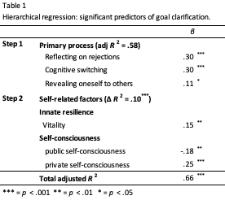
Primary process behaviors explained 58% of variance (adjusted R² = .58). Self-related traits explained an additional 10% (ΔR² = .10, p < .001; total adjusted R² = .66). Private self-consciousness was the strongest predictor (β = .25, p < .001), followed by public self-consciousness (β = −.18, p = .003) and vitality (β = .15, p = .011), supporting H1 partially, H2, and H3 (Table 1). H4 was supported: the interaction was significant (ΔR² = .01, p = .010), with private self-consciousness facilitating goal clarification in approximately 85% of students, while the effect disappeared for the top 15% highest in public self-consciousness (Figure 2).
Figure 2
Interaction Effect of Private and Public Self-Consciousness

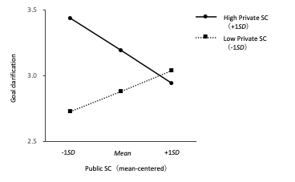

Conclusions
Vitality functions as an unconditional stable resource throughout job hunting. For most students, approaches fostering inward career reflection support goal clarification. For the top 15% highest in public self-consciousness, however, standard reflective approaches may be insufficient without first reducing evaluation concern—such as via self-compassion—to restore conditions for effective private self-reflection. The innate/acquired resilience distinction further supports differentiated career guidance: leveraging stable strengths while cultivating learnable capacities through experience.

Bibliographical References
Karube, Y., Sato, J., & Sugie, M. (2014). Maintenance processes for job-hunting among Japanese university students: Focusing on rejection experiences. Bulletin of Psychological Research, University of Tsukuba, 48, 71–85.
Karube, Y., Sato, J., & Sugie, M. (2015). Measuring job-hunting maintenance processes of Japanese university students: Scale development. The Japanese Journal of Educational Psychology, 63, 386–400.

