Table 2: Latent Class Model Identification and Fit Summary
No. of class | AIC | BIC | G^2 (LR/ Deviance  Statistic) |  | Class1  % | Class2  % | Class3  % | Class4  % | Class5  % | Entropy
1 | 27947.4 | 28070.7 | 7802.4 | ECPS | 100 |  |  |  |  | -
 |  |  |  | PCM | 100
2 | 26970.6 | 27222.5 | 6777.5 | ECPS | 25.8 | 74.2 |  |  |  | 0.772
 |  |  |  | PCM | 24.4 | 75.6
3 | 26435.1 | 26865.7 | 6194.1 | ECPS | 65.4 | 20.7 | 13.8 |  |  | 0.795
 |  |  |  | PCM | 67.1 | 20.2 | 12.7
4 | 26067.6 | 26876.8 | 5778.6 | ECPS | 22.8 | 46.4 | 13.4 | 17.5 |  | 0.758
 |  |  |  | PCM | 20.6 | 49.3 | 12.4 | 17.8
5 | 25941.7 | 26779.5 | 5604.6 | ECPS | 11.3 | 9.1 | 41.9 | 20.9 | 16.8 | 0.773
 |  |  |  | PCM | 10.8 | 7.8 | 44.8 | 19.5 | 17.2
LR: Likelihood ration; ECPS: Estimated class population shares; PCM: Predicted class memberships
Note: AIC-Akaike Information Criterion; BIC-Bayesian Information Criterion; G^2 [Likelihood ratio/deviance statistic]. The identified model is represented by a bolded row.

Table 3: Estimated probabilities of three class model by latent class membership
Health lifestyle behaviors |  |  | Class-1 (Healthy and active)  n=1055 (67.1) | Class-2  (High-risk substance use cluster)  n=318 (20.2) | Class-3  (High digital engagement sedentary group)  n=199 (12.7)
Substance use | Drank alcohol | No | 0.918 | 0.361 | 0.821
 |  | Yes | 0.083 | 0.639 | 0.179
 | Cigarette smoking | No | 0.955 | 0.129 | 0.792
 |  | Yes | 0.046 | 0.871 | 0.208
 | Tried cannabis/marijuana | No | 0.998 | 0.413 | 0.920
 |  | Yes | 0.002 | 0.587 | 0.080
Sleep | Sleep duration | ≤5 hours | 0.021 | 0.126 | 0.134
 |  | 6-8 hours | 0.593 | 0.715 | 0.603
 |  | > 8 hours | 0.386 | 0.159 | 0.263
Media use | Time spent on internet (weekday) | <3 hours | 0.447 | 0.274 | 0.043
 |  | 3-4 hours | 0.433 | 0.507 | 0.388
 |  | >=5 hours | 0.120 | 0.219 | 0.569
 | Time spent on electronic games (weekday) | <4 hours | 1.000 | 0.954 | 0.361
 |  | 4-7 hours | 0.000 | 0.042 | 0.451
 |  | >7 hours | 0.000 | 0.004 | 0.188
 | Time spent on electronic games (weekend) | <4 hours | 0.899 | 0.883 | 0.178
 |  | 4-7 hours | 0.097 | 0.117 | 0.448
 |  | >7 hours | 0.005 | 0.000 | 0.375
Other than school activities | Participation in clubs, groups | Never | 0.166 | 0.345 | 0.417
 |  | ≤1 | 0.234 | 0.221 | 0.258
 |  | >1 | 0.600 | 0.434 | 0.325
Anthropo-metric Measurements | BMI | Thin | 0.052 | 0.044 | 0.013
 |  | Normal | 0.719 | 0.679 | 0.605
 |  | Overweight | 0.179 | 0.227 | 0.287
 |  | Obese | 0.051 | 0.050 | 0.095
Protective factors | More exercise or sport | No | 0.640 | 0.498 | 0.723
 |  | Yes | 0.360 | 0.502 | 0.277
 | Improve diet | No | 0.780 | 0.657 | 0.887
 |  | Yes | 0.220 | 0.343 | 0.113
 | Meditated/relaxation therapy | No | 0.919 | 0.887 | 0.921
 |  | Yes | 0.081 | 0.113 | 0.079
 | Stop using drugs | No | 0.999 | 0.927 | 1.000
 |  | Yes | 0.001 | 0.073 | 0.000
 | Sought support from friends | No | 0.776 | 0.677 | 0.795
 |  | Yes | 0.224 | 0.323 | 0.205
 | Online support seeking | No | 0.966 | 0.882 | 0.912
 |  | Yes | 0.034 | 0.118 | 0.088
 | Support from books, magazine, or TV | No | 0.926 | 0.909 | 0.924
 |  | Yes | 0.074 | 0.092 | 0.076
Note: n-unweighted; %-weighted; Protective factors: Adolescents engaged more in exercise or sports, improved their diets, participated in meditation/relaxation therapy, stopped using drugs, sought support from friends, utilized online support, and sought guidance from books, magazines, or TV to help manage emotional or behavioral problems, or to avoid having problems.

Table 4: Suicidality, any service utilization by overall adolescents and adolescents with suicidality, demographic characteristics, and parental cohabitation by latent classes.
 | Class-1  (Healthy and active)  n=1055 (67.1) | Class-2(High-risk substance use cluster)  n=318 (20.2) | Class-3 [High digital engagement sedentary group]  n=199 (12.7) | P-value
Suicidality | n (%) | n (%) | n (%)
No | 1017 (96.6) | 253 (79.1) | 173 (85.5) | <0.001
Yes | 38 (3.4) | 65 (20.9) | 26 (14.5)
ASUOVAD
No | 774 (74.5) | 188 (58.5) | 132 (66.7) | <0.001
Yes | 281 (25.5) | 130 (41.5) | 67 (33.3)
ASUADSUI
No | 1033 (98.2) | 267 (83.8) | 179 (89.2) | <0.001
Yes | 22 (1.8) | 51 (16.2) | 20 (10.8)
Age (Mean 15.36, SD 1.38)
11-14 years | 397 (49.2) | 27 (15.4) | 49 (34.7) | <0.001
15-17 years | 658 (50.8) | 291 (84.6) | 150 (65.3)
Sex
Male | 610 (57.3) | 184 (56.1) | 158 (78.6) | <0.001
Female | 445 (42.7) | 134 (43.9) | 41 (21.4)
Parental Cohabitation (Lived with parents)
No | 236 (0.23) | 138 (0.46) | 72 (0.37) | <0.001
Yes | 819 (0.77) | 180 (0.54) | 127 (0.63)
Major Depression (Diagnostic status)
No disorder | 948 (90.2) | 218 (68.7) | 156 (79.1) | <0.001
Sub-threshold | 59 (5.5) | 27 (8.7) | 16 (8.4)
Threshold | 48 (4.3) | 73 (22.6) | 27 (12.5)
n=unweighted; %=weighted; ASUOVAD- Any service utilization by overall adolescents; ASUADSUI- Any service utilization by adolescents with suicidality
Table 5: Model estimates predicting suicidality and service utilization.
 | Suicidality  OR (95% CI) | ASUOVAD  OR (95% CI) | ASUADSUI  OR (95% CI)
Latent classes (ref. class 1-Healthy and active)
Class 2- High-risk substance use cluster | 3.47***(2.03-5.93) | 1.21 (0.89-1.65) | 4.50***(2.38-8.48)
Class 3- High digital engagement sedentary group | 2.97***(1.54-5.70) | 1.29 (0.90-1.85) | 4.46***(2.08-9.55)
Age (ref: 11 to <15 years) | 0.69 (0.39-1.23) | 1.35*(1.03-1.77) | 0.65(0.33-1.28)
Sex (ref. Male) | 1.81*(1.13-2.89) | 2.07***(1.63-2.62) | 2.67***(1.54-4.62)
Parental Cohabitation (Lived with parents; ref: no) | 0.60*(0.38-0.96) | 0.89 (0.68-1.15) | 0.80 (0.47-1.37)
Major Depression (ref. No disorder)
Sub-threshold | 11.12***(5.92-20.88) | 2.36***(1.56-3.59) | 8.79***(3.99-19.39)
Threshold | 34.92***(20.61-59.18) | 7.05***(4.67-10.63) | 33.60*** (18.11-62.35)

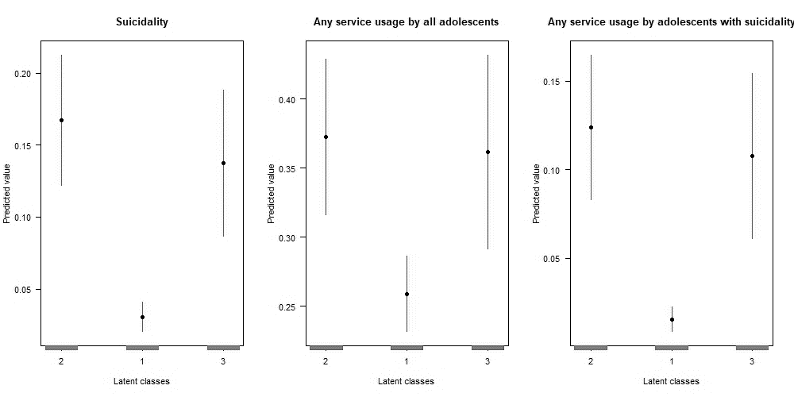
Fig 1: Predictive Margins of Suicidality and Service Utilization Among Adolescents

