Novel Wastewater Treatment Process for PFAS Removal

Paul Rodriguez1, Steven Woodard2,

1Emerging Compounds Treatment Technologies, Inc. Portland, ME  
2Emerging Compounds Treatment Technologies, Inc. Portland, ME

# Abstract Summary

A novel treatment process has been developed with the primary purpose of removing PFAS from difficult to treat wastewaters, including landfill leachate. The system includes enmeshment of an additive into the biological floc of an activated sludge process. The additive is an inexpensive recycled industrial byproduct that has a high sorption capacity for PFAS and is inert/non-toxic. The enmeshment process ensures the additive remains with the biological solids and does not separate/settle out in system tankage. This innovative technology, known as NanoSORB™, offers an extremely cost-effective solution for PFAS removal due to its high removal capacity, simple configuration and relatively low cost of consumables. An on-site demonstration treating wastewater and landfill leachate confirmed that the NanoSORB system is capable of removing PFAS to very low effluent concentrations including to below the Maine drinking water standard.

# Introduction/Background

The presence of per- and polyfluoroalkyl substances (PFAS) in wastewater is nearly ubiquitous. For example, recent studies reported PFAS found in 100% of 42 wastewater treatment facilities sampled in Michigan and 100% of the 18 facilites sampled across the country. Removing PFAS from wastewater, landfill leachate, compost contact water and other matrices with a high degree of co-contamination is projected to require costly upgrades to treatment plants as noted in several recent studies including one published by the Minnesota Pollution Control Agency in 2023. A novel treatment process called NanoSORBTM has the potential to reduce the cost of PFAS removal from biologically treated wastewaters.

# Main Content

While the NanoSORB process can be paired with any biological treatment system configuration including conventional activated sludge, the focus of this case study was application of NanoSORB to a membrane bioreactor (MBR). Figure 1 provides a generalized process flow diagram for the NanoSORB MBR.

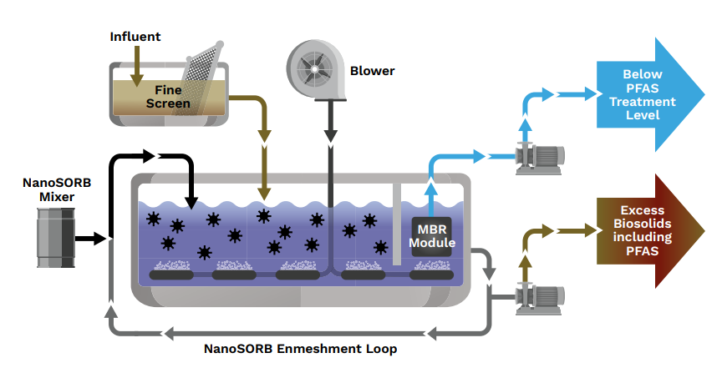

**Figure 1: NanoSORB Membrane Bioreactor General Process Flow**

Once enmeshed in the biological floc, the NanoSORB is given ample time to remove PFAS and other co-contaminants from the aqueous phase due to the relatively long hydraulic rention time (HRT) and solids retention time (SRT) typically employed in activated sludge. Difficult to treat wastewaters such as leachate can severely foul any membranes, reducing their filtration efficiency and ultimately reducing the membrane life. However, Silicon Carbide membranes exhibit a high tolerance to high Fats, Oils, Grease (FOG) and solids concentrations. In addition, the SiC membrane has wide operating window (up to 8psig of transmembrane pressure), coupled with ability to recover 100% after cleans, providing a variety of tools for fouling management. Chemical inertness of the silicon carbide membranes allows for chemical cleaning without affecting membrane life.. These factors, combined with the adsorption properties of NanoSORB, provide an extremely effective system for removal of PFAS and other co-contaminants from a wastewater/leachate matrix without additional pretreatment steps and downstream media vessels typically employed for PFAS laden waters with a high degree of co-contaminants.

A NanoSORB system demonstration was executed as part of a study funded by the Maine Department of Environmental Protection to evaluate PFAS removal technologies as applied on the wastewaters currently received and treated at the Anson-Madison Sanitary District (AMSD) located in Madison, Maine. Wastewater and leachate samples were analyzed for background chemistry in accordance with standard EPA-approved methods, and for 28 PFAS analytes using EPA Method 537.1. The MBR reactor was previously seeded with a nitrifying biomass from a nearby MBR and had been well acclimated to the wastewater/leachate as a result of prior testing phases completed over an 8 month period prior to the start of the NanoSORB trials.

The NanoSORB demonstration began in December 2023 with initial enmeshment experiments and benchtop assessments to confirm the required mixing energy and optimal mixed ratio of biosolids to NanoSORB in the sidestream enmeshment system. For approximately 2 months starting in January 2023, following an initial charge, the system operated on the basis of adding fresh product in proportion to the amount of total solids wasted from the system, assuming conservation of NanoSORB mass and no carryover in the effluent. Otherwise, MBR system operation continued as it had during prior studies and in a manner typical for treatment of wastewater/leachate.

Visual and microscopic evaluations conducted throughout the demonstration revealed complete enmeshment of the NanoSORB product into the biological floc. Bench and demonstration scale tests confirmed that the product was not separating from the floc or depositing in the reactors or grab sample containers. MBR operation during this time period included addition of defoamer to the system to counteract the propensity of leachate and other trucked in wastes to generate foam in the system. The defoamer was successful in eliminating the buildup of foam in any of the reactors or MBR tank during the NanoSORB demonstration period.

PFAS removal was evaluated with respect to the State of Maine’s current drinking water standard, which requires the sum of PFOS, PFOA, PFDA, PFNA, PFHxS, and PFHxA to be less than 20 ng/l. As shown in Figure 1, following an initial dose adjustment the system maintained effluent PFAS below the level required for Maine Drinking water.

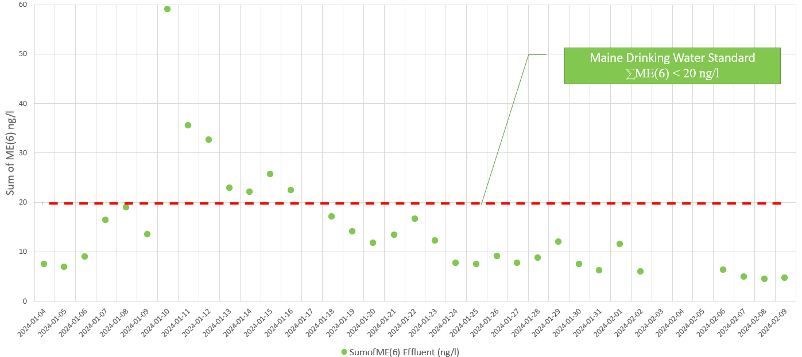

Figure 1: NanoSORB System PFAS Removal (Maine Drinking Water Standard)

The NanoSORB system exhibited a strong propensity for removal of both long chain and short chain compounds, as illustrated by the removals of PFBA, PFPeA, and PFBS shown in Figure 2.

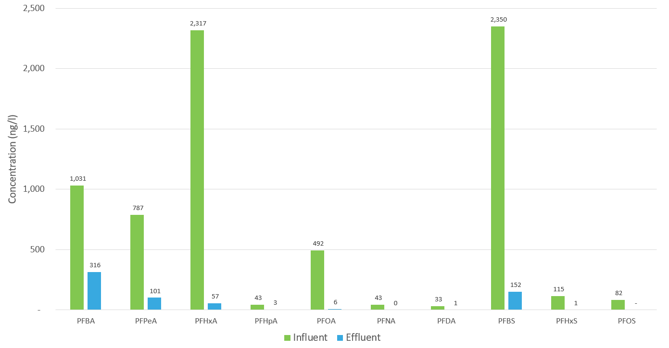

Figure 2: NanoSORB System PFAS Removal by Compound

As noted previously, the NanoSORB system other co-contaminants in addition to PFAS. Many of the constituents that express as non-biodegradable TOC can often accelerate membrane fouling. The NanoSORB system removed a significant portion of the TOC as illustrated in Figure 3 which shows the TOC content in the MBR permeate before and during the NanoSORB demonstration.

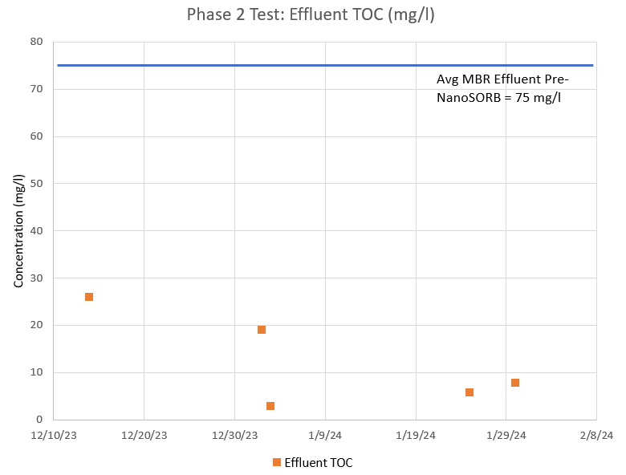

Figure 3: MBR Permeate TOC Before and During the NanoSORB Demonstration

In addition to reducing effluent TOC, the NanoSORB system demonstrated an improvement in mixed liquor filterability, which is the measure of filtered water volume by gravity drainage through filter paper over a 5 minute period. Improvements in mixed liquor filterability highlight the benefit that the NanoSORB system is expected to have on overall operation of a full scale MBR.

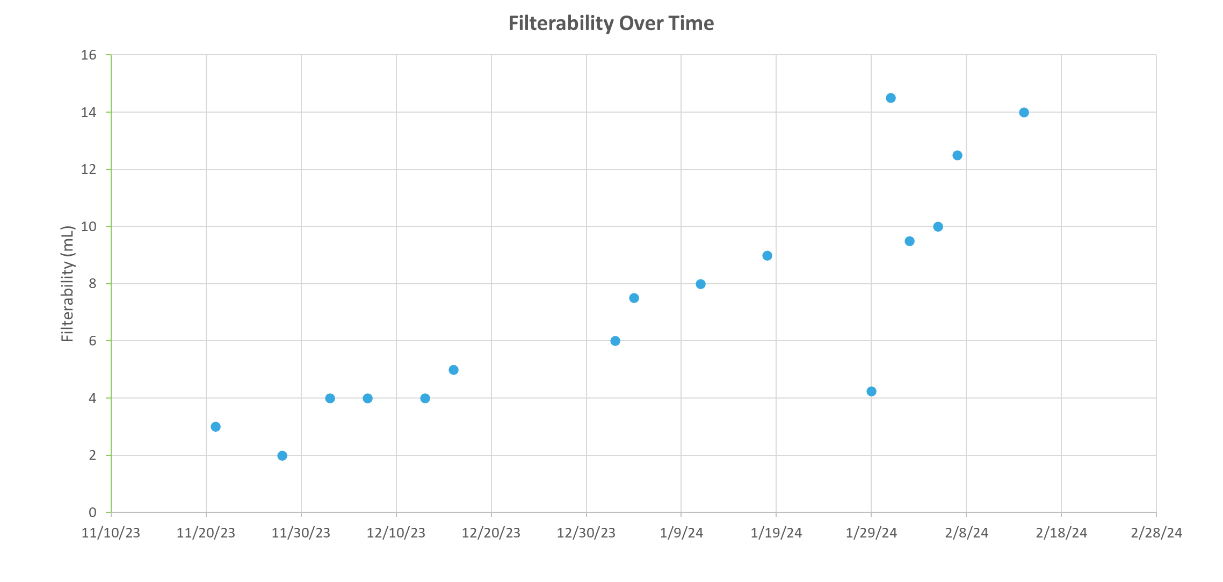

Figure 4: Filterability Enhancement During the NanoSORB Demonstration

# Broader Impacts

Based on the results of the demonstration study presented herein, the NanoSORB process appears to hold promise as a very effective and cost competitive means of removing PFAS from wastewater/leachate through enmeshment of the product into the biomass of the biological treatment system. From an operating cost perspective, because NanoSORB is a recycled industrial byproduct, material procurement costs are less than other commercially available adsorbents. Including the cost of material procurement and disposal, NanoSORB is expected to be only 10-15% of the cost of granular activated carbon. Due to the manufacturing process and particle size of NanoSORB, it is not expected to impact the abrasiveness or fluid dynamic properties of the mixed liquor. Visual observations during the demonstration supported this expectation; however, further study is recommended to confirm this observation. During this presentation additional comparative cost analysis will be presented to facilitate evaluation of this novel process through the context of real-world case studies.