Presentation title: Calculators to individualise the predicted probability of working in a rural area: an answer for the medical workforce issues in non-Metro areas?

Abstract (max. 300 words):
Background: Maldistribution of medical workforce in Australia is well known. Previous studies have explored individual predictors of rural practice among medical graduates. There is, however, no simple way of predicting who is likely to work in a rural area (defined as ASGS RA 2-5) using a combination of those predictors. This study addresses this gap by developing a nomogram to individualise the probability of rural practice.

Methods: A cross sectional survey of the University of Queensland (UQ) Medical students who graduated over a ten-year period (between 2002 and 2011). Multiple Regression models were used to determine the predictors of current rural practice. Variables significant in our final regression model were used to develop the prediction calculator. Each significant variable is assigned a score and a sum of these scores provides an overall score. Predicted probabilities for each individual can be calculated from this score. The model was internally validated and predictive accuracy assessed using a concordance index and then corrected for optimism (1000 bootstrap replicates). Rural background is defined as at least 5-years rural residence beginning primary school and entering medical school.

Results: Of the 2,478 domestic graduates, contact details were available for 1,572 and 48% (n=754) responded to this survey. Of our respondents, 205 (27%) were working primarily in a rural area. Rural background and attendance at a Rural Clinical School were independently predictive and showed strong interaction effects. Bonded scholarship status and partner’s background were also independently predictive of rural practice. These variables were used to develop our nomogram (Figure 1). The bias corrected concordance index for our nomogram was 0.749 and the calibration plot is shown in Figure 2.

Discussion: This calculator quantifies an individual’s predicted probability of rural practice. Such tools can assist decision makers to develop policies that will enhance rural medical workforce.

Fig 1. Calculator predicting current rural practice
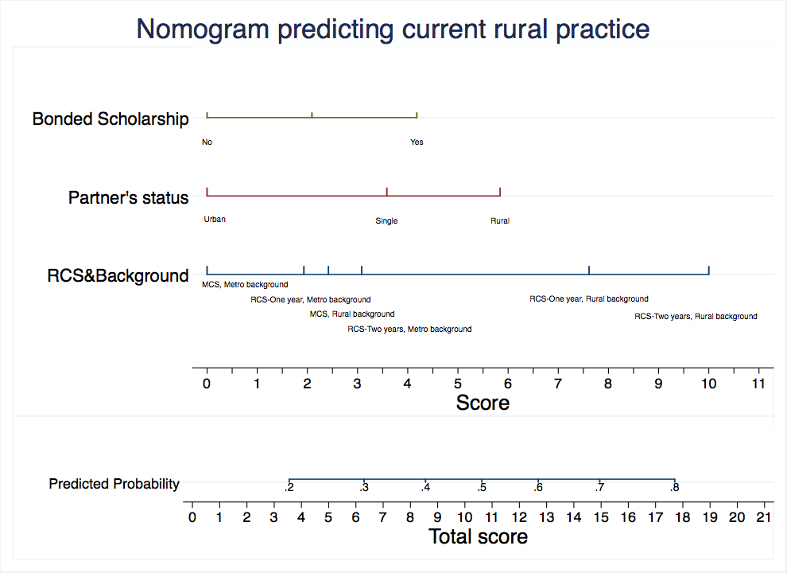

Fig 2. Calibration plot

