*PAPER NUMBER #212*

**Presentation or session title** (100 characters)

Positive Pathways to improve the HIV Care Continuum in different healthcare settings

**Presenting Author(s)\***

G. Brown1, A. Lawson2, M. Robbins2

*Please only list the authors who will be attending the summit. If your abstract is accepted, all authors must register for summit in order for your abstract to appear in the program. For a panel, please list all panel members. We will not accept proposals for all-male panels.

**Affiliation**

1.La Trobe University, Bundoora, Australia. 2. ViiV Healthcare Ltd, London, United Kingdom.

**Country of residence**

UK and Australia

**Type of session** (please select from the dropdown list)

**Poster**

**Theme** (please select from the dropdown list)

Understanding what works

**Objectives/aims** (Please describe the objectives and/or aims of the study or activity you wish to present on, or for the panel you suggest to include in the GEIS 2018 program. Max 600 characters.)

HIV is undergoing the largest social, biomedical and policy changes in two decades, identifying which evidence based interventions (EBI) and how they should be implemented may optimise care and contribute meaningfully to global goals to end HIV.

Rooted in Implementation Science (IS), Positive Pathways for HIV Care (PP), an initiative to map EBI to understand which have the greatest impact, we explored HIV care in eight centres (Europe, USA & Canada) creating a self-assessment questionnaire & a 21-item prioritised EBI compendium. In 2017, PP expanded to seven sites in Australia, Brazil, Japan and Taiwan to determine the utility of PP to other geographies.

**Methods** (What methods were used as part of your study or activity? If you are submitting a panel proposal, what will be the format of your session? Max 600 characters.)

There remains a substantial gap between what we know works and what we are achieving in HIV care. IS aims to bridge the gap between evidence, practice and policy to improve the efficiency and effectiveness of HIV care and management.

Through advisory boards with healthcare physicians (HCPs) from the above sites and additional HCPs from South Korea, Thailand, Colombia, Jamaica, Peru, Mexico and Argentina we reviewed the resultant observations. This confirmed the 21-item prioritized EBIs as important and identified an additional seven (Figure 1), ranked for ease of implementation and potential impact. The self-assessment questionnaire was updated to reflect new insights on optimal HIV care.

Figure 1

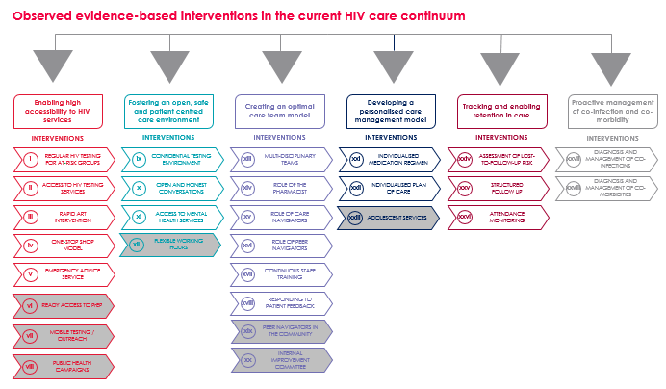

**Main findings** (Please describe the results and/or outcomes of your study or activity. If you are submitting a panel proposal, describe the expected results from this panel. Max 600 characters.)

While the original EBI compendium remained applicable, additional EBI were deemed

important given differences in healthcare delivery systems and need to offer comprehensive services in prevention and key affected populations.

Participants observed cultural differences, notably stigma and discrimination (S&D) particularly in Asia-Pacific, where S&D extended to HCPs managing people living with HIV.

The compendium and questionnaire represent valuable resources for clinics globally; these tools may help optimise the use of finite resources and accelerate efforts to end AIDS. Adapting the resources improved local applicability in different geographies and healthcare settings.

**Please note: If you are submitting an abstract for a symposium or panel**, please ensure your responses above describe the aims and intended results for your panel. Under ‘methods’, please include a description of your session format and panel participants.