PAPER NUMBER #261
The Reporting Quality of Education Systematic Reviews in Campbell Collaboration

Presenting Authors
Jing Zhang^{1,2}, Lili Wei^{1,2}, Xinya Wang^{1,2}, Lijuan Si^{1,2}, Xuemei Han^{2,3}, Yongxin Pan^{1,2}, Yixin Zhou^{1,2}, Kehu Yang^{2,4,5}, and Jinhui Tian^{2,4,5}

Affiliation
- School of Economics,Lanzhou University,China
- Centre for Evidence-based Social Science Research,Lanzhou University,China
- School of Public Health,Lanzhou University,China
- School of Basic Medicine,Lanzhou University,China
- Centre for Evidence-Based Medicine,Lanzhou University,China

Country of residence
China

Objectives/aims
Campbell Collaboration is a platform that provides high-quality evidence and promotes it to practice.In recent years, the Campbell collaboration has published a number of systematic reviews that are considered high-quality evidence.We try to analyze the systematic reviews of Campbell collaboration.We chose systematic reviews under education classification and adopted visual analyses of the cooperation between countries, agencies and authors.We also use meta-analysis to evaluate the quality of educational assessments.

Methods
We searched for systematic reviews under education classification in the Campbell collaboration before February 2018, using visual analyses of the collaborative relationships among countries, agencies, and authors. We use the MOOSE table to evaluate the quality of the literature. STATA 13.0 software was used to make a meta-analysis of the quality of Campbell education systematic reviews.

Main findings
The results show that the fund support is statistically significant in item 7 (OR = 9 95% CI: 1.72, 46.99), item 9 (OR = 0.13 95% CI: 0.02, 0.68), item 11 (OR = 30.07 95% CI: 1.48, 612.09) and item 14 (OR = 5.60 95% CI: 1.15, 27.37) ;the year that reviews published is statistically significant in item 7 (OR = 12.57 95% CI: 2.19, 72.27) and item 16 (OR = 48.38 95% CI: 2.44, 961.10) .The statistically significant item in the number of authors was item 11 (OR = 13.00 95% CI: 1.39, 121.38).The results are shown in Table 1.It indicates that the Campbell Collaboration education Systematic reviews should be more standardized, and more fund support encourage researchers to expand the search scope.
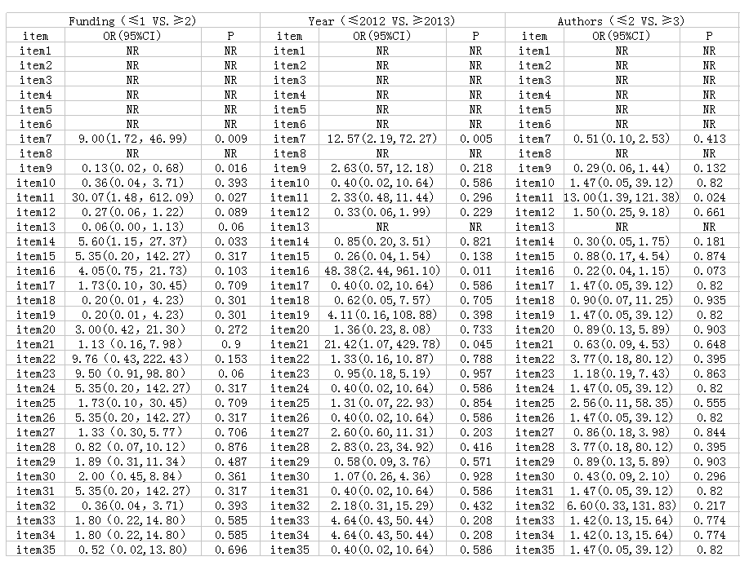
Table 1：

Please note: If you are submitting an abstract for a symposium or panel, please ensure your responses above describe the aims and intended results for your panel. Under ‘methods’, please include a description of your session format and panel participants.

