

The Australian Society of Agronomy Inc.

Fellowship Award Nomination Form

2026

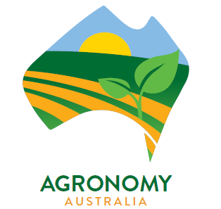

The Australian Society of Agronomy Inc.

Fellowship Award Nomination Form

2026

The Australian Society of Agronomy may award up to 10 Fellowships at the Australian Agronomy Conference.
The ‘Australian Society of Agronomy Fellowship Award’ shall be awarded for important contributions to Australian agronomy including laboratory and field research, development, extension, administration and support of the careers of fellow agronomists.
Nominations must be made by a financial member of the society and must be accompanied by a case in support prepared by a nominator and seconder and supported by two financial members of the society.
Please read and comply with Section 8.2 The Fellowship Award in the Rules prior to completing this form.
Completed nomination forms should be emailed to the two addresses listed below by 31 March 2026. In the event the submitted nomination form has not been acknowledged, it is the responsibility of the nominator to confirm the nomination has been received within 7 days of submitting the nomination.
Iain.Forrest@nt.gov.au office@agronomyaustralia.org.au
Iain Forrest Dr Sue Knights
Secretary Executive Officer

Details of the nominee for the Fellowship Award
Name
Address
Email address
Phone number

Details of the nominator
Name
Address
Email address
Phone number
Signature

Details of the seconder
Name
Address
Email address
Phone number
Signature

Details of two supporting financial members of The Australian Society of Agronomy Inc.
Name
Address
Email address
Phone number
Signature

Name
Address
Email address
Phone number
Signature

Please address the following information either as separate sections in to this nomination form or as a collated pdf
a) the case in support of the nominee (limit 1000 words) (insert text or attach as separate document)
b) the nominee’s curriculum vitae (insert text or attach as separate document)
c) the nominee’s publication list. (insert text or attach as separate document)
and email the completed nomination to both Iain Forrest Iain.Forrest@nt.gov.au and Dr Sue Knights, Agronomy Australia office, office@agronomyaustralia.org.au, by 31 March 2026.

