Impact of Amantadine on Neurocognitive Function in Aneurysmal Subarachnoid Haemorrhage: A Systematic Review and Case Series.

J,Raftesath, Clinical Nurse Consultant Neurosurgery, Royal Prince Alfred Hospital Sydney.
K,Muralidharan, Neurosurgery Registrar, Royal Prince Alfred Hospital Sydney.
R,Fonseka, Resident Medical Officer, Royal Prince Alfred Hospital Sydney.

Background

Aneurysmal subarachnoid haemorrhage patients can suffer from severe neurocognitive impairments such as decreased conscious levels, memory and language impairments. Administering the Parkinson’s drug amantadine as a neuro stimulant has shown promising results in the traumatic brain injury population group but there is limited study in the aneurysmal subarachnoid patient group.

Method

We retrospectively identified eight cases at a single institution (Royal Prince Alfred Hospital, Sydney) after year 2000 with a diagnosis of an aneurysmal subarachnoid haemorrhage that were administered amantadine after ictus in an attempt to improve neurocognitive function.

We performed a literature search on aneurysmal subarachnoid haemorrhage patients who were administered amantadine and measured their neurocognitive status after year 2000. The PRISMA statement guidelines were followed when selecting studies for inclusion and extracting data. Please see Figure 1.1

Results

We identified eight patients at our institution that met eligibility criteria. Four patients had a GCS improvement of at least two points within 21 days after amantadine initiation. This is summarised in Table 1.1

The extracted data from our literature search showed in two studies (Akcil et al and Ruhl et al) where amantadine was introduced early showed significant improvement in level of consciousness in participants who received amantadine compared to the controls.

Conclusion

The case review and literature search supports Amantadine along with current standard treatment can improve consciousness levels and improve neurocognitive function in aneurysmal subarachnoid haemorrhage patients. More research is needed to find out the best population group, effective dosage and duration as well as timing of its initiation the acute care setting.

Patient | Age, sex | Aneurysm location | WFNS, mFisher | GCS on admission | GCS when amantadine commenced | Days after ictus when amantadine commenced | GCS 7 days after amantadine commenced | GCS 14 days after amantadine commenced | GCS 21 days after amantadine commenced
SQ | 54M | MCA | IV, III | 10 | 14 | 37 | 14 | N/A | N/A
GL | 83M | Supraclinoid ICA | V, III | 3 | 3 | 32 | 4 | N/A | N/A
RL | 76F | ACA | V, I | 3 | 11 | 18 | 12 | 12 | N/A
AL* | 64F | MCA | V, III | 3 | 11 | 44 | 11 | 11 | 13
EH* | 78F | PCOM | V, IV | 6 | 11 | 47 | 13 | 14 | 14
KH* | 60F | Basilar | V, IV | 3 | 9 | 181 | 10 | 13 | 14
YL* | 61M | PCOM | IV, III | 8 | 10 | 19 | 11 | 11 | 15
SD | 73F | Terminal ICA | V, IV | 5 | 13 | 23 | 14 | N/A | N/A
Table 1.1. Summary of data from case series. *: patients whom we considered had an apparently beneficial neurocognitive response to amantadine.

Figure 1.1 PRISMA flow-chart for search strategy.
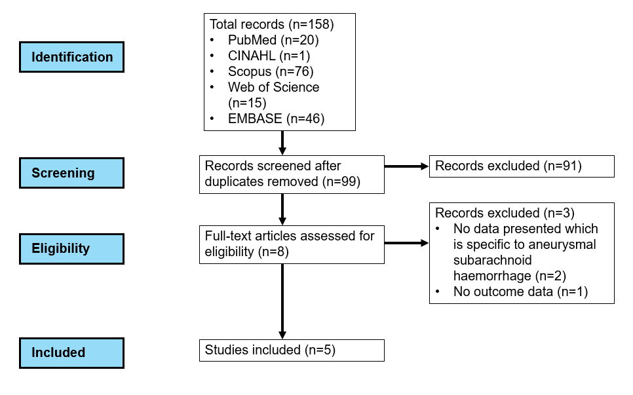

References

1. Akçıl EF, Dilmen Ö K, Vehid H, Tunalı Y. Can Amantadine Ameliorate Neurocognitive Functions After Subarachnoid Haemorrhage? A Preliminary Study. Turk J Anaesthesiol Reanim. 2018;46(2):100-7.
2. Avecillas-Chasin JM, Barcia JA. Effect of amantadine in minimally conscious state of non-traumatic etiology. Acta Neurochirurgica. 2014;156(7):1375
EP - 7.
3. Gatto LAM, Demartini Z, Jr., Telles JPM, Figueiredo EG. Does amantadine improve cognitive recovery in severe disorders of consciousness after aneurysmal subarachnoid hemorrhage? A double-blind placebo-controlled study. Clin Neurol Neurosurg. 2024;237:108135.
4. Lehnerer SM, Scheibe F, Buchert R, Kliesch S, Meisel A. Awakening with amantadine from a persistent vegetative state after subarachnoid haemorrhage. BMJ Case Rep. 2017;2017.
5. Rühl L, Kuramatsu JB, Sembill JA, Kallmünzer B, Madzar D, Gerner ST, et al. Amantadine treatment is associated with improved consciousness in patients with non-traumatic brain injury. J Neurol Neurosurg Psychiatry. 2022;93(6):582-7.

