**Abstract**

**Title:** Depletion of TRMT2A alleviates pathological features in an MJD/SCA3 mouse model

**Authors:** Tiago Moreira-Gomes (1,2,3, FCT fellowship: 2022.11008.BD) , David V.C. Brito (1,2), Ricardo Afonso-Reis (1,2,3), José Miguel Codêsso (1,2,3), Sofia M. Calado (1,2), Aaron Voigt (4,5), Clévio Nóbrega (1,2)

1 ABC-RI, Algarve Biomedical Center Research Institute, Universidade do Algarve, Faro, Portugal

2 Faculdade de Medicina e Ciências Biomédicas, Universidade do Algarve, Faro, Portugal

3 Doctoral program in Biomedical Sciences

4 Department of Neurology, Medical Faculty, RWTH Aachen University

5 JARA BRAIN Institute Molecular Neuroscience and Neuroimaging, Forschungszentrum Jülich GmbH and RWTH

Machado-Joseph disease (MJD), also known as Spinocerebellar ataxia type 3 (SCA3), is a polyglutamine disorder caused by an abnormal trinucleotide (CAG) expansion in the *ATXN3* gene, which encodes for an abnormally expanded polyglutamine tract in ATAXIN-3 protein. The expanded protein leads to several molecular events that culminates with neurodegeneration and neuronal loss in specific areas of the brain. This translates into severe impairments across the patient’s body functions, and currently there are no therapies to halt or slow disease progression. Thus, there is an urgent need to identify novel molecular targets to develop disease-modifying therapies. Previously, it was shown that the loss of the tRNA methyltransferase 2 homolog A (TRMT2A) reduced polyglutamine toxicity and aggregation in MJD/SCA3 fibroblasts and Drosophila models. Despite this, the therapeutic impact of Trmt2a knockout in an MJD/SCA3 mammal model was not addressed. The present work aims to investigate in detail the impact of a Trmt2a knockout in a transgenic MJD/SCA3 mouse model. Briefly, MJD/SCA3 mice with the genotypes Trmt2a+/+, Trmt2a+/- and Trmt2a-/- (full knockout) underwent motor behavioral tests every 4 weeks for 12 weeks, including rotarod, footprint, grip strength, and swimming tests. Our findings show that the response of mice motor’s function is dependent on the dosage of TRMT2A protein. In comparison to the control groups, MJD/SCA3 Trmt2a-/- mice exhibited a slower motor deterioration and better gait performance. This is concomitant with an increase in the number of Purkinje cells and cerebellar molecular layer, suggesting neuroprotection. Furthermore, the presence of pathological aggregates was reduced in the retina in the absence of Trmt2a. Transcriptomic analyses of these animal cerebella shed light on cellular pathways impacted by the absence of Trmt2a protein. The impact of genetic suppression of Trmt2a on gene expression related to several cellular mechanisms relevant to MJD/SCA3 pathogenesis were elucidated, with a particular focus on protein homeostasis pathways. These findings suggest that TRMT2A holds promise as a potent therapeutic target, potentially paving the way for novel disease-modifying treatments for MJD/SCA3, both based in pharmacological and in advances medicines.

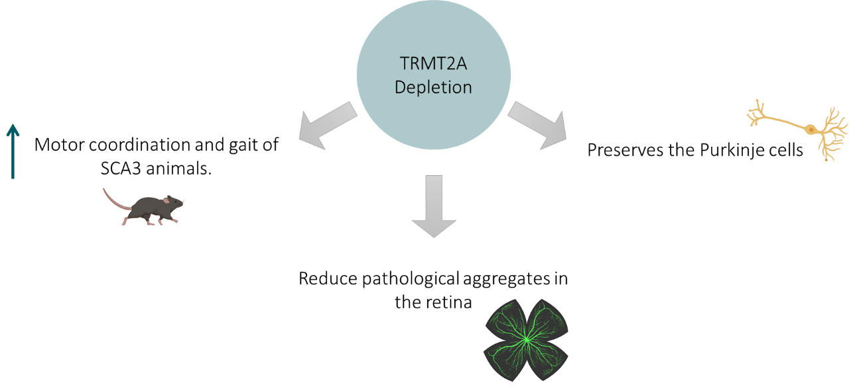

**Figure 1.** Graphical abstract