Advancing Proteostasis-enhancing Therapies: A Novel Assay for Drug Discovery in Machado-Joseph disease

D. Vilasboas-Campos**, J. Humberto-Fernandes**, M. D. Costa**, J. Pereira-Sousa**, J. Lopes**, L. Costa-Meireles**, B. Ferreira-Lomba**, J. D. Da Silva**, F. Conceição***, F. Proença***, Patrícia Maciel**, Andreia Teixeira-Castro**

*Life and Health Sciences Research Institute (ICVS), School of Medicine, University of Minho, Campus de Gualtar, Braga, Portugal; **ICVS/3B's - PT Government Associate Laboratory, Braga, Guimarães, Portugal. ***Department of Chemistry, University of Minho, Campus de Gualtar, Braga, Portugal.

**ABSTRACT:**

**Background/Objectives:** The accumulation of misfolded proteins into aggregates causes cellular toxicity, known as proteotoxicity, leading to long-term detrimental effects and neurodegeneration. This study addresses the lack of effective therapeutic strategies for neurodegenerative diseases (NDs) associated with proteotoxicity, such as Machado-Joseph disease (MJD) or Spinocerebellar Ataxia type 3 (SCA3). We aim to identify molecules with proteostasis-enhancing activity that will serve as broad-spectrum neuroprotective drugs. To achieve this, we conducted a large-scale drug screening using the nematode *Caenorhabditis elegans*. This allows a cost and time-efficient screening of small-molecules while providing valuable biological and pharmacological insights.

**Methods:** We established an automated assay to screen for molecules that enhance cellular protein folding and homeostasis capacity, thereby reducing proteotoxic stress at the whole organism level. We used motor activity, a nervous system-dependent function, following a proteome-disrupting heat-shock (HS) stimulus, as a readout for this assay. Our protocol involved exposing wild-type animals to different durations of HS at 37ºC, followed by automated measurement of their motor activity (Figure1). This assay was then applied to an MJD *C. elegans* model.

**Results and Discussion:** We found that an HS duration of 60 minutes was the most effective in allowing potential treatment effects to be detected, as it caused a significant yet recoverable loss of movement, with potential for recovery using previously known proteostasis-enhancing drugs. Using this newly established protocol, we validated the pharmacologic and genetic modulation of serotonergic signalling and mTOR inhibition as strategies that counteract HS-mediated proteotoxic damage, with activity in models of SCAs. Screening a library of approximately 400 novel compounds, predominantly containing imidazole and chromene-based structures, identified 19 hits that significantly accelerated recovery of the animals' motor activity (Figure 2). These compounds are currently undergoing further testing in models of MJD to evaluate their therapeutic potential, with very promising results. The assay’s design offers a scalable platform for identifying molecules that counteract disease-associated proteotoxic stress, enabling the discovery of novel therapeutic candidates.

**Conclusion:** This novel assay provides a powerful tool to identify compounds capable of mitigating aging and disease-associated proteostasis deterioration. By focusing on MJD, the study lays the groundwork for developing new drug candidates targeting a critical mechanism underlying NDs.

**Figure 1.** Conceptual principle and experimental setup of the fast-throughput phenotypic assay in *C. elegans* for screening chemical compounds that enhance proteostasis.

**Figure 2.** Identification of bioactive novel compounds through screening of chromene derivatives.

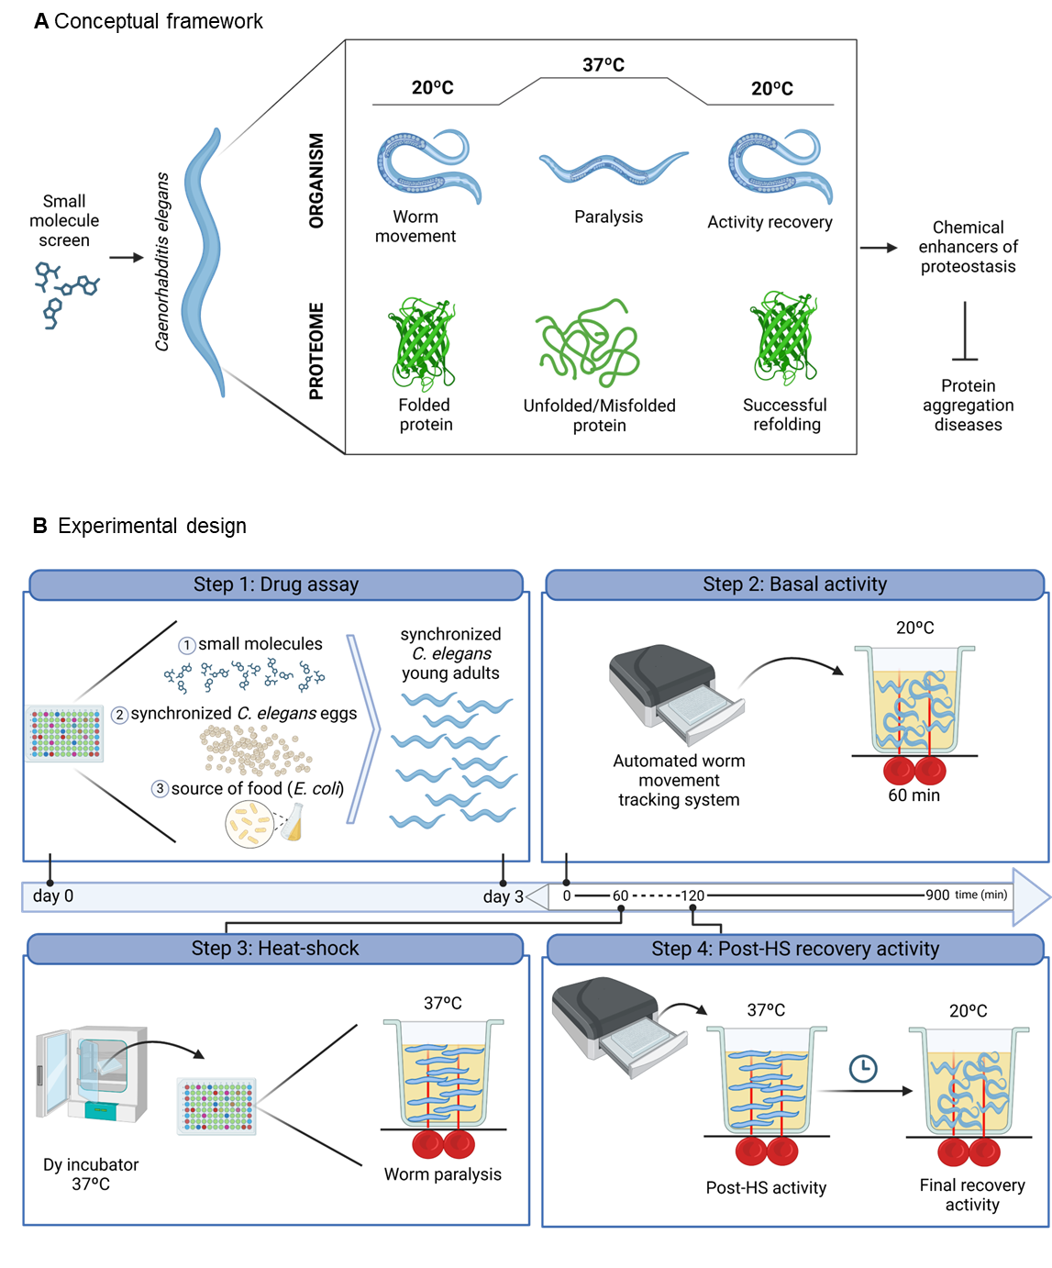

**Figure 1.** (A) Heat-shock (HS)-induced alterations in animals motor behavior are used as a proxy for assessing proteome fitness. At 20°C, the worms move normally with properly folded proteins. When subjected to heat-shock at 37°C, they experience protein unfolding/misfolding and become paralyzed. After returning to 20°C, some worms recover movement, indicating successful protein refolding. This approach enables the identification of potential therapeutic agents for protein aggregation disorders. (B) Experimental pipeline developed to identify chemical modulators of proteostasis in C. elegans. The methodology involves four critical steps: 1) Chronic exposure of C. elegans to small molecules at various concentrations in a multi-well plate - day 0; 2) Assessment of pre-stress (basal) motor activity at 20ºC for 1 hour using an automated worm movement tracking system that detect worm movement based on the interruption of infrared beams in each well. – day 3; 3) Induction of proteotoxic stress and paralysis by placing the plates in a 37°C incubator; and 4) Monitoring post-HS recovery activity using the automated worm movement tracking system, to determine the compounds’ effectiveness in restoring normal locomotion after the noxious stimulus.



**Figure 2.** Pie chart showing that 19 of the screened molecules enhanced recovery of the animals.